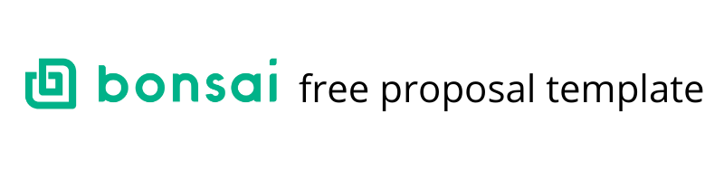

1. Project Description

What are the client’s problems?

If you want your proposal to be the winning one, make sure you spend ample time understanding what your client is facing. In this section, clearly explain your best understanding of the client’s problem. Spend extra time on formulating this part, as it may very well decide if the rest of the proposal will be read or not

How are you going to solve the problems?

If your proposal properly answers this question, then you’re on the right track to writing a winning proposal. Get into the finer details of how you’re going to solve the problem, explain in detail while making sure to keep projections accurate and realistic. This is also a great section to highlight any knowledge that can set you apart from the competition.

2. Timeline

How long will it take to finalize the project?

Be as clear as possible and break the project into as many milestones as it makes sense. The big question to answer here concisely is how long will it take to complete the project. Be sure to set out realistic expectations for both parties, even though you might feel tempted to underestimate the timeframe - it’s not a good idea.

3. Pricing

How much does the client have to pay?

Your pricing scheme is an essential part of any proposal, and it’s probably one of the deciding factors that the client will spend time evaluating. Be flexible and try to adjust your pricing based on the client, making it as simple or as complex as the project demands it. Some options to choose from are itemized fee summaries, periodic milestones or hourly rate.

4. Mode of Payment

How should the client pay you?

Try to be as concise as possible in this section and whenever possible, try to be flexible and choose the payment method that works best for both you and your client. Paypal is in most cases the obvious choice, but there might be cases where you need to be more flexible, so make sure you do that and avoid overcomplicating the payment process.

5. About Us

Who are you and what are your skills?

This section is all about you, your business, past accomplishments, and any other information relevant to the project you’re sending the proposal for. Go ahead and brag about your skills, this is the perfect opportunity to do so.

Send automated proposal templates using Bonsai.

