Wholesale Line Sheet Template

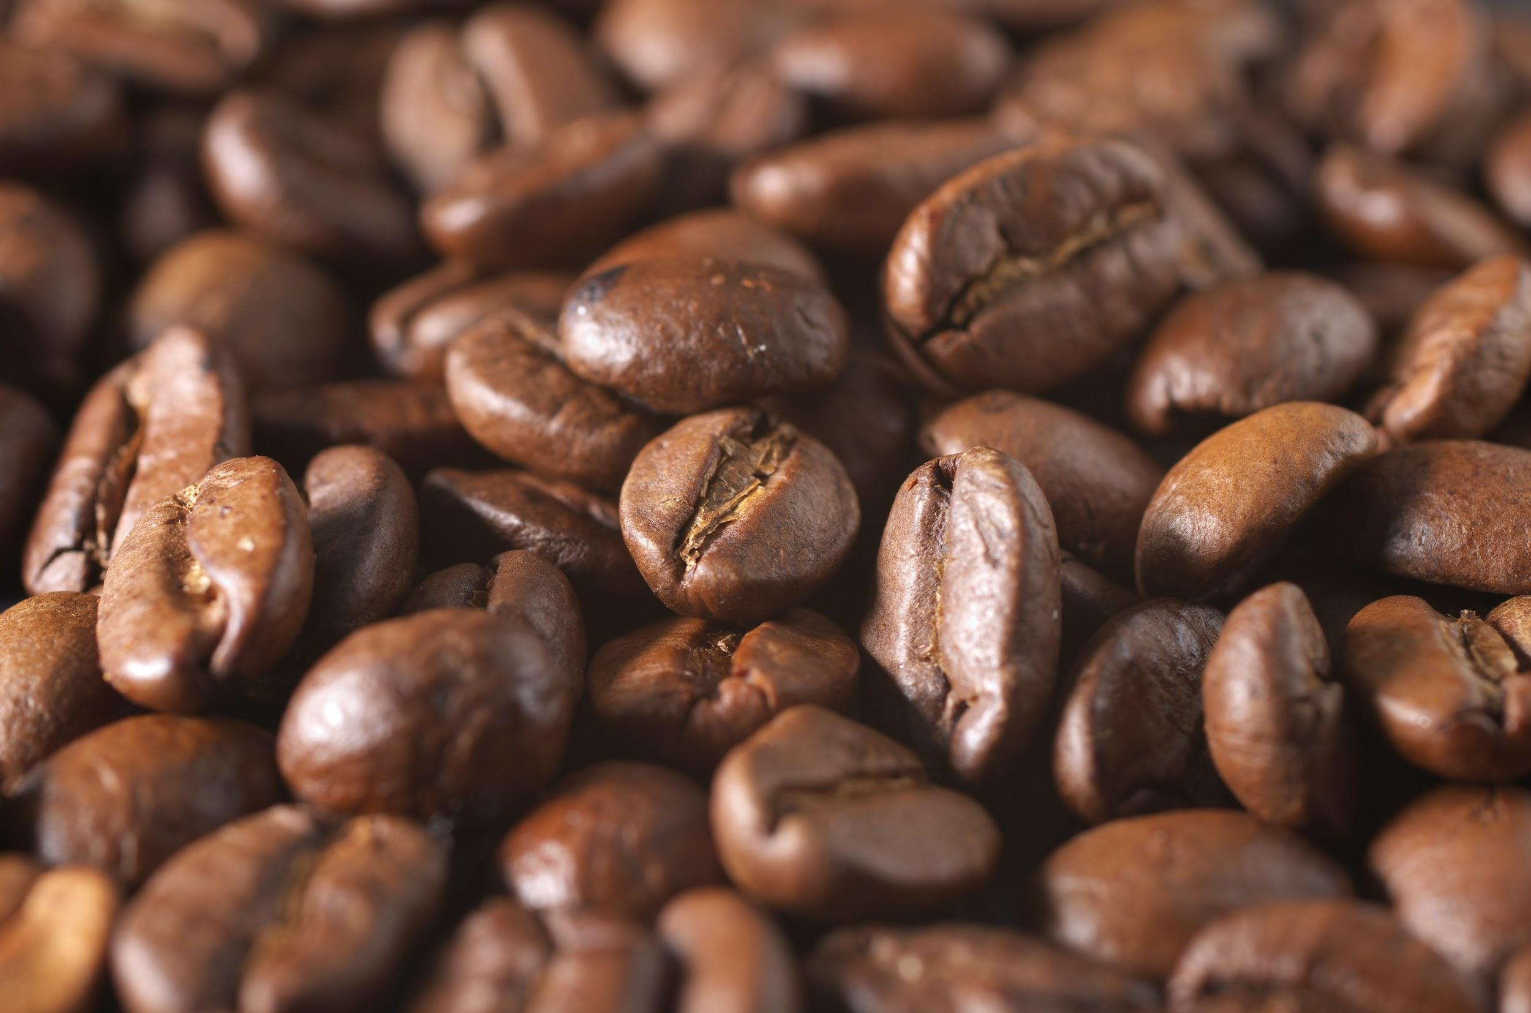  Columbian Medium Roast  $6.99/lb Wholesale  Item-ID: c-0001 | 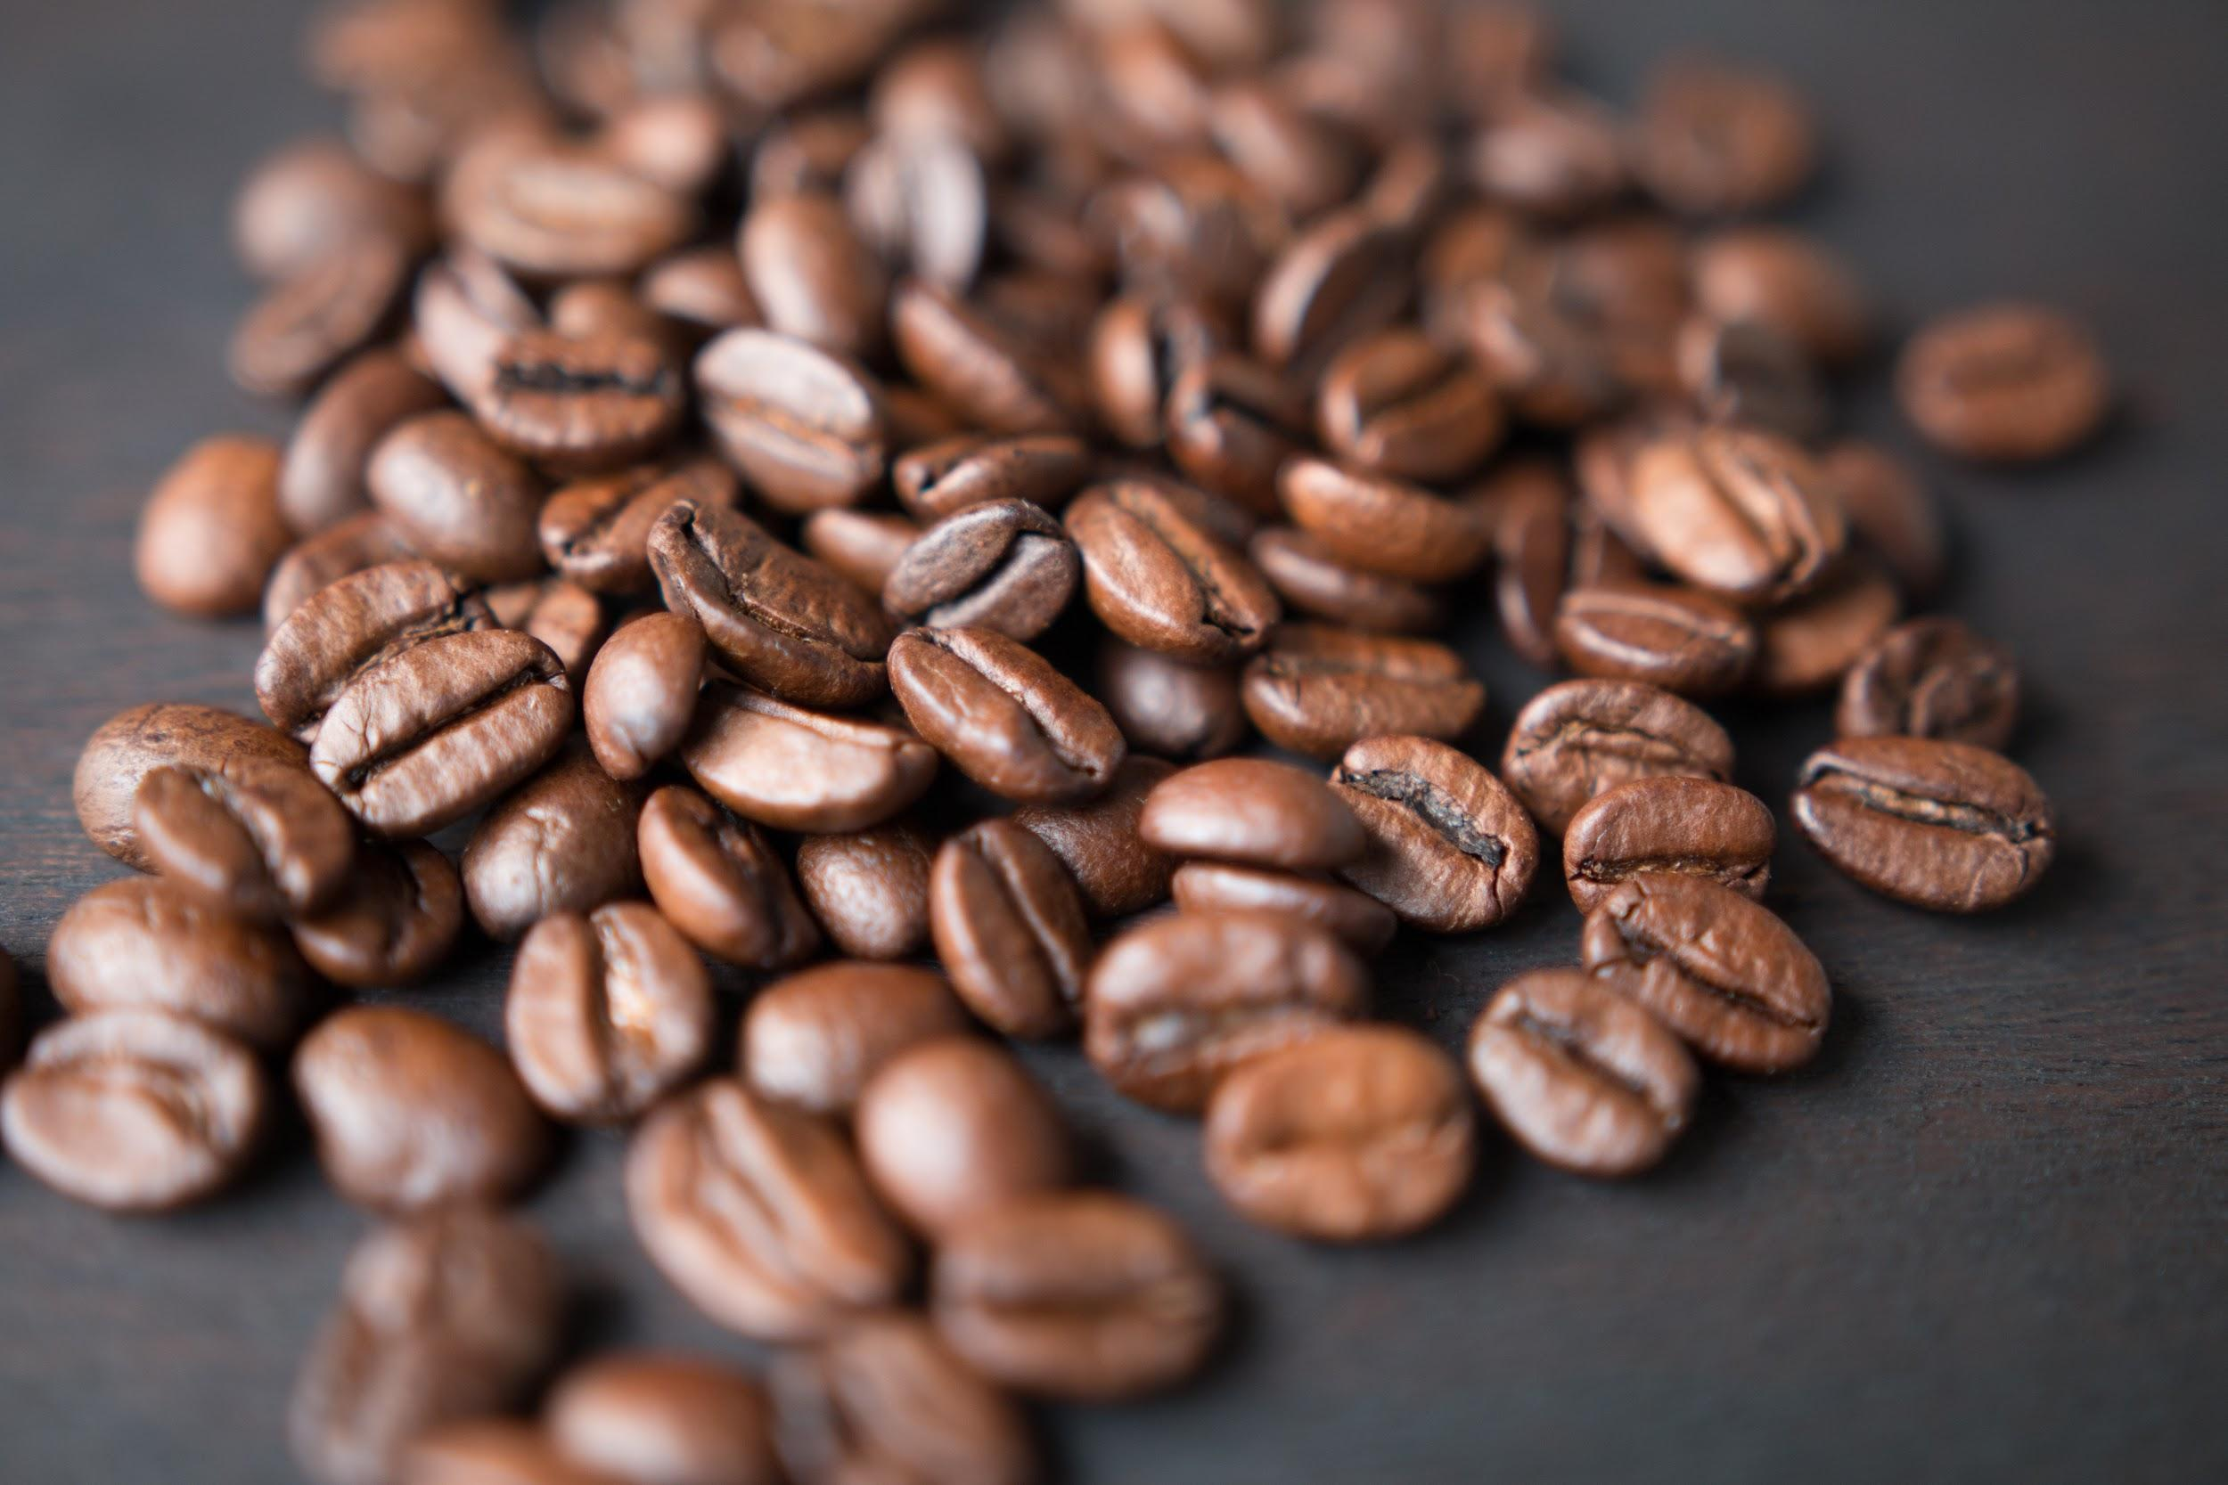  Guatemalan Medium Roast  $5.99/lb Wholesale  Item-ID: c-0002 | Ethiopian Light Roast  $6.29/lb Wholesale  Item-ID: c-0003
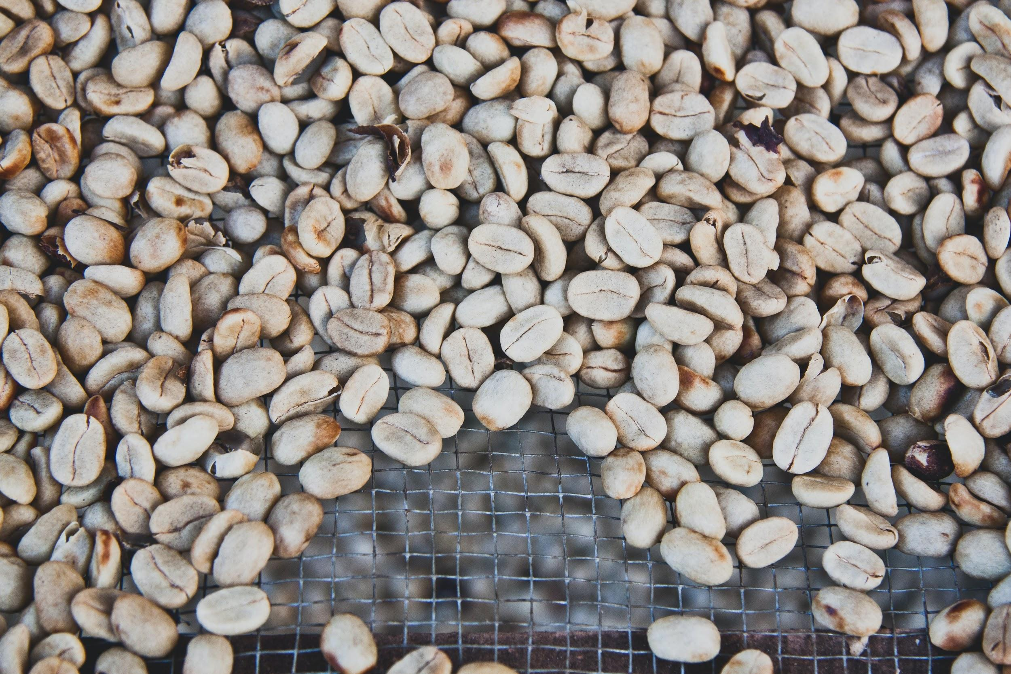  Columbian Light Roast  $6.29/lb Wholesale  Item-ID: c-0004 | 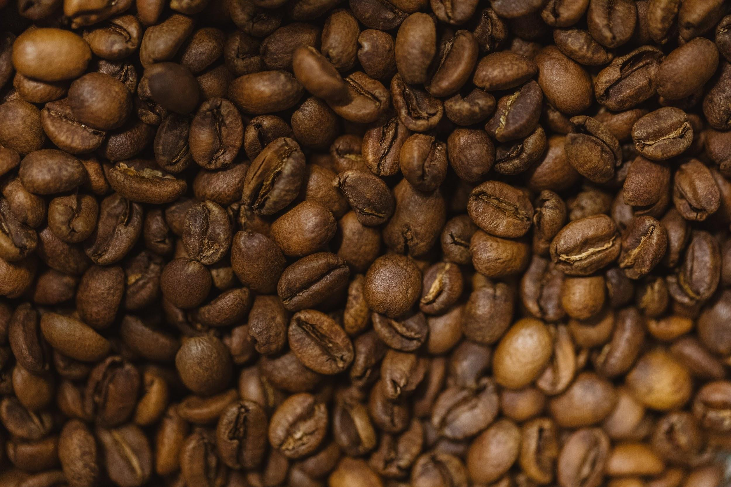  Costa Rican Honey Roast  $8.99/lb  Item-ID: c-0005 | 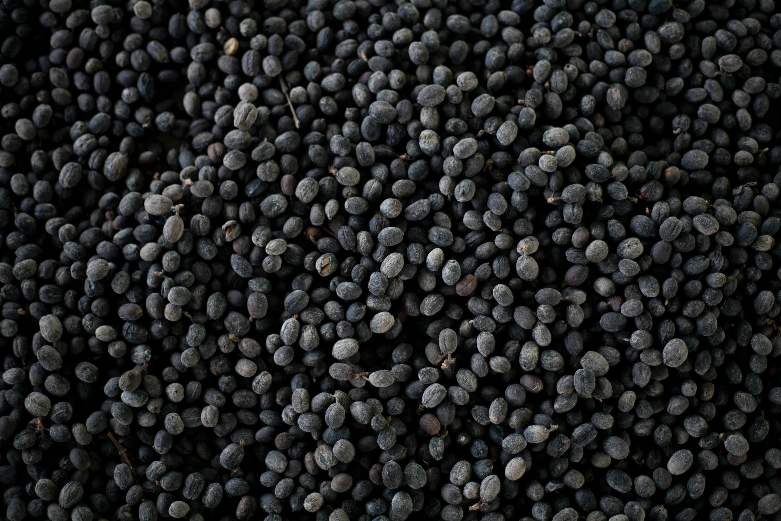  Ethiopian Dark Roast  $7.29/lb Wholesale  Item-ID: c-0006
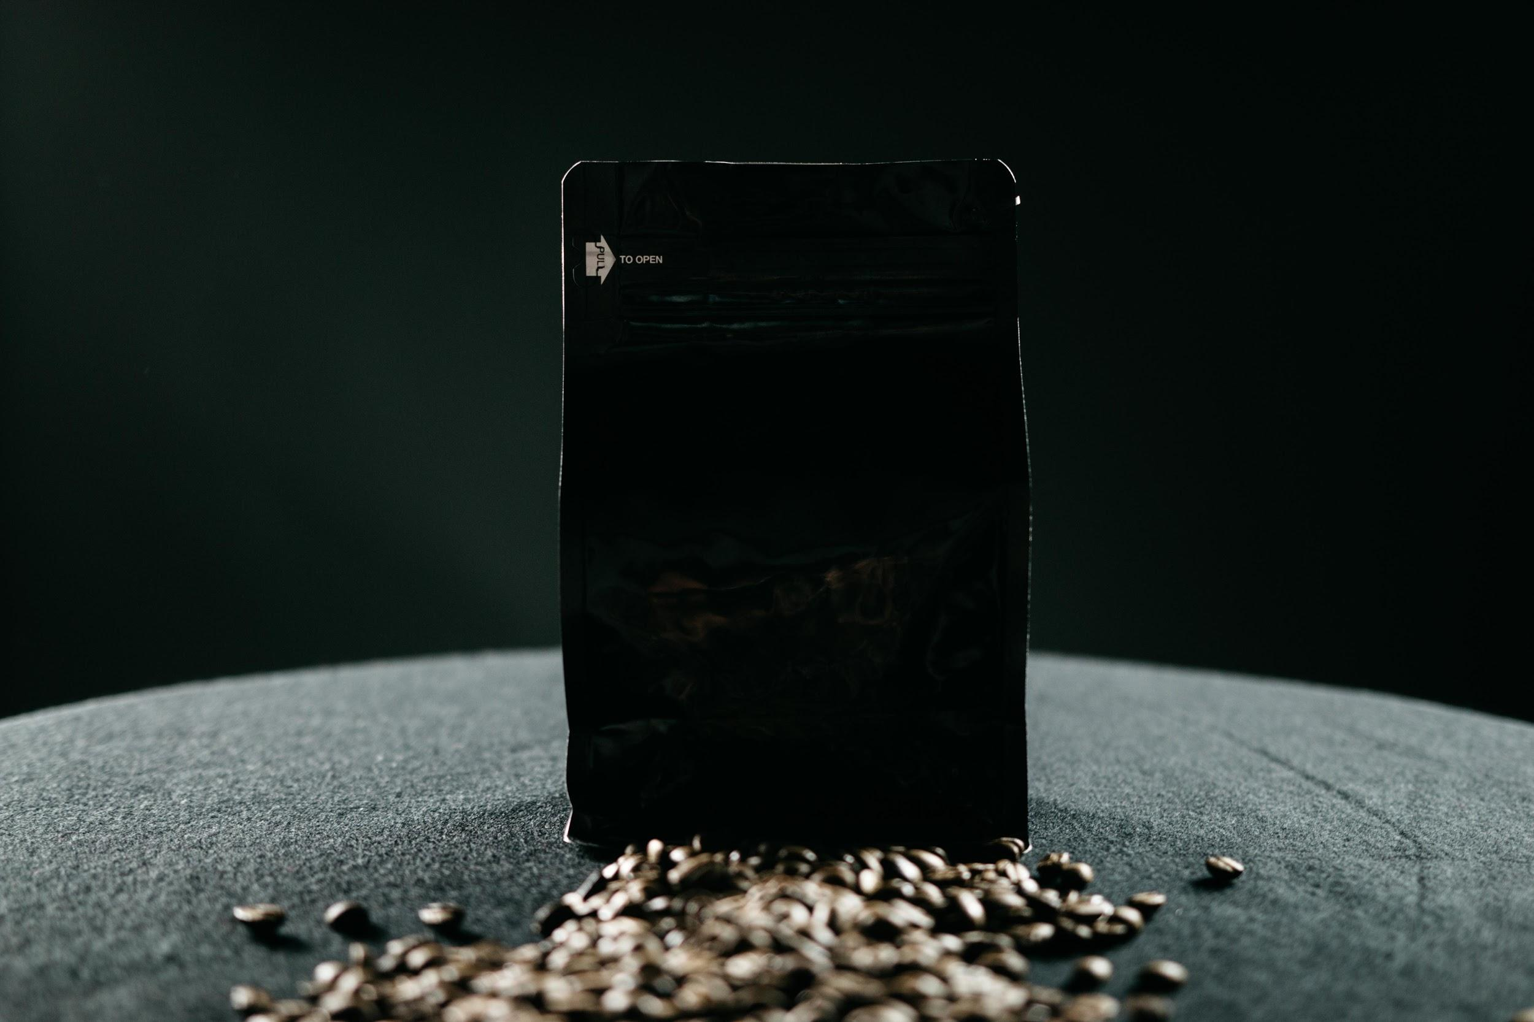  Columbian Medium Subscription  $15.99/month  Item-ID: s-0001 | Guatemalan Medium Subscription  $14.99/month  Item-ID: s-0001 | Ethiopian Light  Subscription  $15.29/month  Item-ID: s-0001

