2020 Drama Company
Intersection: Beat

Film glossary
Definitions taken by Fiona Hallenan-Barker from
- National Film and Sound Archive: nfsa.gov.au/preservation/preservation-glossary
- Australian Screen: aso.gov.au/about/glossary

General terms (A-Z)
Term | Definition
Acoustics | Sound: The characteristics that acoustically differentiate one environment from another; such as a living room from a recording studio or a concert hall.
Aspect ratio | Relationship between the width and height of a picture as it is displayed on a screen. It is expressed as a ratio of width: height.
Auteur | French term meaning ‘author’; a filmmaker who has a distinctive, recognisable vision. An Australian example would be Paul Cox.
Black and white film | A film where all scenes no matter what the original colour are represented in shades of grey.
Camera angle | Position from which the camera frames what is filmed.
Cellulose nitrate film | The first type of film base used in motion pictures, and the most common until 1951. Cellulose nitrate film is highly unstable and presents a very serious fire risk.
Censorship rating | Rating (G, PG, M etc) given to a motion picture by a film classification body (in Australia, The Classification Board), according to certain classification guidelines. Also known as Classification Rating.
Cinematographer | Person who designs or directs the positioning of the camera and lighting for each shot; the director of photography. The cinematographer can also be the camera operator, but this is not always the case.
Cinema verite | Style of documentary from the French term ‘cinema of truth’. Similar to 'direct cinema’, it describes a style of filmmaking that follows the subject in an observational style with minimal or no use of filmmaking techniques such as voice over or lighting.
Composition | Arrangements of elements in a shot in relation to each other and to the viewer; the way they are framed.
Cut | Abrupt transition from one shot to another; a splice between two frames of a film.
Depth of field | Area in perfect focus in front of and behind the subject. Anything within this 'depth of field’ will appear sharp.
Director | Person who has primary control over a film’s creative aspects, as well as over the direction of the principle cast and crew.
Dissolve | Gradual transition between two shots where the images from one shot are replaced by images from another.
Documentary film | Program type that seeks to represent reality or remain factual; a non-fiction film.
Editing | Selection and assembling of the pieces of film (shots) which will comprise a finished movie; the process of fine-tuning a script.
Fade | Gradual appearance (fade in) or disappearance (fade out) of an image or sound from or to a black screen.
Feature film | Full length fiction film running over 60 minutes in duration. Called feature because of its place as the main feature in a cinema program in the days when cinemas ran shorts and newsreels.
Film | A motion picture or movie.
Film language | Way in which films tell stories and affect the viewer; the elements of filmmaking employed to tell the story in a particular way.
Frame | Rectangle formed by the outside of a movie screen; to arrange a shot’s composition; also each separate image in a motion picture film.
Gauge | Refers to the format of the film stock. For example super 8 mm, 16 mm, 35 mm.
Genre | Style of film dictated by particular thematic conventions.
High-angle shot | A downwards shot where the camera is in a higher vertical position than the subject.
Intertitle | Piece of descriptive text which appears in between scenes or shots of a film. Commonly used in silent films to clarify action or dialogue.
Mise-en-scene | From the French term for ‘putting on stage’; the arrangement of cinematic elements; what appears in the frame. The mise-en-scene determines the visual style of the film.
Montage | French term for editing.
Motion picture | Series of images on a strip of film, usually projected at the rate of 24 frames per second, which make up a conceptually complete work. Also referred to as a film.
Newsreel | Short film compilation featuring news stories about current events. These were commonly screened before a feature in the days before television.
Noise | When used technically noise degrades the quality of the reproduced image or sound. In digital or video images, noise may result in a coarse or grainy structure to the image: in sound, it may produce distorted sounds or hiss, rumble etc.
Pan | Camera movement created when the camera swivels horizontally on a stationary tripod (from the word ‘panorama’).
Print | The projectable version of a film.
Reconstruction | Process of rebuilding a film from its various sound and visual elements. It may be done in a case where parts of a film have been newly recovered or rediscovered. An example is The Sentimental Bloke (1919).
Restoration | Process of returning an artefact to as close to its original condition as possible. An example of a film which has been restored is Jedda 1955, PG).
Scene | Section of film unified by time or place; a segment of film that depicts a single situation or incident made up of a number of frames. Film scripts are divided into scenes.
Score | Music written specifically for a film. Separate from the film soundtrack.
Screenplay | Film script.
Shoot | To film something.
Soundtrack | Commonly refers to music not specifically written for a film but which is used in the film, such as popular songs.
Stop-motion | Animation technique whereby the impression of movement is created by filming a sequence of one or two still frames at a time. An example is Harvie Krumpet (2003, PG).
Storyboard | Pictorial representation of a film sequence often depicted as a series of comic book style drawings. Part of a director’s preparation for a film shoot.
Subtitle | Written text which commonly appears in the lower part of the screen to translate dialogue for foreign audiences.
Tracking shot | Shot where the camera (mounted on a mobile platform) steadily travels along a horizontal plane to the object being filmed. Also known as a dolly shot.
Voice-over | Recorded dialogue, usually narration, that comes from an unseen, off-screen voice.
Widescreen | Any aspect ratio wider than 4:3 or the standard Academy Frame. See Aspect Ratio.
Zoom | Shot which moves closer to, or away from, the subject using the lens rather than moving the whole camera in or out.

Camera shot
Any set-up of the camera so that something can be filmed; also used as a verb, with the same meaning as ‘filmed.’

Close-up
Camera shot showing a close-up view of the character.
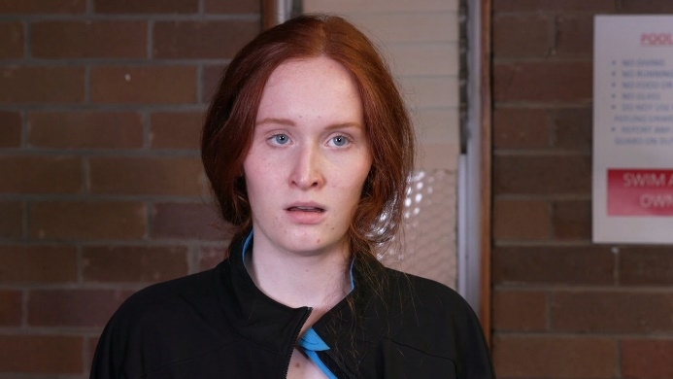

Extreme close up
Closer than a close-up view of the character focussing on their face


Deep focus
Shot where the foreground and background are equally in focus.
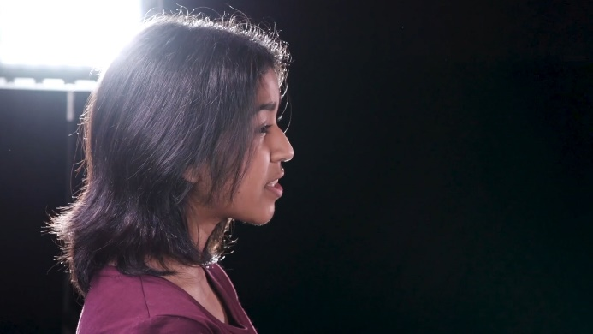

Long shot
Camera shot which makes the character look far away; often used to show an object in relation to its surroundings.

Medium shot
Camera shot midway between a close-up and a wide shot.
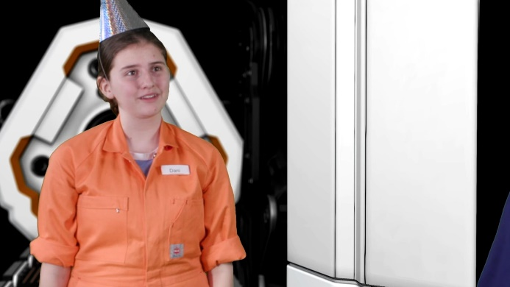
Wide shot
Shot which covers the action of the scene in a wide or panoramic view.
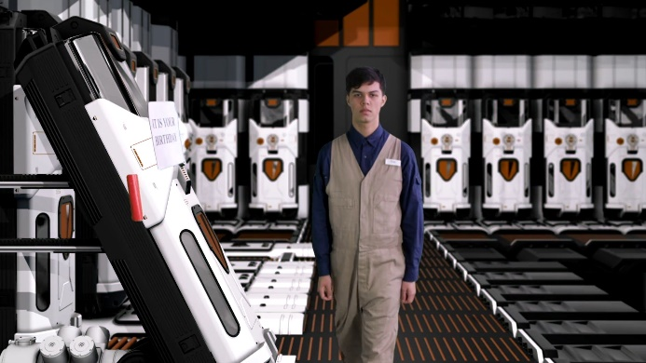

Camera angles

Eye level
Camera is at eye level establishing the speaker
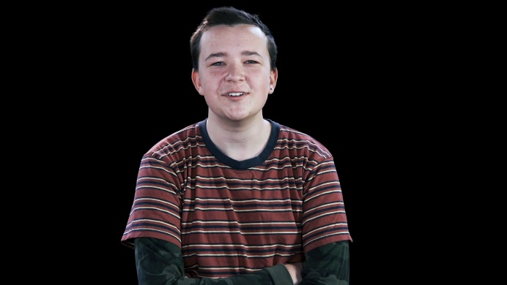

High angle
A shot from a high angle looking down


Low angle
An upwards shot where the camera is in a lower vertical position than the subject.


Camera framing

Two shot
A shot that frames both characters
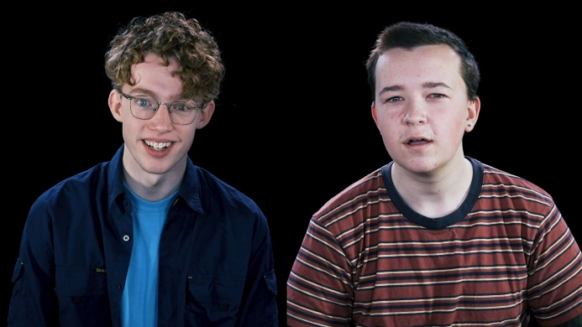

Over the shoulder shot
A shot between two characters framing the speaker

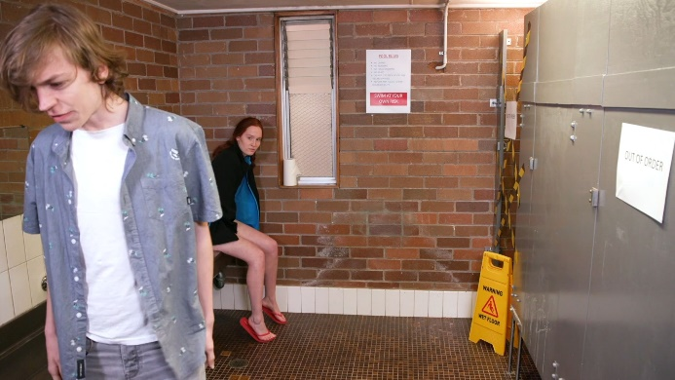

Point of view shot
A shot framing the other characters from one character’s point of view
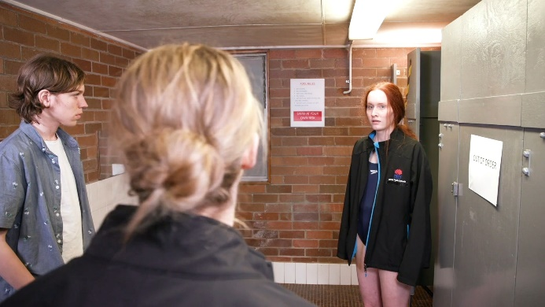

Reverse shot
A shot framing the other characters in the previous point of view shot

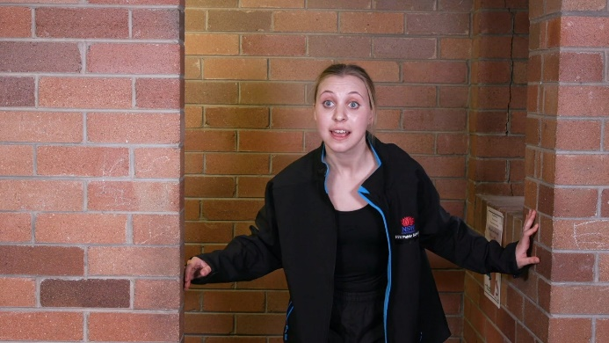

Reaction shot
A shot revealing the reaction of a character

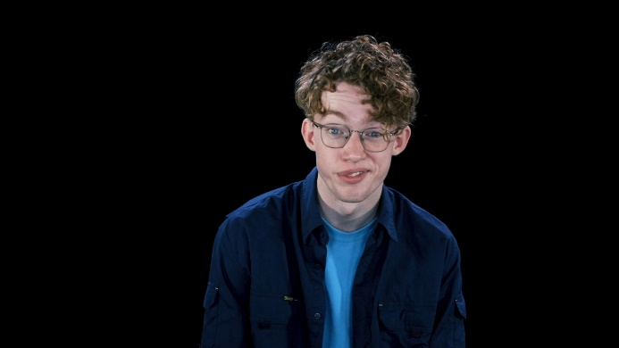

Insert shot
A cutaway shot that adds information to the visual story.


