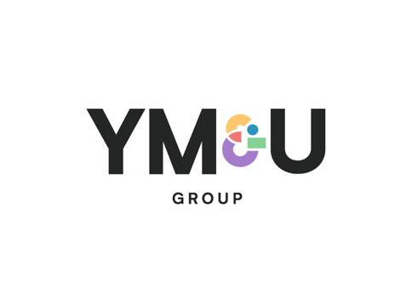

Administrator

Based: Central London

Reports to: Administration Manager

About the group…
A leading management and professional services company based out of the UK and US, YMU provides a portfolio of services to a wide range of clients consisting of leaders in entertainment, film, music, radio, television and sport, including athletes, authors, digital influencers, media rights holders, musicians, producers, TV personalities and voiceover artists.
About the job…
An exciting opportunity has arisin within our business management division for an Administratior to join the team. Reporting to the Administration Manager, the Administrator’s role is to assist the Accounting teams with administrative and support services to ensure that they fully utilise their time effectively.
Key Responsibilities…

- Scanning and maintaining filing systems and records
- Creating engagement letters and dealing with correspondence
- Updating Company audit system with client information
- Dealing with and creating correspondence
- Liaising with clients, suppliers and bankers
- Preparing paperwork for opening bank accounts, making payments and sending cheques and remittance advices
- Undertaking any other tasks/duties as may reasonably be required
- Archiving storage
- Booking couriers
- Ordering office stationary
- Sorting and distribution of the post daily

About You…

- 1-2 years previous experience in a data entry or office administration position
- Strong verbal and written communication skills
- Team working skills
- High attention to detail
- Strong organisational skills

What we offer…

We offer a wide variety of benefits including:

- Unlimited holiday
- Access to flexible working conditions - we believe with performance comes freedom
- Generous bonus scheme
- Private medical and life Insurance after 12 months' service
- Enhanced parental leave
- Staff equality share and bonus scheme
- Perkbox employee benefit platform

