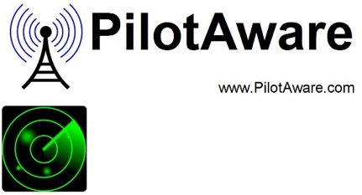
Graffiti
See and be Seen, Write across the Skies

Overview
PilotAware Graffiti is the latest addition to the family of PilotAware products. At 30 grams, it provides the lightest addition of any data ready Electronic Conspicuity device.
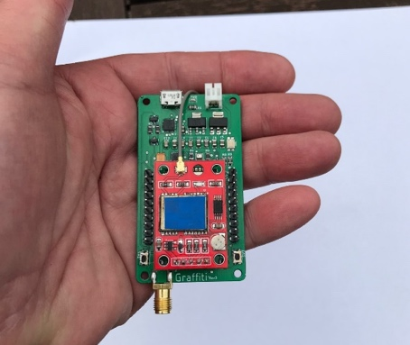
Capable of seeing and being seen by all existing PilotAware equipped aircraft, and also tracked by the European network of ATOM/GRID stations.
Graffiti is a PilotAware beacon and an air to ground data hub providing the core for future applications uplinked from the expanding ATOM/GRID network.
When Graffiti connects to the ATOM/GRID network a bi-directional communication mechanism allows the uplink of all known traffic including ADS-B, Mode-S(MLAT), FLARM, OGN, Fanet+ and (TBD).
Specification | Value
Input Power | 5-24v 250mA
Size | 65mm x 40mm
Weight | 30 grams
Transmit Power | 250 -500 mW
Frequency | 869.525Mhz
Altimeter | -1000 to 60,000ft
3D Gyro
GPS Receiver | Yes
Micro USB | Power/Data Link
Power in | 7-24V
ATOM/GRID also provides Flight information Services such as in-flight METAR data and point-to-point messaging services across the entire network so there are many air-to-air, air-to-ground and ground-to-air applications for Graffiti technology.
Graffiti technology is very powerful but small and light enough, to fit to the smallest of UAV aircraft and to be carried by individuals of multiple air sports including Paragliders, Paramotors Hang-gliders and Parachuting.
Graffiti is provided in 2 deliverables, (i) as part of a PilotAware standalone device or (ii) for OEM integration.†
†For OEM developers, under NDA and commercial terms, a Software Design Kit (SDK) is provided, with a set of libraries and an Application Programming Interface (API). These allow complete customisation and access to internal data for GPS, Traffic and Flight Information Services and access to the ATOM GRID Network.
Example from API Development Kit For more information Support@PilotAware.com.
