Your Business name, contact information and logo here:

Client name:
How to Prepare for
Recording Your
Life & Stories

Preparing for your
My Life & Stories
Recording Sessions

Step One:
Outlining Your Story and Choosing Your Chapter Titles

What to do:

There is a list of suggested chapter titles on page 4.

Please look them over.
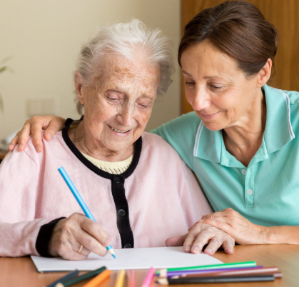

Decide if you want to include any of these titles.

Create or add your own chapter titles.

Or change the titles as you wish.

NP
Use the pastel note cards to print your chapter titles, one chapter per card.
Then, put the pastel cards to one side.

Now sit back and think for a while.

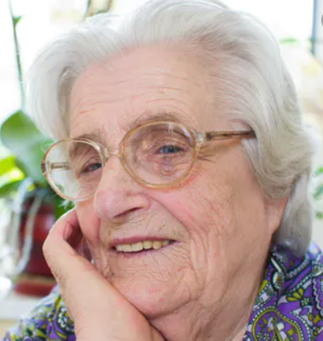
When you are ready, put the chapter titles in order.

You can always change your mind later.
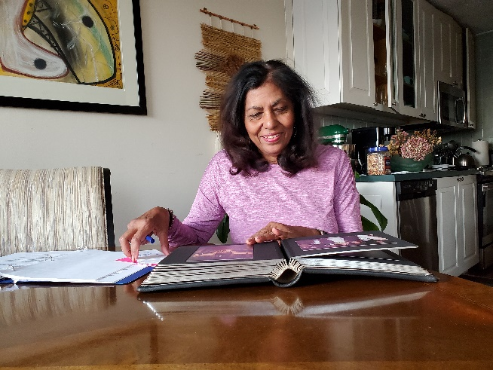

Ideas for Chapter Titles
(remember, you can change and/or add new titles)

My great grandparents

My grandparents
My parents

My brothers/sisters

My early years

At home with my family

My school years (elementary, middle and high school)

My college years
Entering the workforce

My military service

Meeting my husband/wife

The early years of my marriage

Starting a family

Raising my children

Family life as my children grew up

When my children left home

My later years

Lessons learned
What I want to pass on

Step Two:

Remembering and Preparing Memory Joggers

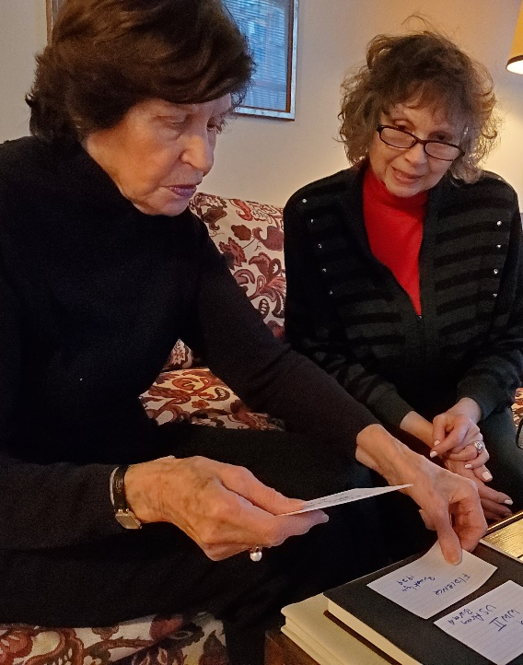

Memory joggers are a few words to help you remember what you want to say.

A memory jogger can be a name:

Sampson Keneally, my great grandfather

June Elliott, my best friend in elementary school

John Dresser, my first boss

Or a date:

August 15, 1916, when Grandpa Earl arrived at Ellis Island

December 17, 1927, my mother’s birthday

April 16, 1996, first grandchild was born

Or a place:

Munich, Germany, grandmother Hillary’s birthplace

Cape May, New Jersey, where I went to boot camp

Amsterdam, my honeymoon

Or an event:

My son’s wedding

My high school prom (1971)

My daughter’s college graduation (2004)

Or a situation:

My bike accident – age 12

Buying my first home

Moving across the country with the family

If you wish, you can write your memory joggers on white note cards, one memory per card.

Then you will put the pastel chapter title note cards and the white memory jogger note cards in the order you want your stories to follow.

You do not need a memory jogger for everything, just the dates or names etc. you might forget.
You can also look at photos.
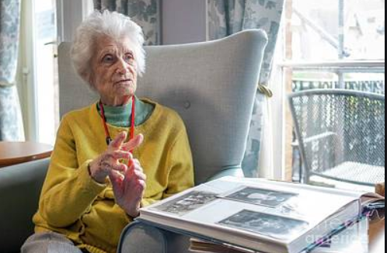
You will decide which photos to include in your book.

But for now, the photos are just to help recall.

So, basically, all you must do now is remember.

To help you remember, on the next 8 pages you will see a big list of prompter questions.

You do not have to answer every question.

If something comes to mind and you want to be sure to add it, note it on a separate white memory jogger card.

No pressure. No deadline.

The questions are just meant to stir up memories.

So, just relax and remember.

Do this once. Or do this over and over. You set your own schedule.

Ready, let’s begin.

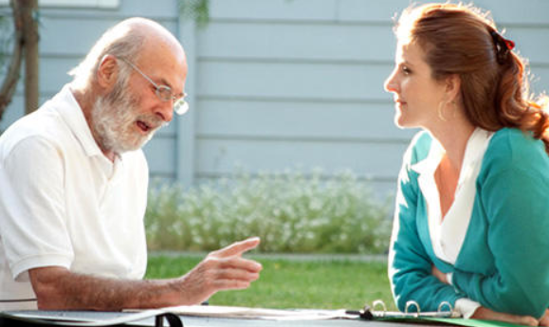
My grandmother’s parents:

· What were there full names?
· Where were they born: what city, town or village and country?
· When were they born?
· If they immigrated to the US, when did they arrive?
· How did they get here?
· What did they do when they arrived in the US?
· What was their life like when they were young?
· What else do I know about them?
· If I met them, what do I remember?

My grandfather’s parents:

· What were there full names?
· Where were they born: what city, town or village and country?
· When were they born?
· If they immigrated to the US, when did they arrive?
· How did they get here?
· What did they do when they arrived in the US?
· What was their life like when they were young?
· What else do I know about them?
· If I met them, what do I remember?

- Are there any family stories that were passed down?
- What else do I remember or want to share about my great grandparents?

My mother’s parents:
- What were their full names?
- What was my grandmother’s maiden name?
- Where were they born: what city, town or village and country?
- When were they born?
- If they immigrated to the US, when did they arrive?
- How did they get here?
- What did they do when they arrived in the US?
- What was their life like when they were young?
- what was their life like as adults?
- What else do I know about them?
- If I met them, what do I remember most?

My Father’s parents:

- What were there full names?
- Where were they born: what city, town or village and country?
- When were they born?
- If they immigrated to the US, when did they arrive?
- How did they get here?
- What did they do when they arrived in the US?
- What was their life like when they were young?
- What else do I know about them?
- If I met them, what do I remember most?
- What were my grandparents doing at the time I was born?
- What else do I remember or want to share about my grandparents?

My Mother:
- What was my mother’s maiden name?
- When was my mother born?
- Where was she born?
- Where was she raised?
- What do I know about my Mother’s life when she was growing up?
- What else do I know about my Mother’s life before I was born?
- What was she proud of?
- Was she ever ashamed or embarrassed about anything in her past?
- What types of jobs or work did my Mother choose to do? Do I know why?
- What sticks with me most about my Mother’s life before I came along?
- Did my Mother have any unusual mannerisms?
- Did my Mother have any unusual habits?
- What was her personality like as a younger person?

My Father:
- When was my father born?
- Where was my Father born?
- Where was he raised?
- What do I know about my Father’s life when he was growing up?
- What else do I know about my Father’s life before I was born?
- What was he proud of?
- Was he ever ashamed or embarrassed about anything in his past?
- What kinds of work did he choose to do? Do I know why?
- What sticks with most about my Father’s life before I came along?
- Did my Father have any unusual mannerisms?
- Did my Father have any unusual habits?
- What was his personality like as a younger person?

My Early Years

- What city or town and state was I born in?
- What do I know about the world I was born into?
- What kind of home did we live in when I was born?
- Did we ever move when I was very young? Why?
- What was I told I was like as a baby and toddler?
- What did I love to do in my early years?
- Did I attend pre-school? If so, where?
- Did I have any illnesses or problems during those years?
- Where did I spend most of my time in those early years?
- What games did I love to play?
- Who were some of my best friends in my early years? What were their names?
- What music did I love most then?
- What radio and or TV shows did I watch?
- What do I remember about how my mother and father raised me?
- What are my most special memories of my early years?

At Home with My Family
- If I had brothers and or sisters when did they come along – before or after me?
- What are their names?
- How did I get along with my siblings?
- Did I have a favorite sibling?
- Did we have any family rituals? What were they?
- What did we do at breakfast time?
- What did we do at lunch time?
- What did we do at dinner time?
- What did we do on weekends?
- How did we get ready for school?
- What was it like when I got home from school?
- Did my friends come over to my house? What did we do there?
- What was my neighborhood like? Who were my neighbors?
- What was my home like?
- Did I share a room or have my own room? How did I decorate it?
- Did we have a summer home?
- What did we do on family vacations?
- Did I or we have a pet or pets?
- What do I recall about the pets in our family?
- What were my family’s favorite radio or TV shows?
- Did we watch or listen together? What was that like?
- Did we ever travel together as a family? Where did we go? What was it like?
- What did I love and what did I hate about family life at home?

My School Years

- When did I start going to school? What year? How old was I?
- What was the name of my elementary school?
- How far from my home was it?
- What are my earliest memories about starting school especially the first day of school?
- How did I get to school? Did I walk or ride? With whom?
- What was my elementary school like?
- Who were some of my favorite teachers? Why?
- What are some of my most lasting memories about elementary school? What was I good at? What subjects were hard for me?
- Who were some of my best friends? Do any stay friends after elementary school ended?
- Did anything happen to me in elementary school that had a lasting effect on my life? If so, what was it?
- What school did I go to after elementary school? What was the name of that school? Where was it located?
- What do I remember most about the school I attended after middle school?
- Where did I go to school when I started in 9th grade?
- What was the name of that school?
- What subjects did I do well in?
- Did I struggle with any of my subjects or classes? Which ones?
- What did I like or love about high school?
- What did I dislike or even hate about my high school years?
- Who were some of my best friends in high school? What became of them?
- What are some of my most recurring memories about my high school years?

My College Years

- Why did I decide to go – or not to go - to college? What goals did I have? What did I want to study?
- What colleges did I apply to? Which colleges accepted or rejected me?
- What college did I decide to attend and why? Where was it located?
- Who were my closest friends in college?
- Who were the professors I was most influenced by? Why?
- What are my most recurring memories about my college years?

Entering the workforce

- What was the first paying job I ever had? Why did I take this job? Who did I work for? What was this job like?
- What other jobs did I have during or after school?
- What was my first real job after graduation?
- How did I get that job? What was it like? What do I remember most?
- What other jobs did I have as a young adult? Where did I work? For whom? Are there any recurring memories about these jobs?

Meeting My Spouse and Getting Married
- How did I meet my spouse? In what year? Where? What are my most recurring memories about our meeting?
- When did we decide to get married?
- How did I feel about getting married?
- Where and when were we married? What was the wedding like?
- What did we do as a married couple before our kids came along?
- Where did we live and why?
- What did we enjoy doing in our spare time?
- What kind of work did my spouse do?
- What are my most recurring memories of my married years before children?

Starting a Family
- What is the name of my child – or what are the names of all my children?
- When was my first child born? Where?
- When were my other children born and where?
- What did I experience with their births?
- What was it like being a parent?
- What were some of my most recurring memories of being a parent to my young children? What were some of the struggles? The joys?

Family Life -Raising My Children
- What was it like to bring my babies home.
- What was it like around our home as my children grew up? How did we all get along?
- What were some of our most happy memories as a family?
- Where did we go on vacation? Why there?
- What was it like as my kids started going to school?
- What was it like when they got home from school?
- How did my kids get along with one another?
- What made us laugh?
- What got us angry?
- What challenges did we face as a family?
- How did we balance work and family needs?
- What did we do at dinner time?
- What was bedtime like?
- What was life like when the kids were in elementary school?
- What was life like when the kids were in middle and high school?
- What did we try to teach our kids about life and living in the world?

My Later Years:
- What was life like as the kids graduated school and moved out?
- How did I feel then?
- What did we do when the kids moved out? Where did they go?
- What were some of the struggles faced when the kids left home?
- What were some of the joys of living without the kids in the house?
- How did I stay in my kid’s lives as they moved on?
- What major decisions were made at that time? About what to door where to live?
- How did I spend much of my time?
- What is my health like?
- What did I or we do for entertainment?
- Who are some of my closest friends? What do or did we do together? What has become of them?
- What were some of the joys I experience during these later years?
- What were some of the struggles?
- What are my most recurring thoughts about my later years?

Lessons Learned:

- What lessons about life do I want to pass on to my kids and grandkids and their children too?
- What values do I want to pass on?
- What did I learn that I want them to benefit from?
- What do I believe about the world and their future?
- What do I hope for them most of all?

