Pinot Bianco  Ticino  Denominazione di origine Controllata |  | 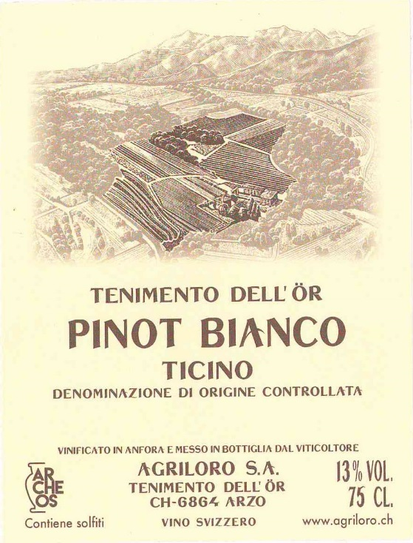
Production area | Tenimento dell’Ör in Arzo
Grape varieties | Pinot Bianco
Colour | Straw yellow with greenish reflections
Perfume | Very fine and discreet with a marked minerality accompanied by elegant fruity notes.
Flavour | Long and persistent, with a lively and nervous character thanks to a well present acidity and an excellent aromatic complexity.
Aging | 4/5 years
Alcoholic content | 13 Vol.%
Vinification | Soft pressing followed by fermentation and ageing for 11 months in Cocciopesto amphorae with a capacity of 1,000 litres. Regular re-introduction of the yeasts using the 'bâtonnage' technique.
Service | It is advisable not to serve at temperatures below 10°C to have a good aromatic expression.
Gastronomic combination | Freshwater fish, white meat and cheese.

