DR. Franco Conforti, Clinical and Experimental Science, Faculty of Medicine, University of Southampton.
REPORT
19th International Colloquium on Lung and Airway Fibrosis (ICLAF) 2016, Dublin, Ireland.

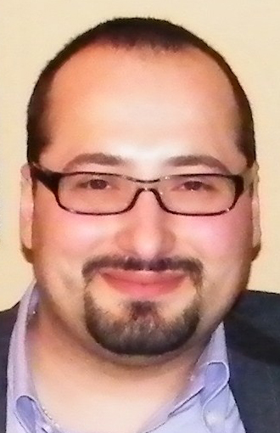

In first place I would like to express all my appreciation to Action for Pulmonary fibrosis for giving me the opportunity to attend 19th International Colloquium on Lung and Airway Fibrosis (ICLAF) 2016. The ICLAF conference is a unique event to present and join the best science focused on pulmonary fibrosis with the top experts from around the world. The 2016 edition has been held in Dublin and co-chaired by Professor Seamas Donnelly and Professor Michael Keane, two of the main experts of lung fibrosis biology and respiratory medicine. It has been a unique opportunity for a young scientist like me to get in touch with the top expert of the field and a strategic experience to get the last update about Scientific and Clinical research on lung fibrosis. Most importantly it has been a great opportunity to present my scientific work and receive important comments from the key investigator of this harmful disease. I presented my work as a poster presentation on the topic “treatment for pulmonary fibrosis” receiving great appreciation and interest from many scientist and clinician with the opportunity to engage remarkable collaborations with other research centres.
The different works presented at this meeting focus on the new frontiers in the investigation of pulmonary fibrosis for better understanding of the mechanism, diagnosis and prediction of the disease in order to lead to best outcome for the life of the patients. Innovative and strategic presentation point out what we can learn from other fibrotic disease and cancer that could be critical for understanding and face lung fibrosis for which the cause of disease still unknown. In summary, the ICLAF conference has been a great opportunity to meet the top expert of respiratory medicine with particular interest in lung fibrosis. Most importantly I had the opportunity to learn the last findings from the scientific and medical international community on lung fibrosis and present them my scientific work.

