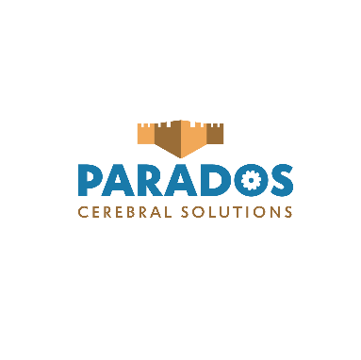
About Parados:
Parados is a data analytics company that provides athletic organizations with performance optimizing strategies by focusing on cognitive load management. Our platform uses artificial intelligence to help predict and mitigate the risk of head & cervical injuries by combining health monitoring software with wearable devices.
Traction:
$100 000+ in non-dilutive funding has been secured to date through a combination of pitch competitions, revenue from contract work and research for the Concussion Legacy Foundation of Canada (CLFC), ACOA and NRC grants, low-interest loans, and personal savings. Just over 50% has been spent with the following outcomes:
- Design of prototype mouthpiece electronics by RPC NB
- MVP mobile and web app, includes
  - Risk assessment process based on clinical research
  - Simultaneous data collection from two IMU sensors– at the moment these are 3rd party sensors being used for preliminary testing
- Detailed report by Dr. Mandal, data security and cryptography expert at UNB, explaining the security measures/algorithms necessary to implement in our entire system
- Project with Acadia Institute for Data Analytics to implement Machine Learning is currently in progress
- Contract to develop our platform on a private secure cloud, compliant with PIPEDA, GDPR, HIPAA regulations including 2 years of hosting, with the following capabilities: File sharing, CRM / BRM, Medical Database, Video / Webinar Platform, Virtual Development platform, etc. with most of this done or underway
*All IP is currently developed and/or owned by Parados, protected through agreements supplied by McInnes Cooper or the NRC.
Differentiations:
Causal approach: The great majority of competitors in this space are taking a symptomatic approach; focusing on diagnosis and treatment rather than prevention even though customers are demanding a solution that predicts injuries. This also ends up complicating the legal side of researching, testing, marketing, and using a device.
Holistic solution: by monitoring physiological and psychological factors both beforehand and in real-time using an ideal combination of software and hardware, Parados gets a complete picture of the situations that lead to traumatic brain injuries and the subsequent effects on physical and mental wellbeing.
Risk compensation phenomenon: several studies have observed that safer equipment only leads to more dangerous behavior in wearers, therefore Parados is focused on data analysis and providing corrective feedback. Data collection through a mouthpiece is more accurate than helmets or skin patches due to being directly attached to the skull, and a spine sensor allows better insights on different types of impacts (direct hit to the head, whiplash, hard change of direction, etc.).
Performance-based sales: Parados emphasizes not only the time, money, and health benefits but also the performance increases that come with avoiding serious head injuries.
Team:
The team is currently composed of three full-time employees and a handful of part-time contract workers. We have two biomedical engineers with specializations in biomechanics and electrical coming on full-time in the next two months. The executive team is composed of:
Pascal McCarthy – CEO: Background in mechanical engineering, biomechanics and technology management. Has been working with the CLFC since Feb 2020, former professional athlete.
Nayeli Marcial – COO: M.Eng in mechanical engineering, specialization in biomechanics with previous startup experience.
Juliana Duque – Sales & Marketing Lead: Specialized in B2B sales, experienced in HR & PR, former rugby player.
Norbert Demps – Interim CTO: Serial entrepreneur with previous successful exits for software house solutions, former high-performance coach and athlete.
Parados currently has one advisor: Adrienne Crampton, PhD in TBI Rehab Science, Director of Innovation at the CLFC and former McGill hockey player.
Traction and next steps:
Parados has been accepted into and participated in a number of Incubators and Accelerators including:
- Propel
- iBoost Zone at Ryerson University
- League of Innovators Labs
- Venn Garage
- Be 4 Change
- Planet Hatch
Parados is currently selecting early adopters to participate in a limited launch starting September 2021 while taking part in the Planet Hatch Sales accelerator. We have recently been accepted into the CyberNB CyberHatch incubator as part of the first cohort and are drafting project proposals with Mitacs, NBIF and the NRC for our next stage of development.

