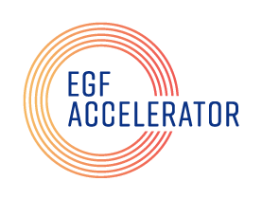
The EGF Accelerator Fellows Program

Application

Name:

Email Address:

Home Address:

Work experience:

Education:

What aspect of educational inequity do want to improve? How? Why are you the right person to tackle this problem? (Be succinct. We are looking for five paragraphs or so here.)

Would you be able to attend sessions on a weekday morning (10 a.m.-noon)?
Yes ☐
No ☐

Would you be able to attend sessions on a weekday evening (4 p.m.- 6 p.m.)?
Yes ☐
No ☐

Upload your application form here and get instructions on making your application video.

If your files are too large please email the application and video to egffellows@egfaccelerator.org.

Finalist will be invited for a remote interview.

