Community Project Grant
Example budget for a community event
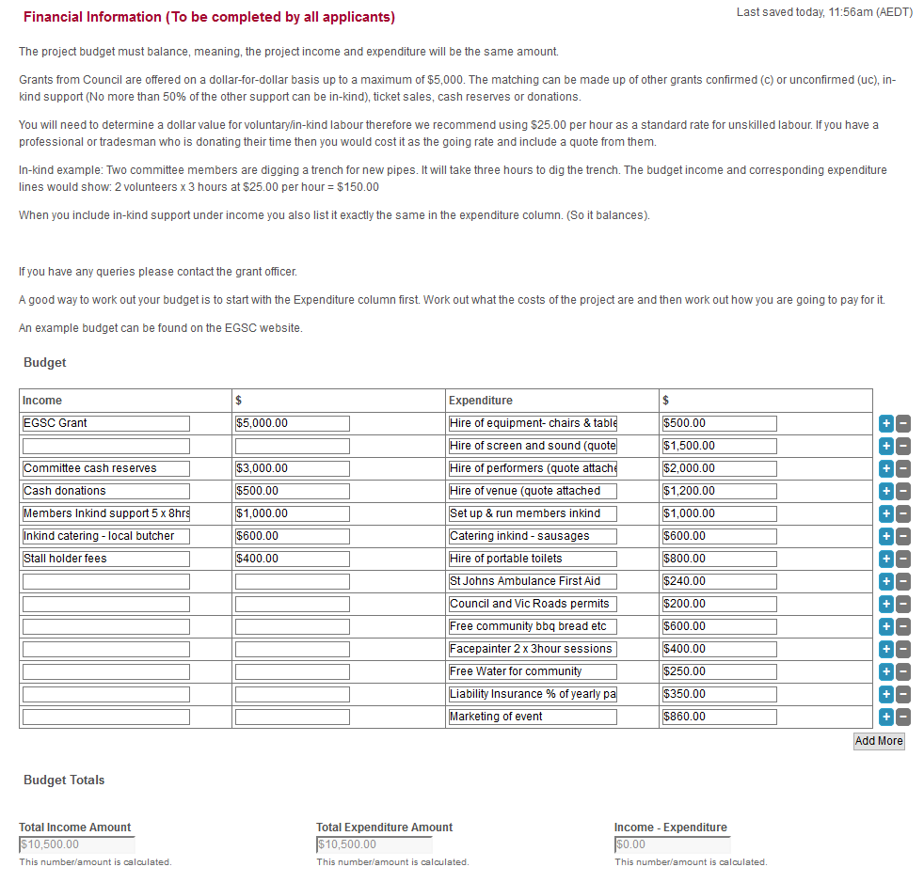
Note: This is an example and figures have been made up. For your budget you would get quotes where required and attach them as part of the application.
The Budget Totals will add as you go. You will know when the budget is balanced because the Income – Expenditure total will be $0.00.
The example grant request is $5,000 so we need to see a budget that totals $10,000 or over. Of the $5,500 other support only $2,500 of that can be inkind support. (No more than 50% of the other support can be inkind). If you are, for example, requesting $2,000 from the grant then we would need to see at least another $2,000 in the budget but $1,000 of that could be inkind.

