2023 Partner School Template

Subject: Sign up to our school’s skills platform | Gain real skills and meaningful work experiences | Grandshake

Body
Dear Students (or Parents),

As an official partner with Grandshake for 2023 we invite you to sign up this year and get started with upskilling and gaining real-world work experience. You can sign up online at www.grandshake.co/signup

What's Grandshake? Grandshake is a national online skills platform that provides meaningful virtual work experiences & upskilling opportunities to young people. You will gain access to Grandshake’s catalogue completely free and gain many other benefits:
  - Gain real-world industry skills: Work on real-world projects designed by leading national companies
  - Get exposure and recognition: Have your work recognised and the potential for it to be showcased by employers
  - Give a small commitment, for a big reward: Join a virtual experience anytime and anywhere for only a few hours a week
  - Earn an industry microcredential: Build a credible portfolio by completing Grandshake virtual experiences & Upskilling microprograms
  - Join a nation-wide community: Grow your network. Join an inclusive community; full of professionals, students and mentors who are there to support your passions.

Grandshake programs are on-demand and accessible on mobile, tablet or laptop. Join anytime, anywhere. This easy and free resource makes your career education at school easier while also giving you real connections to industry. We give you opportunities such as:
  - Mentorship,
  - Grandshake Ambassador programs, and
  - Paid work experience.

Grandshake is completely FREE! Please sign up today to start acquiring real skills and meaningful work experiences without leaving school or home.

Create your account at bit.ly/PartnerStudent
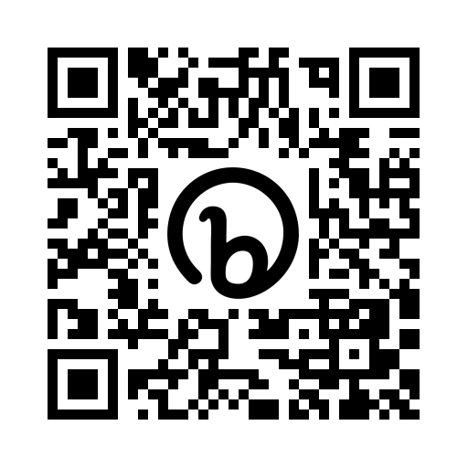
Let us know if you have any questions. Alternatively, contact the Grandshake team in case of technical inquiries at hello@grandshake.co.

