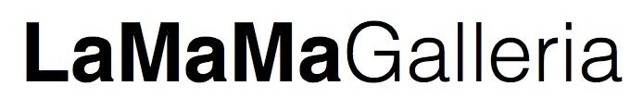
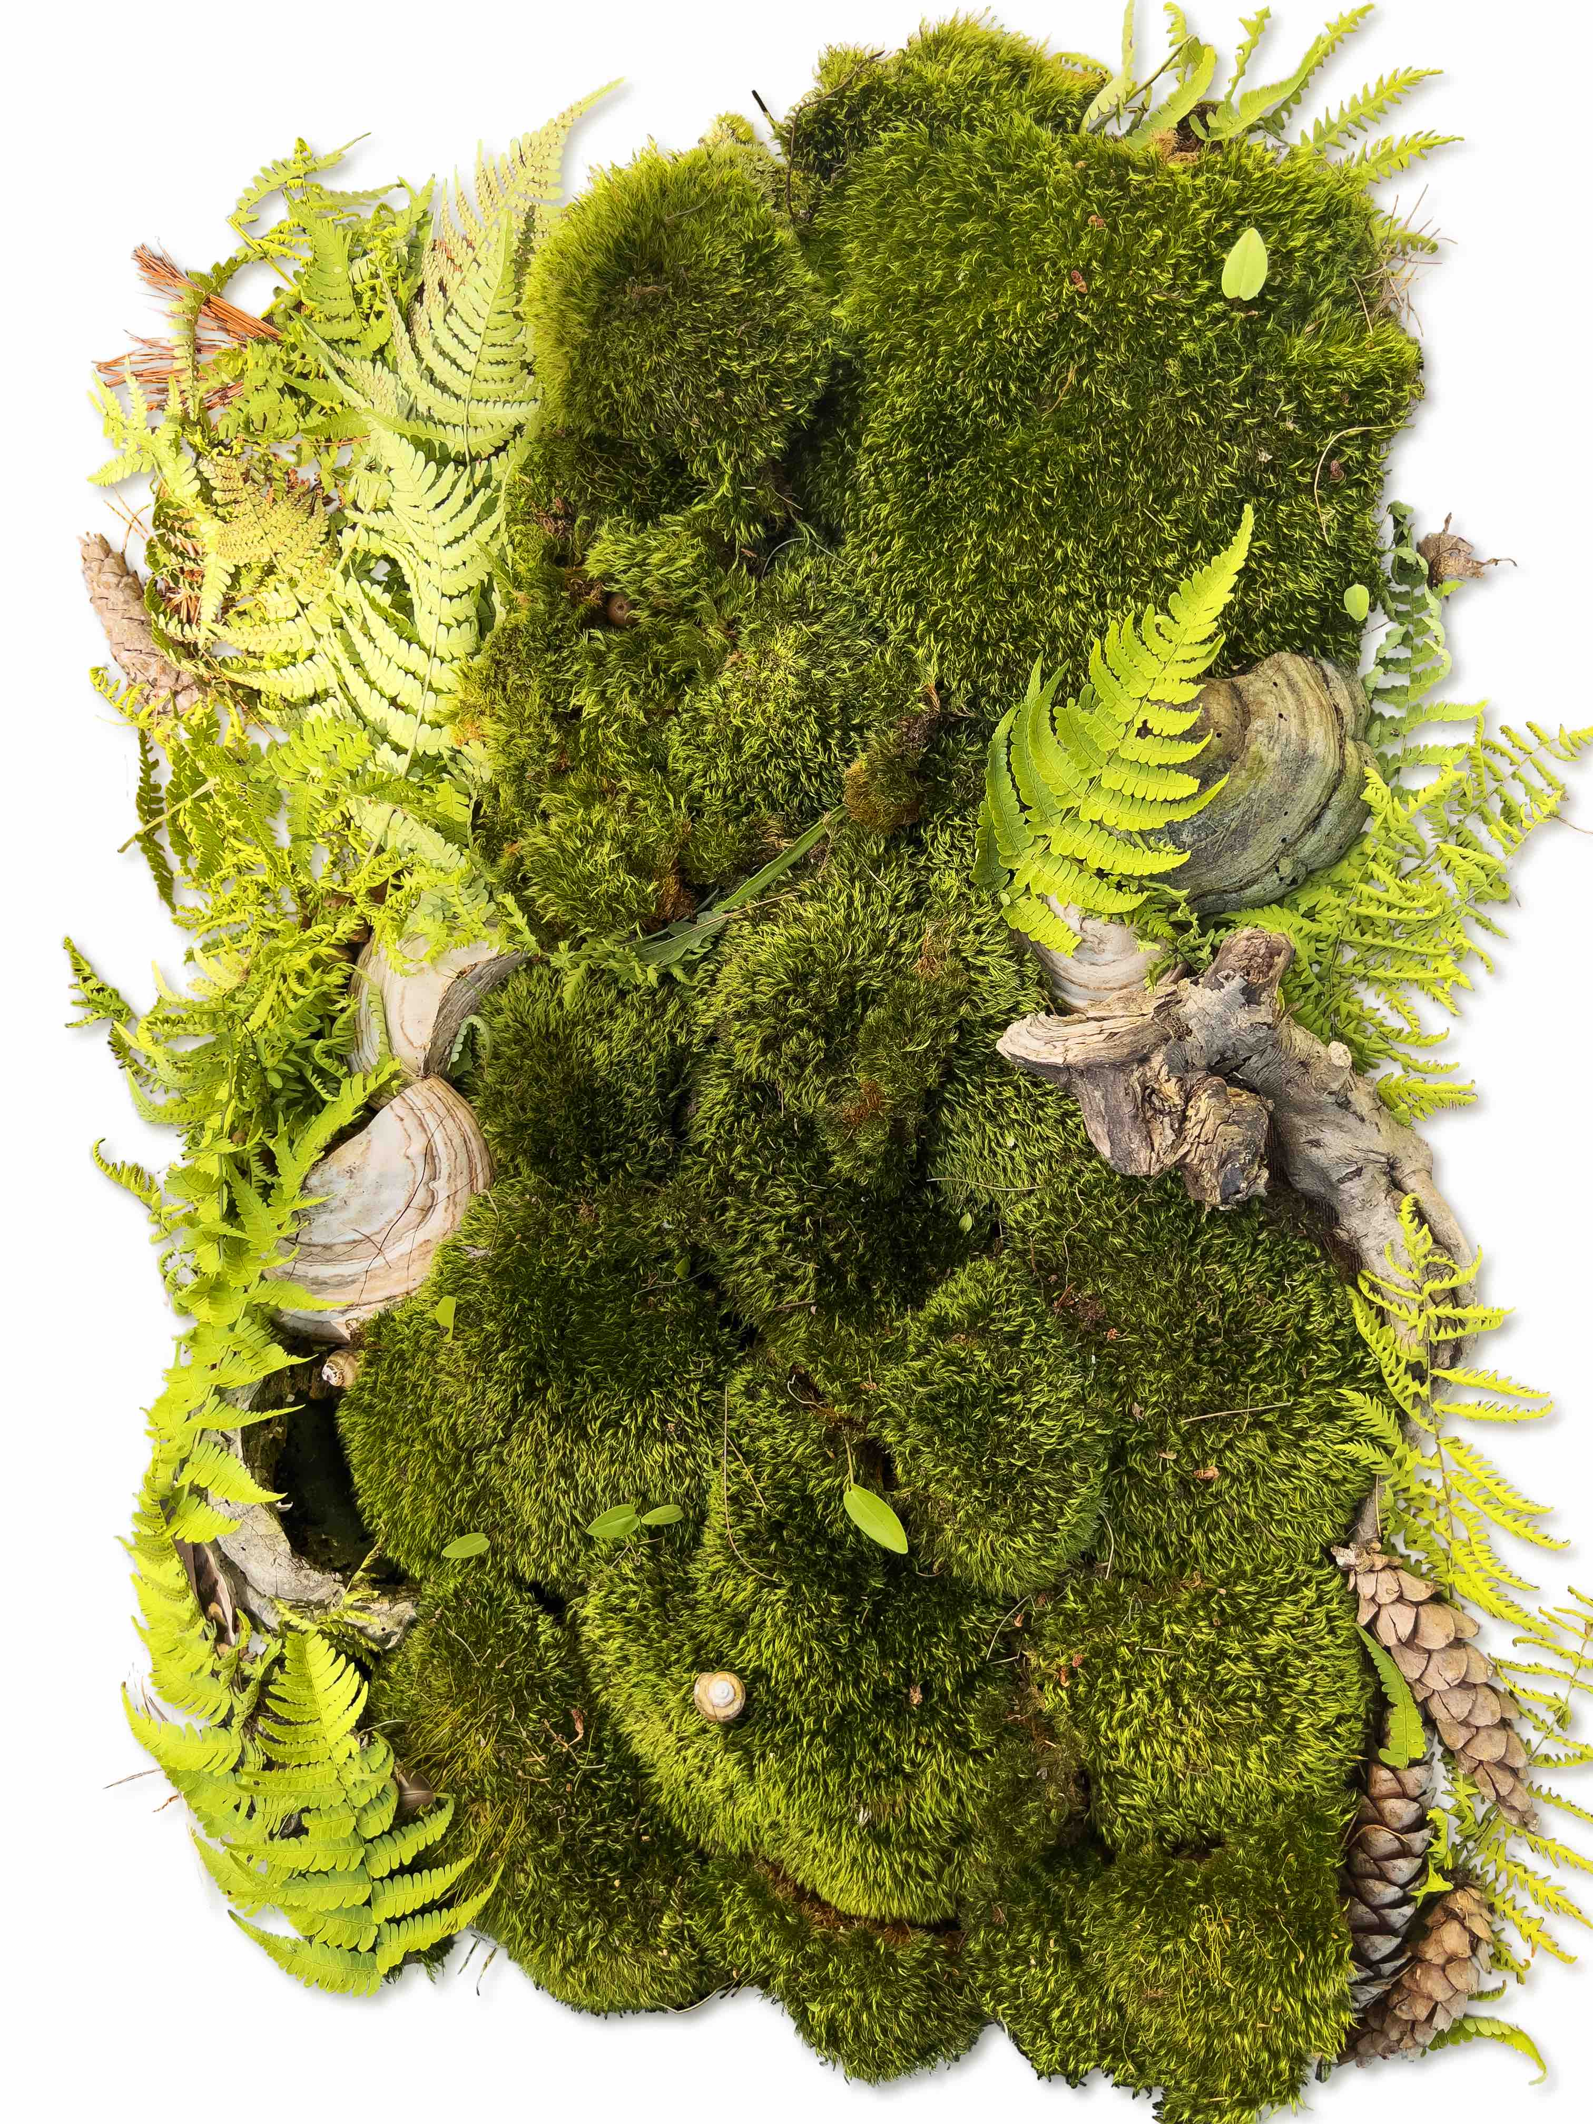
47 Great Jones Street | New York, NY 10003 212.505.2476 lamamagalleria@gmail.com www.lamama.org

Alex Chowaniec
We Love You and Support You on Your Journey
October 7 – November 4, 2022

Opening Reception: October 6th, 6 – 8pm
Closing Reception: November 4th, 6 – 8pm

New York, NY, August 29th 2022 – La MaMa Galleria is honored to present Alex Chowaniec, We Love You and Support You on Your Journey The exhibition will be on view at 47 Great Jones Street, New York, NY (between Bowery and Lafayette St. – please note that the address is different from that of the La MaMa Theater), from October 7th to November 4th, 2022, Thursday Sunday 1-7 PM. The opening reception will be held on Thursday, October 6th, from 6-8PM.

Many years ago, someone akin to a death doula said that we can greet passages in
to and out of this world with the same words: we love you and support you on your
journey. The three-part exhibition of sculptural paintings, documentation of ephemeral
works created in nature, and print takeaways, is an offering to share the journey
together. The arc is rooted in full spectrum advocacy: support for reproductive health,
cancer awareness, end of life, and healing. The three parts represent our passages and
living mythologies guided by precepts of accessibility, advocacy and the collective
archive. The works are records of their own transformations. The takeaways serve as
discursive tools and invite us to act together. The figurative watercolors on polymer,
exposed to a kind of proverbial funeral pyre, become twisting skins merging ever closer
to the body from which they were formed. The ephemeral paintings are made in and
return to the landscape. We are one body.

ABOUT THE ARTIST
A Canadian artist living in New York, Alex Chowaniec’s projects engage intertwined
questions of technology and the body; a gendered body as a social technology, and a
national body as enviro-political mythology.
–Jarrett Earnest
ABOUT LAMAMA GALLERIA
Founded in 1984, La Galleria is a nonprofit gallery committed to nurturing experimentation in the visual arts. La Galleria encourages an active dialogue between new media, performance, the plastic and visual arts, curatorial projects, and educational initiatives. It serves the East Village community by offering diverse programming to an inter-generational audience, and expanding the parameters of a traditional gallery space. As a non-profit, La Galleria is able to provide artists and curators with unique exhibition opportunities that are largely out of reach in a commercial gallery setting. https://www.lamama.org/programs/la-mama-galleria
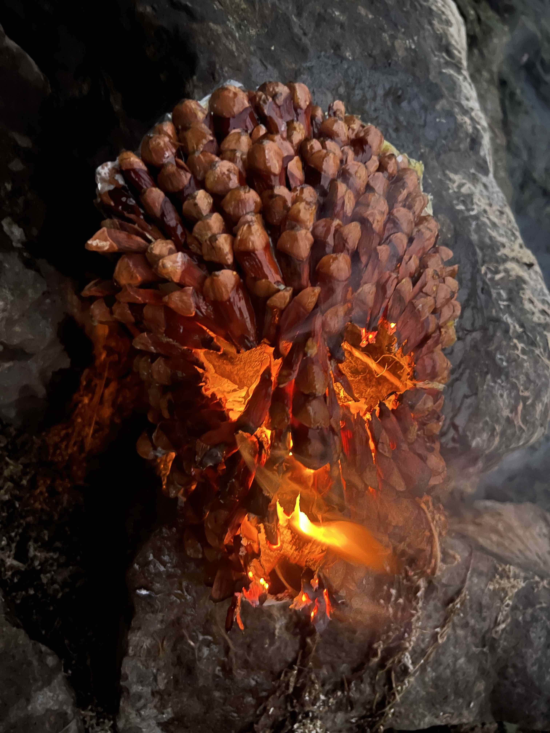
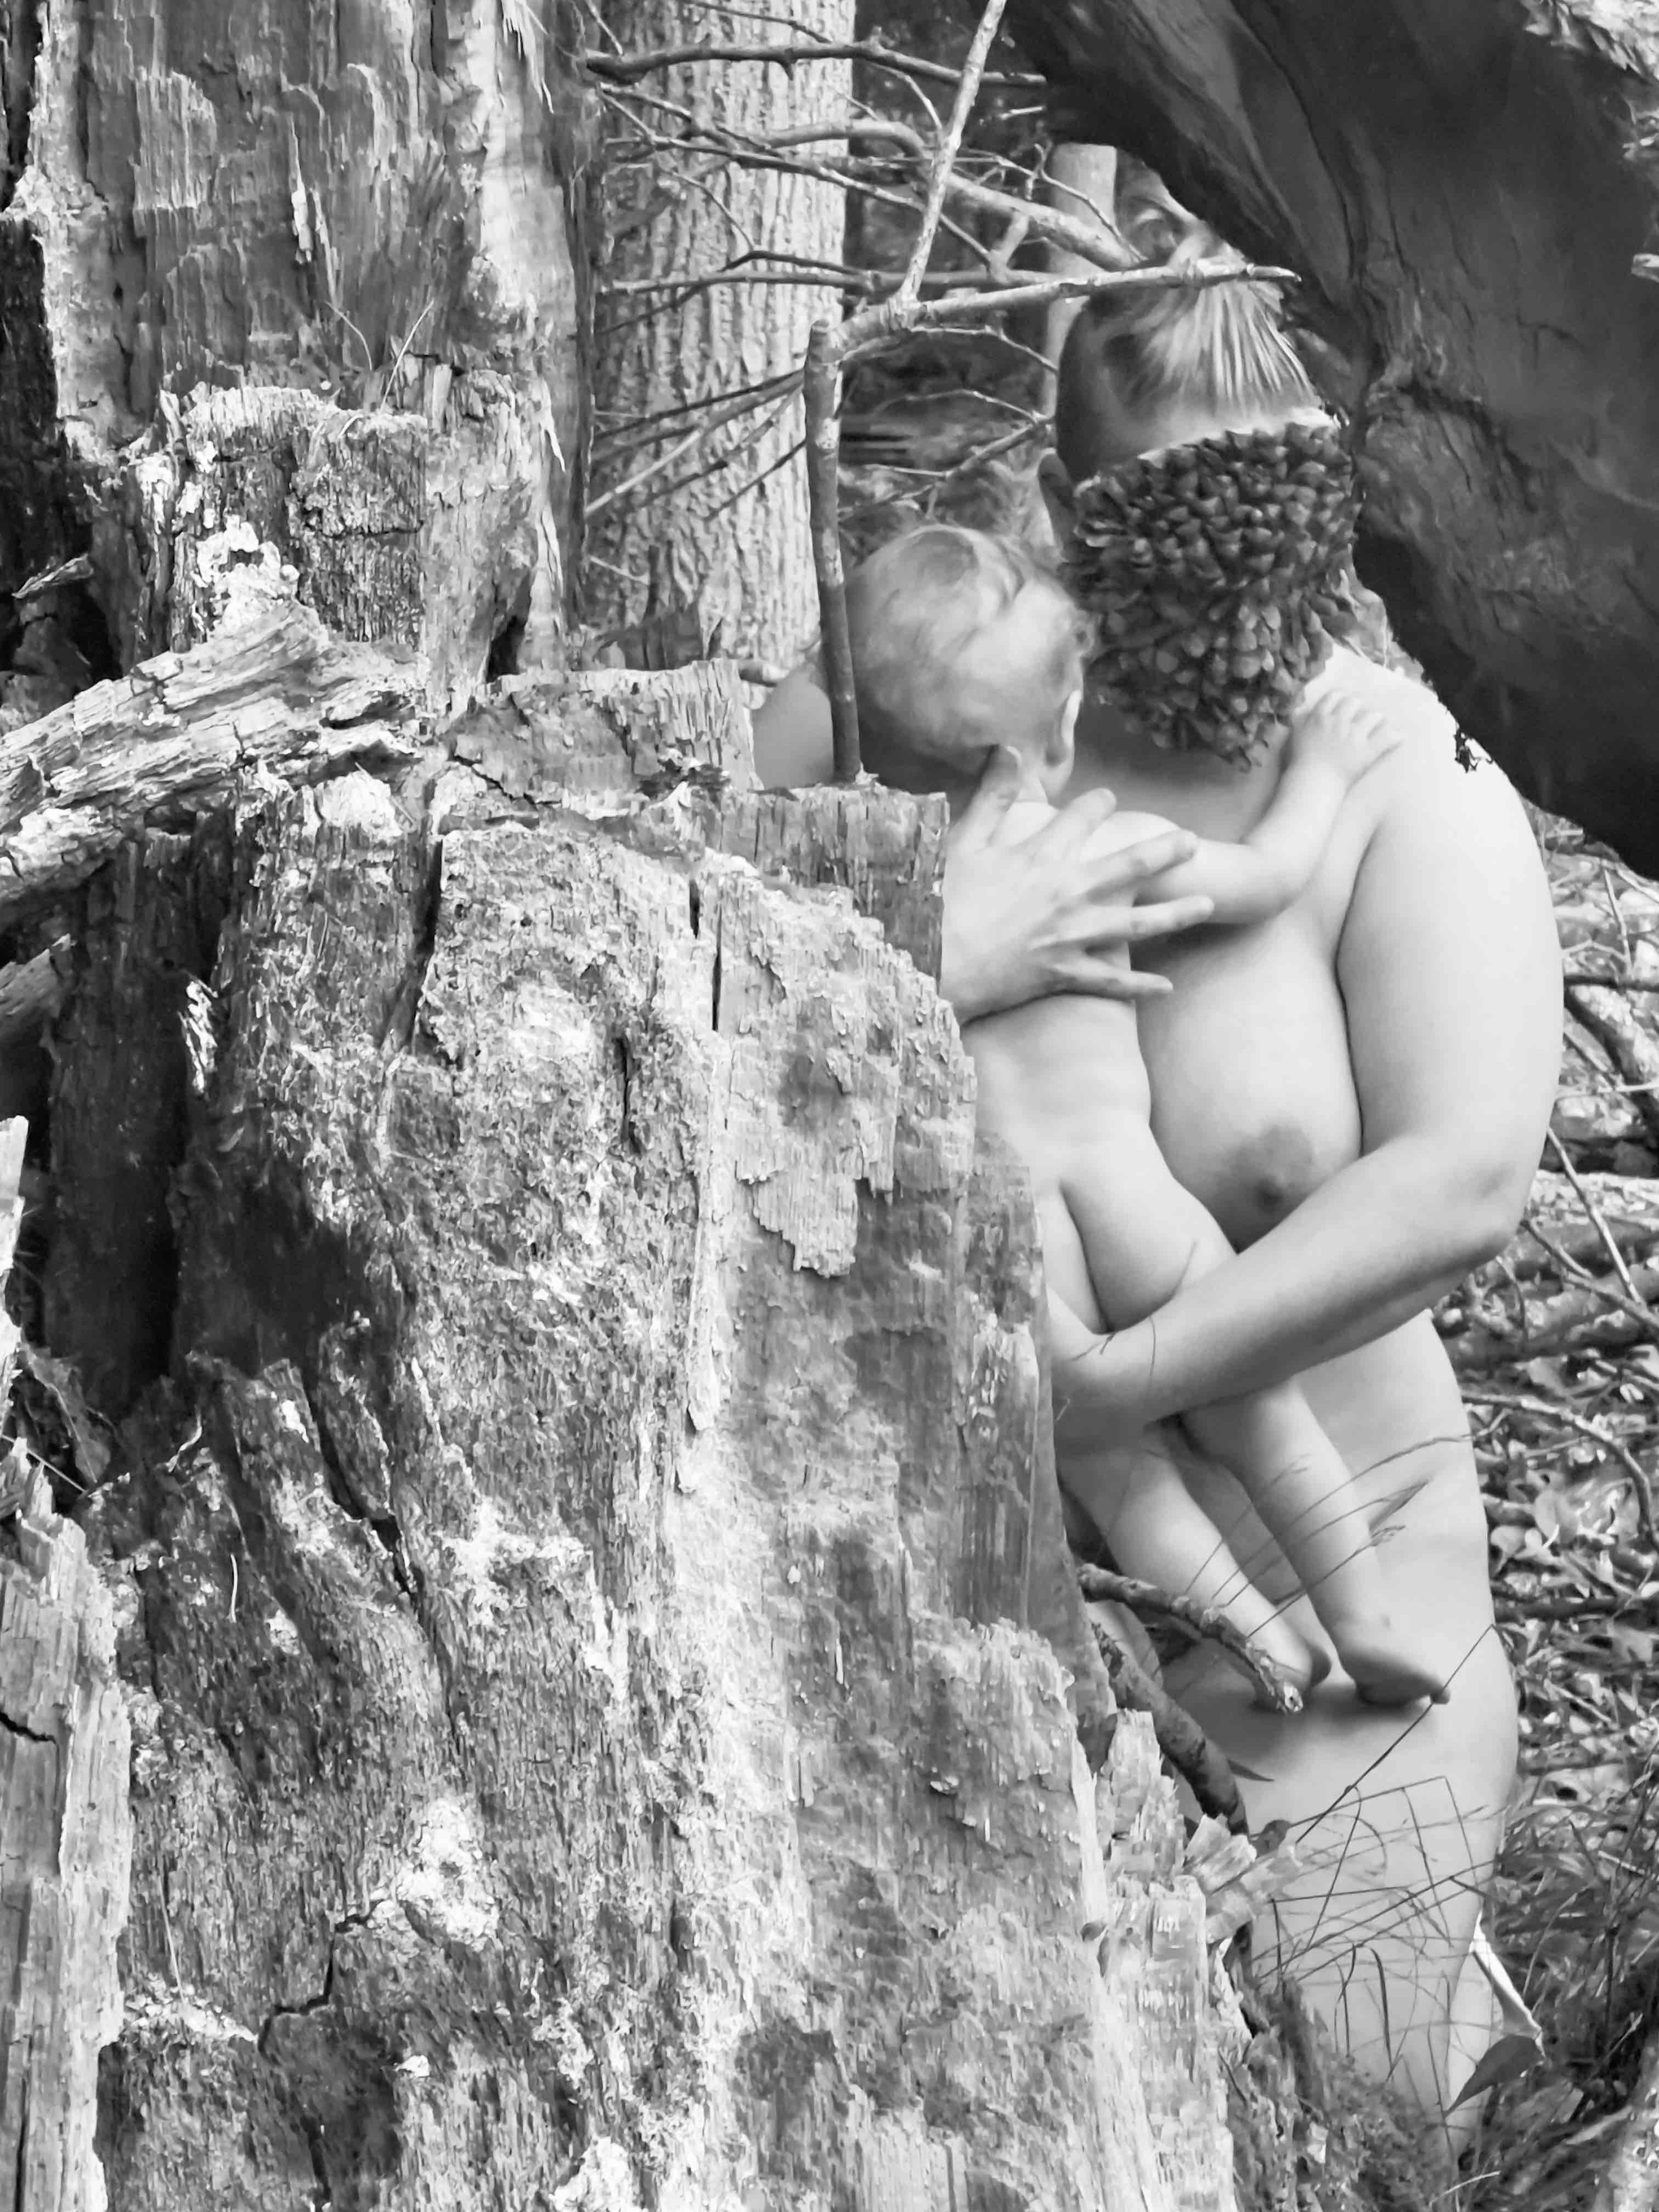
For press inquiries, images and interview requests, please contact the gallery at lamamagalleria@gmail.com
Image credit: Alex Chowaniec
Top: Alex Chowaniec I am putting down new roots (Transplant Portrait), 30x40in, Archival digital print on paper, 2022
Left: Alex Chowaniec We will always be a part of each other IV, 30x40in, Archival digital print on paper, 2022
Right: Alex Chowaniec We will always be a part of each other II, 30x40in, Archival digital print on paper, 2022

