You me and we: Homework Project
For this half term children will need to complete a project on their family history, this will run in tandem with our ‘You, me and we’ topic we are studying in school. The children will need to produce a piece of homework from the project each week and upload it onto Seesaw. At the end of the project children will be performing a short presentation on some of their homework pieces. This will take place on the week commencing 18th October.
Additionally, certain homework pieces have due dates attached to them; the children will need to bring in one of the pieces with a due date attached so we can showcase the children’s homework in our classrooms and corridors. The table below is a list of potential homework pieces for the children to choose from. They have been organised into creative based and research based activities, therefore ideally we would like the children to choose two creative based pieces and three researched based pieces (or three creative based and two research based)). We are very much looking forward to the amazing homework over the next four weeks and can’t wait to display the children’s homework.

Creative based activities |  | Research based activities
Blueprint of the family home  For this creative task we would like you to create a detailed blue print of your family home. It will need to be drawn from a bird’s eye view (aerial). The blueprint should contain lots of detail and colour. | Family acrostic poem  What does family mean to you? Demonstrate what family means to you by creating your own acrostic poem. For each letter of FAMILY there should be a descriptive/ poetic line describing what family means to you. | Family heirloom  A family heirloom is something that is passed down through generations – it could be an item of jewellery, a painting, a piece of furniture, a photograph etc. When you upload your work you will need to provide a short but detailed paragraph outlining what the heirloom is? Where did it come from? How old is it? Who originally had it?  See example at the bottom of the homework page. | Family tree  For this activity you will need to produce a family tree. A family tree details who is in your extended family – try to go back through generations as far as possible.  A good example of a family tree will have your family members names rather than just mum, dad, grandma or grandad. Additionally try to make the design of your family tree colourful and eye-catching
Collage portrait art  Maria Rivans creates portrait art using recycled paper including newspaper, magazines, scrap paper and any other recycled paper. For this tasks we would like you to create a portrait of yourself in the style of Maria Rivans. | Family Crest  For this task you will need to design a family crest.  Try to incorporate all family members and a family motto in which you live by in your family crest.  All family crests should be colourful and eye-catching. | An interview with a family member  We would like you to conduct an interview with family member. Your questions can focus on their childhood, on their job, their greatest life achievements etc | What’s your culture?  Part of what makes our school so fantastic is the diversity of cultures and backgrounds of the children who attend Danegrove. For this task we would like you to produce a detailed fact file explaining the cultural traditions that you and your family uphold throughout the year.  This could be how you celebrate a religious festival? What type of food you like to cook? What language you speak at home? Any special celebrations that you have with your family?

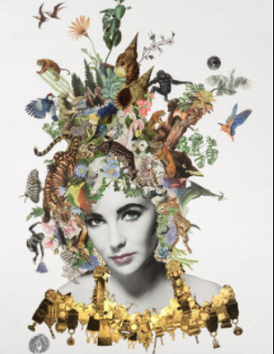
Maria Rivans
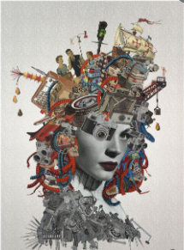

Family tree example

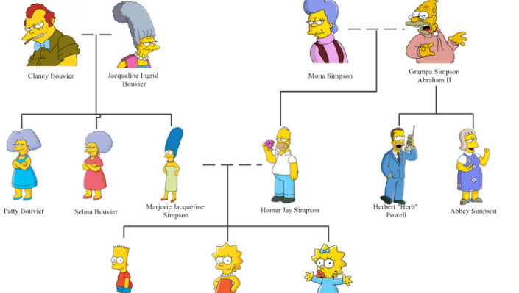

Family crest example Blueprint of your house example
