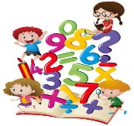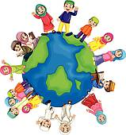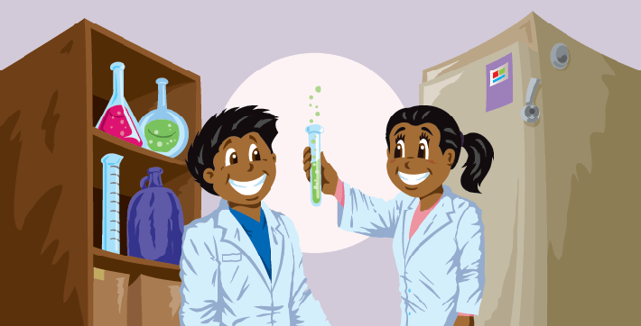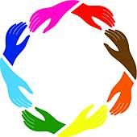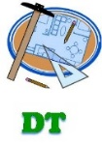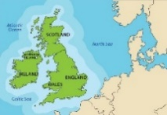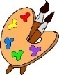 **Year 1 Curriculum Learning** **– Summer Term 2022**

**Music**

* Comparing high and low sounds.
* Create music in response to a non-musical stimulus, such as rivers, floods
* To be familiar with different bands/singers.
* To copy back rhythm, clapping and words

**Art**

* Weaving – under the sea with sea creatures collaged on top
* Explore painting techniques to paint seascapes
* Artists – Turner and Monet

**Maths**

* Addition and Subtraction
* Place value
* Multiplication and division
* Capacity
* Time
* Position/direction

**History** 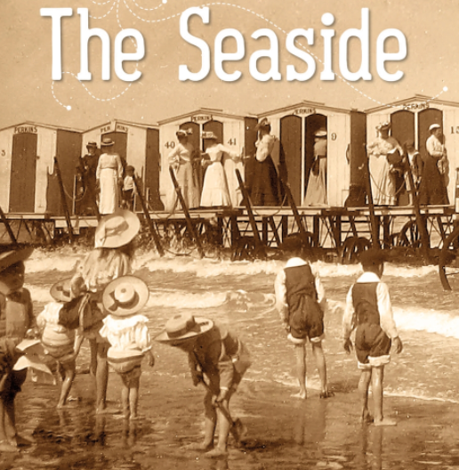

* Seaside – past and present
* Explore the significance of the lifeboat and Grace Darling

**Computing**

* + - * E safety – health, wellbeing and lifestyle
* Coding – using Bee-Bots
* Programming

**DT**

* Moving pictures – Sea creatures in seas/oceans
* Relationships-Building positive, healthy relationships
* Changing Me-Coping positively with change

**PSHE**

**Science**

* Animals
* Plants
* Seasonal Change
* Ball skills - Hand part 2
* Gymnastics

**Dance/P.E.**

**Geography**

Seaside, seas and oceans

* Exploring UK, its capital cities and locating the oceans
* Understanding what an island is by looking at the UK and our holiday destinations

To explore the journeys of two explorers

**English**

* Narratives
* Non-fiction – seaside postcards
* Poetry – summer/seaside
* Diaries – The Lighthouse Keepers Lunch
* Instructions

**R.E.**

* Religions – Christianity, Judaism, Sikhism
* Who is special to us
* Celebrate important festivals
* To understand beliefs about the world

**Year 1**

**Seas and Oceans/The Seaside**

**Summer Term 2022**