Winners of 1st Annual NFT Awards Announced
- 2020 NFT Awards winners were announced via livestream on December 9
- ˈsä-v(ə-)rən-tē by Micah Johnson has been named 2020 NFT of the Year
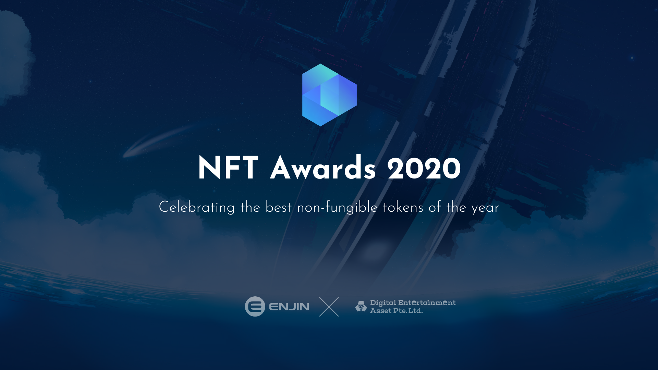
9 December 2020, SINGAPORE — Enjin and Digital Asset Entertainment (DEA) have announced the winners of the first annual NFT (Non-Fungible Token) Awards program.
<embed awards ceremony video: https://youtu.be/EKq_DTqh7PM>
ˈsä-v(ə-)rən-tē by Micah Johnson was named NFT of the Year. A time-sensitive photographic artwork, ˈsä-v(ə-)rən-tē (pronounced “sovereignty”) documents two young boys and allows viewers to directly contribute to their cause. Each year on their respective birthdays, a layer change reveals the boys' career aspirations and a Bitcoin wallet to collect contributions for their future.
“During my baseball career, I thoroughly enjoyed the process and the grind far more than any award or accolade. However, being nominated for NFT Awards has a special place in my heart because it was a team effort,” said Johnson. “The space welcomed me in with open arms and pushed me to elevate my artistic output, culminating with my latest work on ASYNC. Being nominated alongside some of the artists I look up to is incredibly humbling.”
Along with NFT of the Year, winners were awarded in the following categories:
- Adoption Potential: Crypto Stamp by the Austrian Post
- Best Art NFT: Picasso's Bull #1/1 by Trevor Jones
- Best Utility NFT: "Off The Charts" - Proof of Attendance by Binance
- Most Innovative NFT: Right Place & Right Time (Bitcoin Hourly Price Offset) by Matt Kane
- Best Charity NFT: Kitty by Paris Hilton
- Best Gaming NFT: Millipede by The Sandbox
After being sold at auction for the record-setting price of US$223,000 on December 2, F1® Delta Time’s first Apex race track segment “Formula 1 Grand Prix de Monaco 2020 1A” received the Most Valuable NFT award.
Determined by community voting, the People’s Choice title was awarded to five tokens:
- 64 GALLON TOTER by ROBNESS
- Crypto Stamp by the Austrian Post
- The People's Potato by Second Realm
- Knife by Nifty Wizards
- Pop Star from JobTribes by DEA
Winners of the 2020 NFT Awards were decided by two rounds of judging: 24 blockchain industry figureheads served as preliminary judges, selecting nominees to advance to the finals. Winning NFTs were then determined by the Main Judges, a panel of leaders from tech, gaming, and entertainment:
- 3LAU, Artist/Musician
- Etsuji Nakai, Google Cloud Solutions Architect
- Nobuyuki Idei, former CEO & Chairman of Sony
- Nao Udagawa, Managing Director of BANDAI NAMCO Entertainment Inc.
- Shigeki Morimoto, Game Designer & Advisor of the Pokémon series
- Sherry List, Leader of Microsoft’s Azure Heroes NFT rewards program
- Nicolas Pouard, Ubisoft’s Blockchain Initiative Director
NFT creators and collectors interested in participating in the 2nd Annual NFT Awards can follow the program on Twitter and sign up on nftawards.org to be notified when nominations open in 2021.
About Enjin
In 2009, Enjin launched the Enjin Network, a gaming community platform that boasts over 20 million users. In 2017 following a successful ICO that raised $18.9 million, Enjin began building a suite of products that make it easy for everyone to develop, trade, monetize, and market with blockchain.
Comprised of the Enjin Platform, Explorer, Wallet, Beam, and other tools and services, Enjin’s tools enable game developers and studios to utilize tokenized digital assets as part of their acquisition, retention, engagement, and monetization strategies. The Enjin ecosystem is fueled by Enjin Coin (ENJ), an Ethereum-based cryptocurrency used to directly back the value of Enjin-powered blockchain assets. For more information, visit https://enjin.io.
About Digital Entertainment Asset
DEA is a Singapore-based company founded in August 2018. DEA’s original crypto asset DEAPcoin (DEP) was listed on world renowned exchanges including OKEx, Bithumb Global , Bittrex Global, INDODAX, and DIGIFINEX. DEA also released its first game, JobTribes, a card trading battle game, as well as Digital Art Auction, a marketplace for trading digital assets. DEA’s goal is to realize a world in which people can “play to earn,” through combining blockchain technology with digital entertainment. For more information, visit https://dea.sg.
Media Contacts
Bryana Kortendick
Enjin VP of Communications
bryana@enjin.io

Kozo Yamada
DEA Chief Marketing Officer
info@dea.sg

###

