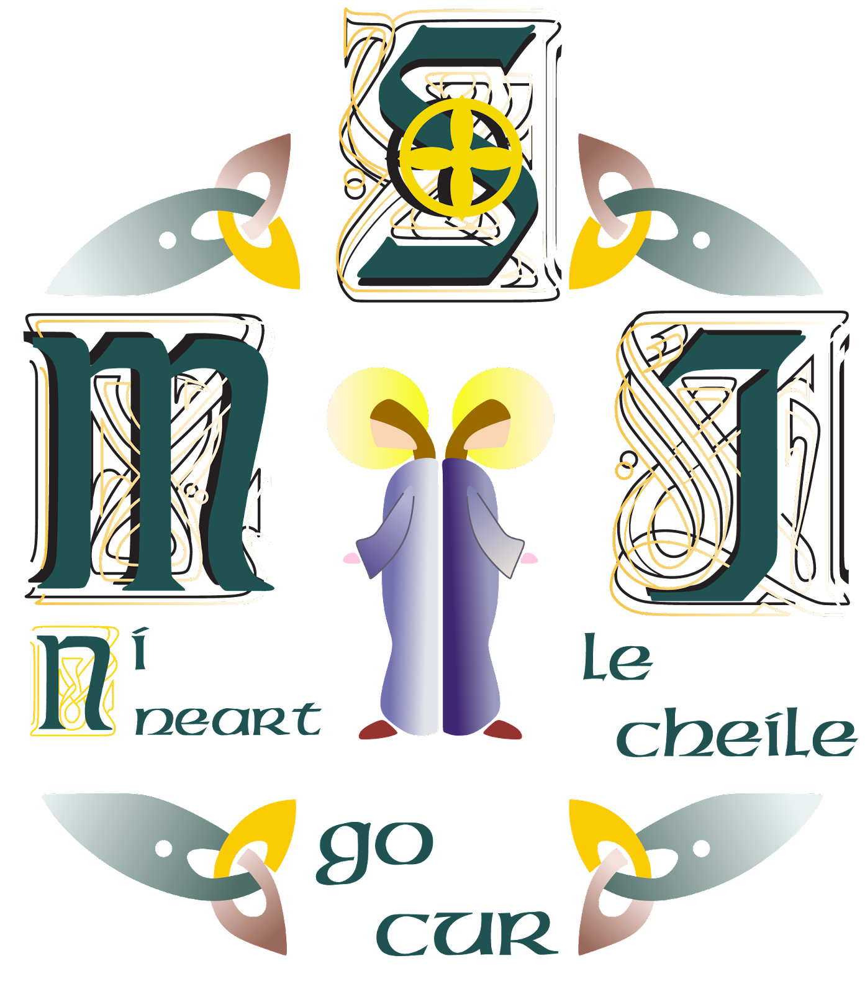

The Board of Management of Scoil Mhuire & Íde invites applications from suitably qualified persons for the post of Principal to take effect from

1st December, 2022.

The school is a Catholic Voluntary Secondary School (Category XVI) under the trusteeship of Comhairle Scoil Mhuire & Íde  Roll No: 64170L

Scoil Mhuire & Íde is a co-educational school with an enrolment of 760 students.

Application form and further details may be obtained from the school website, www.smincw.ie

Completed Application form, plus 5 copies, must be signed and sent by registered post only to the

Scoil Mhuire & Íde, PO Bos 13539, Newcastle West, Co. Limerick

to arrive no later than 4 pm on Wednesday, 24th August, 2022.

Envelope should be marked “Application”.

Shortlisting may apply.

The Board is an equal opportunity employer.