Cyber Security with NIST Framework to Adhere to Compliances

Lower Colorado River Authority is a non-profit public utility, which functions as part of a US state legislature, and is actively engaged in water stewardship, energy and community service.

- Evaluate various business entities operated by the client using the NIST Cybersecurity Framework
- Update and improve their cyber security protocols
- Prepare process documents on the implementation of security controls for these entities both for the present and for reaching the desired levels of implementation in the near future

- Meticulously maintained and operated a variety of cyber security measures and software that enhanced multiple security functions such as access control, monitoring and vulnerability assessment.
- Ensured up-to-date protection from malicious software and cyber threats, by implementing tests and measures that remediated and mitigated risk at different tiers within the client’s cyber security system.
- Recommended and established best practices that enhanced system security across the grid for all of the client’s business entities.
- Provided valuable insights to the client in order to ensure compliance with the latest security regulations, standards and laws.
- Created and delivered security training materials and classes for multiple stakeholders involved, thereby developing a robust cybersecurity ecosystem based on a holistic and growth-oriented approach.

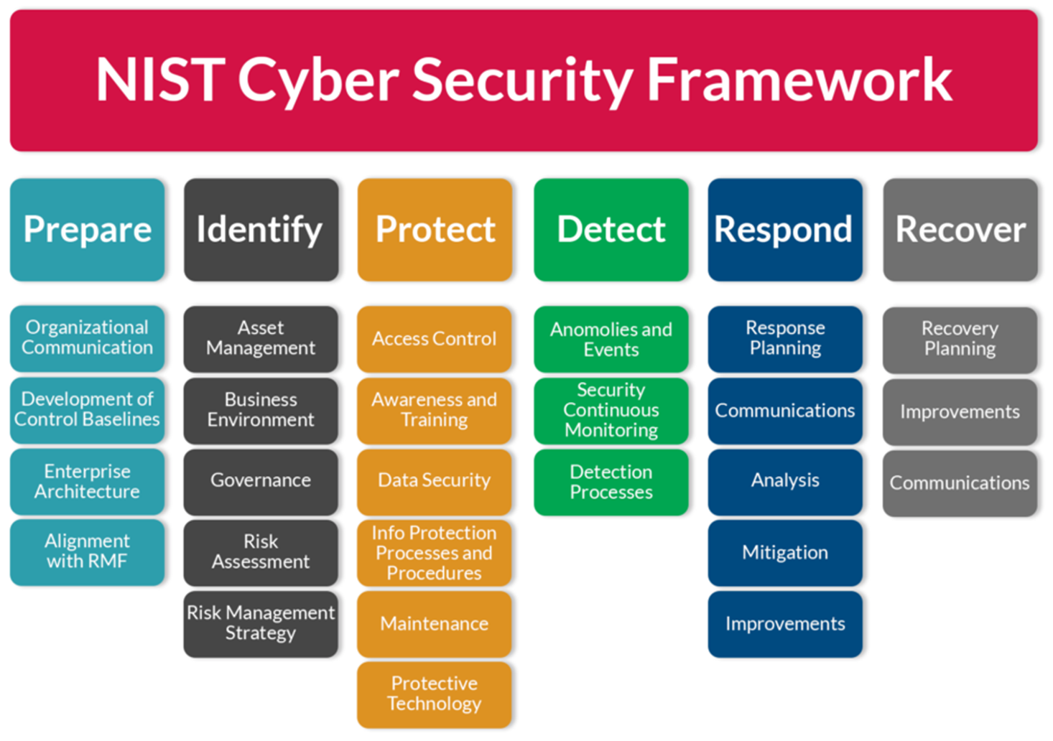
Framework

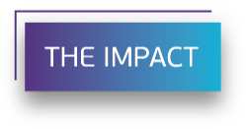
- Improved client’s technical understanding of cyber security threats
- Implemented and ensured technical security compliance solutions for NERC, PCI, FBI CJIS, HIPAA and other regulatory requirements.
- Improved client’s threat detection, threat intelligence and incident reporting, while also reducing its vulnerability significantly
- Collaborative efforts in mentorship, compliance and quality control helped elevate the client’s cyber security framework to an advanced level.

