Automated Transportation Security Administration (TSA) Checkpoint Wait Times System for Passenger Satisfaction

Dallas/Fort Worth International Airport, also known as DFW Airport, is the primary international airport serving the Dallas–Fort Worth metroplex area in the U.S. state of Texas. It is the largest hub for American Airlines, which is headquartered near the airport. It was the third busiest airport in the world by aircraft movements and the tenth busiest airport in the world by passenger traffic in 2019. It is the ninth busiest international gateway in the United States and the second busiest international gateway in Texas.

- Client wanted to analyze influx of passenger and wait times at the airport. Long queues create long wait times, as a result customers develop a negative experience at Airport. It also has the potential to cause missed flights
- This project sought to optimize checkpoints to reduce congestion and to monitor real-time checkpoint situational awareness

- Master and Transportation Security Administration (TSA) Controller tables act as the single source of operational hours and the schedule data
- TSA predictive and real time wait systems communicate using the Mulesoft Application programming interfaces(APIs)
- Passenger forecast Model (PFM) python script will insert the data in to an excel spreadsheet which will calculate the predicted time
- APIs take the data from the TSA Controller database as request and generates response which will be fed to the Website and Mobile Apps.
Tech Stack-
- Mulesoft,Python,Linux,Windows,Microsoft Excel , Oracle DB Server
- MS SQL Server,Tomcat,Groovy
Solution Architecture
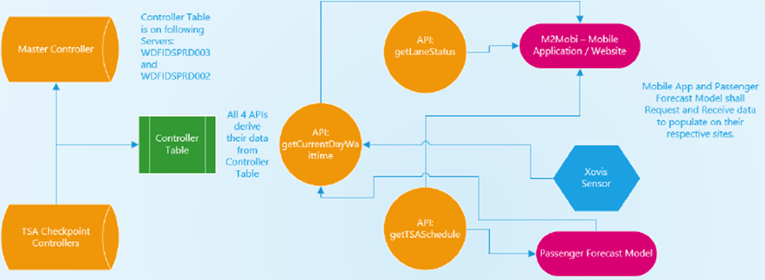

- A cost effective automated solution was provided by leveraging capabilities of fetching dynamic data derived from controller tables eventually shared via APIs
- Improved quality and accuracy of data related to passenger wait times
- Traceability/predictability of wait time behavior is helping to target the airport to serve the customers better
- Effective reporting equipped with dashboards and trend analysis
- Single source of integrated data across enterprise
- Predictive analysis of wait times is helping Airport Customer Experience team to activate/deactivate the checkpoints at terminals based on the traffic.

