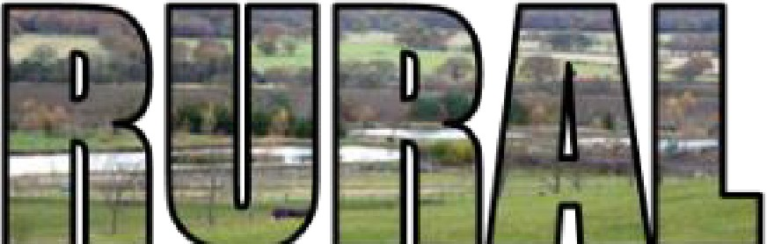

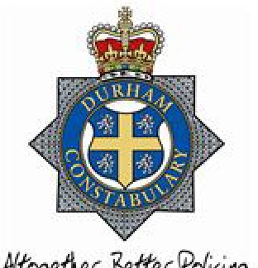
RON H O ' IM E D'"V'ICTPIMOSI COMM ISSIONER

Putting.VIC- tlm fir5t in County Durham ,rnd Darlington

County Durham and Darlington are beautiful places to work and live. We’re really lucky to have great, rural open spaces. And it is, on the whole, a very safe place to live. We’re not it immune to crime, however, and the nature of where we work and live has natural implications for the police.
In 2016 we set out a vision for rural policing:
“People living in the rural areas of County Durham and Darlington will feel safe. They will know that their concerns about crime and anti-social behaviour will be understood and addressed by the Police and partners.”
And, in 2017, through the ‘Rural Policing Statement: One Year On’ update, we set out the work done to making that vision a reality. We told you about the additional four wheel drive vehicle with automatic number plate recognition (ANPR) technology for our rural teams to use, and the training given to call-handlers to help them better understand rural issues – and several other rural-focused initiatives.
This year’s update continues to recognise that policing in rural areas is often different to policing in towns and sets out what has been done to address crime and anti-social behaviour, and what more can be done – by all of us, working together.
This year the National Police Chiefs’ Council (NPCC) released their Rural Affairs and Wildlife Crime strategies. At the same time, the spotlight has been shone on people’s experience of crime in rural areas in this year’s National Rural Crime Survey.
Now is as appropriate a time as ever to restate our commitment to keeping rural communities safe – and, in so doing, to update you on our work.
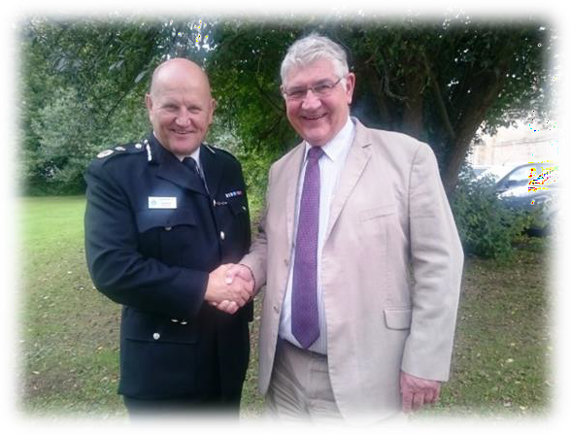

Ron Hogg, Police Crime and Victim’s Commissioner (R) and Mike Barton, Chief Constable of Durham Constabulary (L)

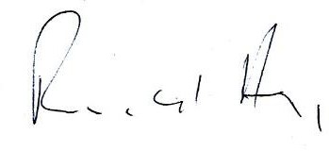
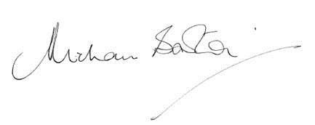
Ron Hogg, Police, Crime and Victims’ Commissioner (PCVC)

Mike Barton, Chief Constable, Durham Constabulary

Victims
Supporting victims continues to be the golden thread which runs through all of our work:
Every crime or every incident of anti-social behaviour has a victim at its heart.

Priority: Improve Community Safety in Rural Areas
The Police, Crime and Victims’ Plan 2018- 2021 sets out a priority to improve community safety in rural areas.
The PCVC publishes quarterly performance reports, setting out how the outcomes which the Plan describes are being achieved. The performance report includes discussion of community safety, crime and confidence in rural areas.

Policing Rural Areas
Issues highlighted in the NPCC’s Rural Affairs Strategy such as theft of farm equipment, poaching, equine-related crime and incidents, and fly-tipping reflect many of the concerns raised by people living in rural areas across County Durham and Darlington.
Equally, concerns about speeding and unsafe driving, and anti-social behaviour, are also raised by local people living in the rural parts of Durham and Darlington.
And the loneliness and isolation which some people in rural communities experience, can make them feel especially vulnerable.

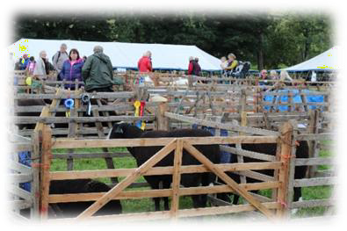
Over the past several years the budget of Durham Constabulary has reduced significantly. This has, understandably, raised concerns about the resources available for rural policing. However the Constabulary’s commitment to neighbourhood policing in rural areas remains firm and unchanged.
The Constabulary’s Neighbourhood Policing Teams are also supported by a dedicated rural team within the Special Constabulary. Among their day-to-day police duties the Rural Specials participate in Farmwatch (see below) and other rural operations.
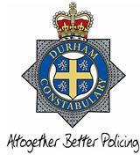

Rural and Wildlife Crime
The Constabulary collects data showing levels of recorded crime and incidents, and also conducts regular surveys to find out about people’s experiences of crime and policing. Recorded crime data tends to show that crime in the force’s most rural

areas is lower than the force area as a whole. Indeed, this appears to reflect the national picture.1
At the same time, though, the National Rural Crime Survey suggests that some people living in rural areas were unlikely to report a crime or incident to the police, perhaps because they feel that the police would be unable to respond satisfactorily. The tables below show how recorded crime compares between County Durham and Darlington as a whole, and the Constabulary’s most rural areas.
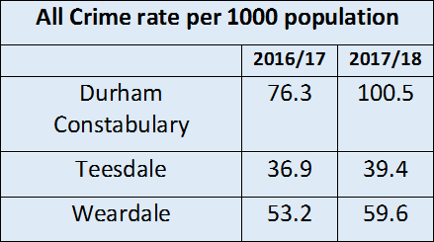
There are also particular types of crime – such as wildlife crimes – where, even when incidents and crime are recorded, the overall volume of crime and incidents is low and almost certainly under-reported. Yet the impact of these crimes, such as the illegal killing of birds of prey, can be significant for nature, the local community and the economy.
Looking at the National Rural Crime Survey for 2018, results suggest that Durham performs significantly better than the national average. This reflects the

1 ‘Rural Crime Statistics’, Office for National Statistics, 25 January 2018,
Constabulary’s outstanding inspection reports in recent years.
However, there is no room for complacency. We are very clear that rural communities in Durham and Darlington need and deserve the best possible service from their local Police teams.

Working with Communities
Addressing community safety in rural areas is not the responsibility of the police alone. Working in partnership with people living in rural areas and organisations which represent the interests of rural communities is important.
The shared emergency services hub at Barnard Castle continues to be an excellent example of partnership working. Indeed, it offers the opportunity for police officers, the fire and rescue service, the ambulance service and mountain rescue to talk and collaborate with each other every day.
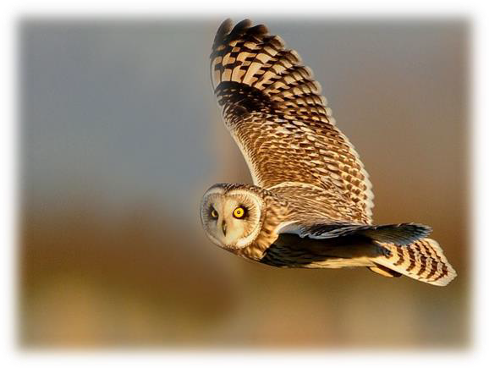
2

https://www.gov.uk/government/statistics/rural- crime, (accessed: 12 July 2018).
2 Short Eared Owl photo – Brian Rafferty

Rural Affairs Strategic Group
One of the ways the Constabulary and the Office of the Police, Crime and Victims’ Commissioner engages with rural communities is through the Rural Affairs Strategic Group, which his office helps to administer.
The group meets throughout the year and offers a forum for people living and working in rural areas to work with the police to address community safety.
Farmwatch
Farmwatch is a partnership. It is able to happen through farmers and the Constabulary working together effectively.
Being part of this partnership allows farmers and the police to work closely together to set up operations, to share vital intelligence, and – ultimately – to create a safer environment.
Prevention
The PCVC paid for a discrete and permanent property marking system for neighbourhood policing teams to use.

The ‘Dot Peen’ machine regularly appears at shows across Durham and Darlington with neighbourhood teams.
Property marked with the new system can then be listed registered on the national register at www.immobilise.com.
Keep an eye out on social media for drop- in session dates. Interested people can also contact their neighbourhood team – details of which can be found on www.durham.police.uk
Reoffending
Reducing crime, reducing the number of victims of crime, and making communities safer necessitates reducing reoffending.
The Police, Crime and Victims’ Commissioner has prioritised reducing reoffending and improved rehabilitation, in rural as well as urban areas.
Checkpoint, Durham’s innovative and award-winning diversion scheme for low- level offending, is one example of this work.

Car locked
Prevention
Outside
lights
Outbuildings
secure

Community Speedwatch
Community Speedwatch is a scheme to help local people work with the police to monitor and address speeding concerns. It’s good to see how the scheme has grown over the past two years:

Community Speed Watch
Activities/Deployments in Rural Areas3
2016 | 98
2017 | 167

Being present – and being seen to be present
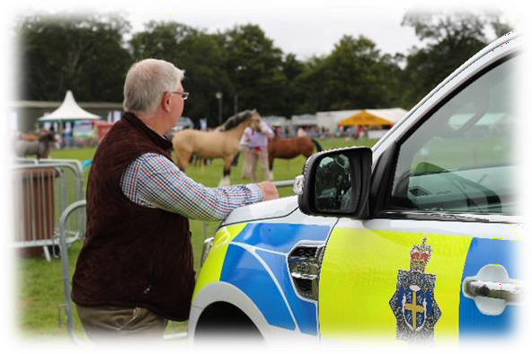
Keep in the Know – a system that anyone with an email address can sign up to – continues to be one very important way in which people across Durham can learn about the activities of their neighbourhood policing team.
The system increases the flow of information between the police and communities, and has a clear impact on preventing and detecting crime and anti- social behaviour in our communities.
As PCVC, Ron Hogg is keen to visit and understand the rural areas of County
Durham and Darlington. For example, this year, Ron and his staff have attended rural shows in Lanchester, Sedgefield, Wolsingham, Peterlee, Stanhope, Eggleston, and Hurworth. Ron also writes monthly columns in the Teesdale Mercury and Weardale Gazette, and takes full account of any feedback he receives.
These activities are important opportunities to consult rural communities about their experiences of rural crime.

Updates
Community Safety Responders (CSRs)
CSRs work for Durham Constabulary as PCSOs, County Durham and Darlington Fire and Rescue Service as retained firefighters and as first responders for the North East Ambulance Service. And the number of these well trained individuals, serving rural areas, remains the same this year.
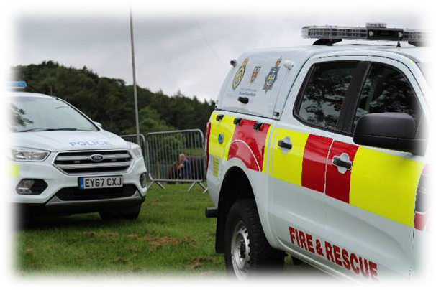
Cross-border working
Rural policing does not stop at force borders. That’s why the NPCC have published their rural affairs and wildlife crime strategies, and why the Police, Crime

3 Barnard Castle and Crook Sectors.

and Victims’ Commissioner works with other Police and Crime Commissioners through the National Rural Crime Network (NRCN).
The NRCN enables a better understanding of community safety in rural areas – and it coordinates the National Rural Crime Survey.
Durham Police Officers also regularly collaborate with Cumbria Constabulary and North Yorkshire Police, particularly in relation to Farmwatch operations.
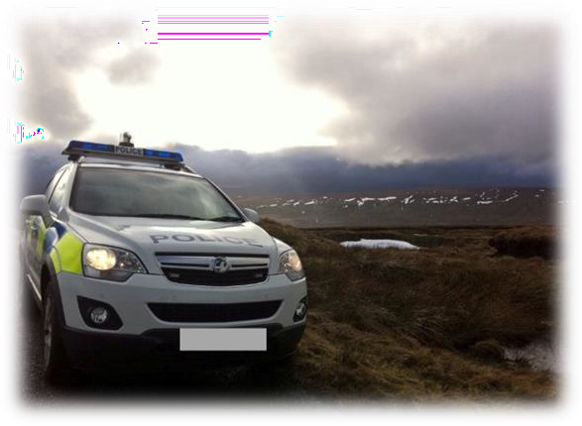
Community Peer Mentors
Community Peer Mentors are volunteers who support people who are vulnerable or isolated as a result of anti-social behaviour, or because they are victims of crime – they operate across County Durham, including in rural areas.

Coming in 2019
Police Community Support Volunteers (PCSVs)
The Constabulary plans to recruit additional PCSVs – volunteers who can provide a more visible police presence in rural areas.
Drones
Durham Police also plans to supplement its fleet of drones which often prove invaluable in having sight of large rural areas quickly.
Domestic Abuse research
The National Rural Crime Network – a collaboration established by 28 Police and Crime Commissioners representing rural areas – is this year undertaking national research to better understand the barriers faced by victims of domestic abuse in rural areas.

Working Together to Combat Crime in Rural Areas
This statement is merely a snapshot of the work which is always taking place to improve community safety in rural County Durham and Darlington.
And we also recognise that there is always more that might be done to engage with and work with people who live in rural areas to combat crime and improve community safety.

You can help!
Your knowledge, and your experience, are vital to enabling the police to tackle crime.
You can do this anonymously by phoning Crimestoppers’ new dedicated Rural Crime Reporting Line (0800 783 0137) or through an online form.4
You can also contact Durham Constabulary through calling 101 – but in an emergency always phone 999.
And, as ever, the Police, Crime and Victims’ Commissioner welcomes your thoughts on the work of Durham Constabulary as it pertains to rural affairs. You can contact the office by email general.enquiries@durham.pcc.pnn.gov.uk or telephone (0191 375 2001).

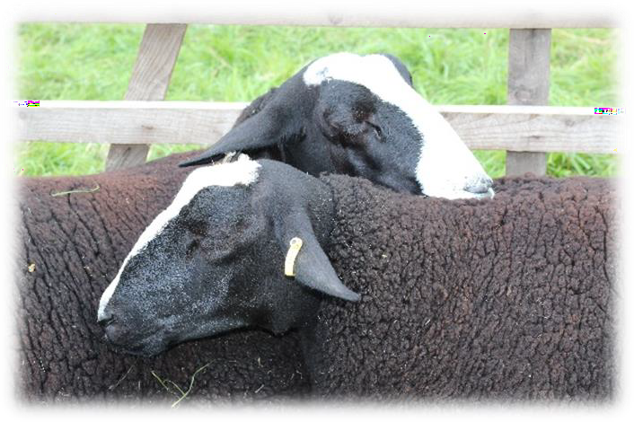

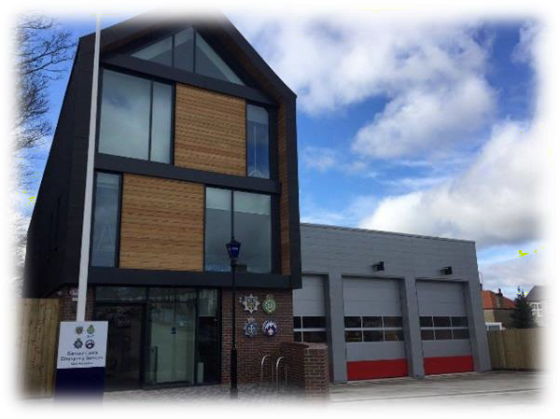
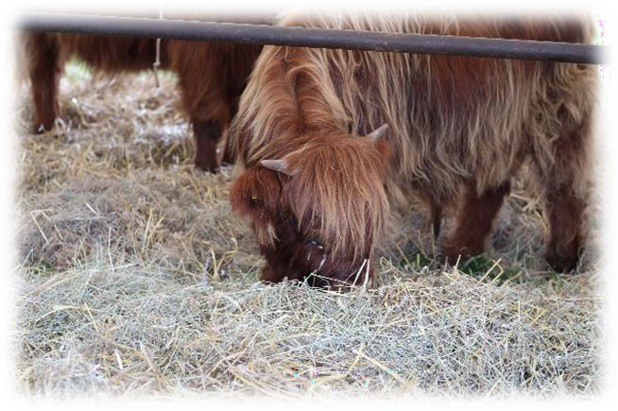

4 www.ruralcrimereportingline.uk

