
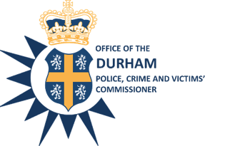

Police, Crime and Victims’ Commissioner for Durham
Police Headquarters
Aykley Heads
Durham
DH1 5TT
Telephone Number: 0191 3752001
Email: general.enquiries@durham.pcc.pnn.gov.uk
Website: http://www.durham-pcc.gov.uk

Councillor Lucy Hovvels
Chair of Durham Police and Crime Panel
County Hall
Durham
DH1 5UL
Sent via email to: lucy.hovells@durham.gov.uk

Acting Police, Crime & Victims’ Commissioner: Stephen White
Acting Chief Executive and Monitoring Officer: Sharon Caddell

24th February 2021
Dear Councillor Hovvels

Thank you for your letter dated 8 February 2021 relating to my report to the Police and Crime Panel on my proposal to increase the precept level. I intend to proceed with maximum increase permitted by the Government for the financial year ending in March 2022: a £15 per year increase for a Band D property. This equates to a 6.97% increase across the council tax bands for the year ending 31 March 2022.

In accordance with Schedule 5 Sections 5(2) (c) of the Police Reform and Social Responsibility Act 2011, I intend to publish both your letter and this response on my website.

Please offer my thanks to the panel for their consideration of my proposal.

Yours Sincerely
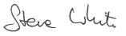

Steve White
Acting Police, Crime & Victims’ Commisisoner



The Police and Crime Commissioner for Durham is an accredited Living Wage Employer with the Living Wage Foundation

