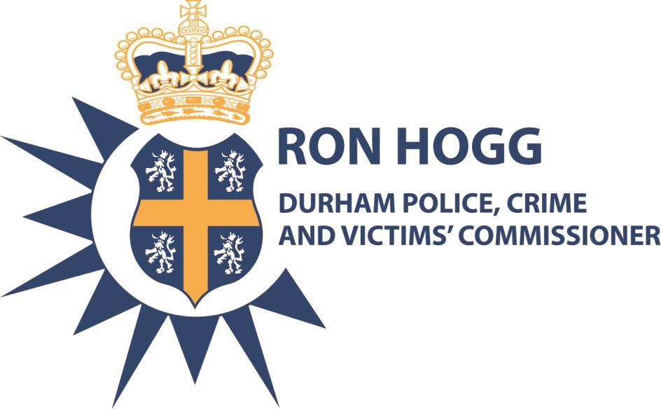

DURHAM

Police and Crime Commissioner and
Police and Crime Panel

Memorandum of Understanding/Partnership Agreement

Introduction

The Police Reform and Social Responsibility Act 2011 brings in new governance arrangements for policing and policing accountability. Principal among these changes is the election of the Police and Crime Commissioner (PCC) and the appointment of the Durham Police and Crime Panel (PCP). The Police and Crime Panel will scrutinise the decisions and activities of the Police and Crime Commissioner. In turn the Police and Crime Commissioner will hold the Chief Constable to account for the delivery of policing services and the achievement of the Commissioner’s objectives.

This work is being delivered in a changing and challenging environment which requires flexibility and a pragmatic approach, high levels of cooperation and joint working, as well as a commitment to supporting each other in the delivery of shared and individual responsibilities.

Our overriding aims are to keep people safe and to provide the very best service that we can to the diverse communities of County Durham and Darlington.

This Memorandum of Understanding/Partnership Agreement is a statement of the Police and Crime Commissioner and Police and Crime Panel’s (our) commitment to build and nurture an effective partnership based on the principles set out in this agreement.

Purpose

The Agreement sets out the broad principles and processes which will guide our work together. It sets out our expectations to support a positive and constructive relationship. It also provides a framework for the development and agreement of additional protocols/procedures to deal with specific issues these could include procedures for dealing with complaints against the PCC or Deputy PCC, Confirmation Hearings for Chief Constable and Statutory Officer posts and Information Sharing.

We will use the Agreement as a means of:

- promoting and encouraging appropriate values and behaviours in partnership working
- constructive mutual challenge and
- reviewing progress

Our key statutory roles and responsibilities

The PCC is responsible for:

- Securing an efficient and effective police force for the Durham Police Area
- Producing, and consulting on, a five year police and crime plan, in consultation with the chief constable, which sets the police and crime objectives for the area.
- Holding to account the chief constable including the power to appoint and dismiss
- Publishing information/data including an annual report
- Setting the annual force budget and police precept
- Requiring the chief constable to prepare reports on police matters
The PCP is responsible for:

- Scrutinising the PCC, to promote openness in the transaction of police business and also to support the PCC in the effective exercise of their functions
- Contributing to the development of the PCC’s police and crime plan
- Reviewing the PCC’s proposed precept
- Reviewing the PCC’s Annual Report
- Reviewing the proposed appointments of chief constable, chief executive, chief finance officer and deputy police and crime commissioner (if proposed) and holding public confirmation hearings for these posts
- Making reports and recommendations on matters relating to the PCC
- Investigating complaints about non criminal behaviour of the PCC

Our principles for successful partnership working Shared objectives
Our shared objective is to tackle local crime and disorder, creating safer communities throughout all of County Durham and Darlington and increasing public confidence.

Community safety is the protection of everyone’s right to live without fear for their own or other people’s safety. It is about impacting on crime, fear of crime and victimisation. It means the empowerment and involvement of all in the community to tackle inequalities, address the underlying causes of crime and create environments in which all people feel safe. It is about quality of life.

We will co-operate with each other, and the other responsible authorities, to reduce crime and anti social behaviour and support an efficient and effective criminal justice system.

Shared values and behaviours

At the heart of successful partnership working is trust. Building trust takes time, but it only takes an instance to damage it. Agreeing shared values and behaviours, which are interrelated and impact on each other, are critical to successful partnership working and developing trust. We have set out below our shared values and how we will behave to demonstrate them. We will hold each other to account and measure ourselves against these principles.

Taking an evidence led approach
Priorities are evidence based and decision making transparent. Effective action is reality based and solution focussed.

We will:
- Ensure that decision making is informed, consistent and transparent
- Be committed to continuous improvement
- Ensure that claims about performance are evidence based
- Actively encourage ideas and innovation
- Manage risk
- Monitor, evaluate and review our work to ensure we respond to changing needs and can demonstrate we are making a difference

Valuing and respecting each other
Respect and value everyone’s contribution.

We will:
- Respect each other’s mandates, obligations and independence
- Recognise each other’s constraints and commitments
- Build effective working relationships with each other
- Recognise the value of everyone’s contribution
- Make accountability real in a constructive way

Public interest
Act in the interest of the public and demonstrate value.

We will:
- Take a balanced and multi-faceted approach to issues
- Focus on long term as well as short term problems, responses and solutions
- Act in the interests of the public good over individual interests
- Demonstrate to the community how we are achieving publicly valued outcomes
- Carry out our work responsibly, with integrity and in a relevant and appropriate way

Building capacity
Build capacity in our partnership.

We will:
- Develop skills, knowledge and experience in order to carry out our roles and responsibilities effectively
- Ensure meaningful dialogue through early consultation and early information sharing of data and analysis
- Tackle difficult and controversial issues

Acting ethically
Act ethically with integrity and build trust. Be honest, open and objective and encourage constructive challenge.

We will:
- Ensure that our dialogue is open and transparent
- Agree how we will achieve democratic accountability
- Declare conflicts of interest and address them
- Use appropriate and simple language
- Be honest and objective
- Encourage questions and constructive challenges
- Agree a mechanism for whistleblowing

Aligning objectives
Harness our collective efforts.
We will:
- Allow sufficient time and capacity to be given to understand an issue and to reflect on its impact
- Establish accountability and give each other constructive feedback
- Make sure that actions are clear, time limited and task oriented
- Ensure that agreed actions are carried out
- Build on our comparative advantages and complement each others contributions
- Share a collective understanding of our partnership and promote the values of our partnership

Specific protocols and procedures

As detailed earlier in the Agreement it may be necessary, over time, to develop and agree additional protocols and procedures to deal with specific issues. This partnership agreement provides the framework for doing this. These protocols may include procedures for dealing with complaints against the PCC or Deputy PCC, Confirmation Hearings for Chief Constable and Statutory Officer posts and Information Sharing

The following procedure is proposed in relation to meetings of the Panel:

Meeting Schedule and Work Programme

The Police and Crime Panel will meet at least four times per year with extraordinary meetings called as and when necessary. It is proposed that the Panel Secretariat (comprising of officers form Durham County Council Legal and Democratic Services and Overview and Scrutiny) will work with the Office of the Police and Crime Commissioner (OPCC) to determine suitable dates bearing in mind the statutory dates laid down for the Police and Crime Plan, precept and budget, annual report etc. The work programme will also take into account the Panel’s duty to review/ scrutinise PCC decisions and actions.

In considering potential meeting dates to which the PCC or a member of his staff is required to attend the Panel Secretariat will wherever possible consult with the OPCC to determine suitable dates. In any event the Chair of the Panel, via the Panel Secretariat, will inform the PCC or staff member in writing giving, where practical, 15 days notice. Such a notice to state the nature of the item on which he or she is required to attend to give account and whether the Panel require any papers to be produced. Where a report is required sufficient time will be allowed for this to be produced.

Where, in exceptional circumstances, the PCC is unable to attend on the required date, then an alternative date for attendance may be arranged following consultation with the Chairman of the Panel. If the Panel require the PCC to attend a meeting, the Panel may (at reasonable notice) request the Chief Constable to attend on the same occasion to answer any questions which appear to the Panel to be necessary in order for it to carry out its functions

Resolving Differences

In any new arrangements there will inevitably be differences of opinion on issues. We will take a positive and constructive approach to resolving any issues in accordance with the
arrangements set out in the relevant Protocol or Procedure. In general officers will attempt to resolve an issue in consultation with the Chair of the PCP and the PCC before referring the matter to the full PCP.

Summary

This Memorandum of Understanding/Partnership Agreement is work in progress. We recognise that these are new and different arrangements and there will be issues to work through and resolve. The quality of our relationship will be more important than any written agreements. If we invest time and energy in maintaining a good partnership working relationship, together we can make a huge difference. We are committed to doing that in a constructive and positive way, remembering always that our shared priority and the reason why we exist is to serve the people of County Durham and Darlington by creating safer communities. It is acknowledged that the relationship between the PCC and the PCP will develop over time. It is agreed that this Agreement be reviewed on an annual basis.

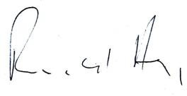

Ron Hogg

Durham Police and Crime Commissioner
Cllr Lucy Hovvels

Chair Durham Police and
Crime Panel

