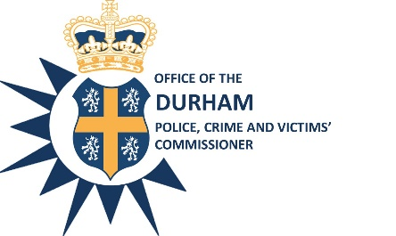 | Durham Police Crime & Victims’ Commissioner/ Chief Constable  Joint Independent Audit Committee  Tuesday 20th October 2020  10:30 a.m. –  Teams Meeting | 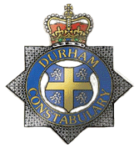
Agenda

- Attendance/Apologies
- Declarations of Interest
- Minutes of the meeting held on 8th September 2020 – Mrs Bambridge (copy attached)
- The Redmond Report Review – Miss Henderson (copy attached)
- Internal Audit Progress Report – Miss Henderson (copy attached)
- Annual Governance Statement (AGS) Action Plan – Miss Henderson (copy attached)
- Update of Report on Retention and Disposal of Firearms – Miss Henderson (verbal update)
- Safeguarding Process during Covid –Mr Ridley/Mr Ashton/Mrs Dutson (copy attached)

Date of next meeting: Tuesday 8th December 2020
Time: 10:30 Place: Remote arrangements/Teams meeting
Sharon Caddell  Chief Executive & Monitoring Officer | G Ridley  Chief Finance Officer

