OFFICE OF THE DURHAM POLICE CRIME & VICTIMS’ COMMISSIONER
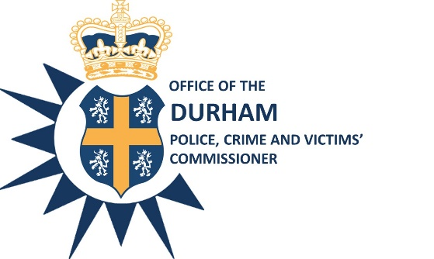

EXECUTIVE BOARD

Date: 7th January 2021

Time: 10:00 a.m. – 12:00 p.m.

Venue: Police Headquarters, Dixon Room and Microsoft Teams Meeting

AGENDA

Item No. | Item | Paper/ Verbal? | Presenter | Time
1. | Introductions and Apologies | Verbal | Mr Steve White | 10:00am
2. | Minutes of the meeting held on 10th December 20 | Paper | Mr Steve White | 10:05am
3. | Action Log Update | Paper | Mrs Sharon Caddell | 10:10am
4. | Covid-19 update | Verbal | Supt S Long | 10:15am
5. | Quarterly Estate Update | Paper | Mr G Ridley | 10:25am
6. | Quarterly ICT Update | Verbal | Supt S Long | 10:40am
7. | Thematic Report- Fraud | Paper | Supt L Gosling | 10:55am
8. | Accountability Report | Verbal | Mr J Atkinson | 11:15am
9. | Efficiency Plan on a Page | Paper | Mr G Ridley | 11:25am
10. | PCVC Strategic Work Plan | Verbal | Mrs S Caddell | 11:40am
11. | Any Other Business:  Next meeting scheduled: 18th February 2021, 10am  Close |  |  | 11:50am  Midday

Steve White
Acting Police, Crime and Victims’ Commissioner

To: The Members of the Executive Board:
Mr S White Mrs S Caddell
Mrs J Farrell Mr D Orford
Mr J Ward Mr G Ridley
Mrs J Trotter Mr C Oakley
Mrs S Sahani
Cc: Mrs G Routledge

