OFFICE OF THE DURHAM POLICE CRIME & VICTIMS’ COMMISSIONER
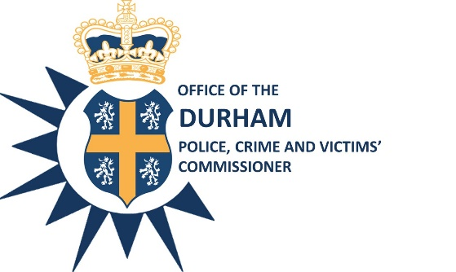

EXECUTIVE BOARD
Date: 8th October 2020

Time: 10:00 a.m. – 12:00 p.m.

Venue: Police Headquarters, Dixon Room or Via Teams

AGENDA
- Minutes of the meeting held on 10th September - Mrs Katy Bambridge (copy attached)
Action Log – Mrs Katy Bambridge (copy attached)

- ICT Strategy – Chief Supt Jonathan Blackwell (copy attached)

- Custody and Estates Strategy Update – Mr Gary Ridley (copy attached)

- Thematic: Road Safety – Supt Colin Williamson/Chief Inspector Graham Milne (copy attached)

- Accountability Report – Mr James Atkinson (copy attached)

- Revision of PCVC Workplan – Covid-19 section – Mr Steve White (copy attached)

- Covid-19 Enforcement Plan – DCC Dave Orford (verbal update)

- Covid-19 Update – ACC John Ward (verbal update)

- Joint Independent Audit Annual Report 2019/20 – Mrs Elsie Davies, Chair of the Joint Independent Audit Committee (copy attached)

Next meeting: Thursday 5th November @10am

Steve White
Acting Police, Crime and Victims’ Commissioner

To: The Members of the Executive Board:
Mr S White Mrs S Caddell
Mrs J Farrell Mr D Orford
Mr J Ward Mr G Ridley
Mrs J Trotter Mr C Oakley
Mrs S Sahani
Cc: Mr J Atkinson & Mrs G Routledge

