OFFICE OF THE DURHAM POLICE CRIME & VICTIMS’ COMMISSIONER
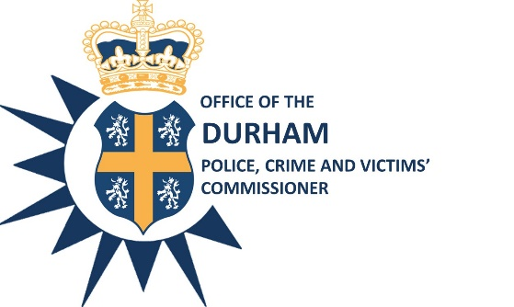

EXECUTIVE BOARD

Date: 29th April 2021

Time: 10:00 a.m. – 12:00 p.m.

Venue: Police Headquarters, Dixon Room or Microsoft Teams Meeting

AGENDA

Item No. | Item | Paper/ Verbal? | Presenter | Time
1. | Introductions and Apologies | Verbal | PCVC S White | 10:00am
2. | Minutes of the meeting held on16th March 2021 | Paper | PCVC S White | 10:00am
3. | Action Log Update- | Paper | CEO S Caddell | 10:05am
4. | Covid-19 update | Verbal | Supt S Long | 10:10am
5. | Thematic Report – Alcohol and Drugs | Paper | Supt N Bickford/D Supt K Weir | 10:20am
6. | PCVC Accountability Report | Paper | Mr J Atkinson | 10:30am
7. | PCVC Strategic Workplan | Paper | CEO S Caddell | 10:40am
8. | National PCC Review | Paper | CEO S Caddell | 10:50am
9. | Quarterly Estates Update | Paper | ACO G Ridley | 11:00am
10. | Quarterly ICT Update | Paper | Chief Supt J Blackwell | 11:15am
11.. | HMICFRS Timetable | Paper | Mrs G Routledge | 11:40am
12. | Safer Streets Update | Paper | Ms Stephanie Kilili | 11.50am
13.. | Any Other Business:  HMICFRS Anti-Social Behaviour Letter Response  Next meeting scheduled: 3rd June 2021, 10am  Close |  |  | 11:57am  Midday

Steve White
Acting Police, Crime and Victims’ Commissioner

To: The Members of the Executive Board:
Mr S White Mrs S Caddell
Mrs J Farrell Mr D Orford
Mr J Ward Mr G Ridley
Mrs J Trotter Mr C Oakley
Mrs S Sahani
Cc: Mrs G Routledge

