Office of the Durham Police and Crime Commissioner
Joint Independent Audit Committee
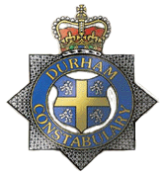
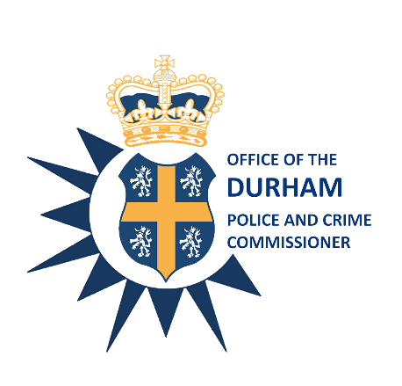

Date: 22nd June 2021

Time: 12:00 p.m. – 15:00 p.m.

Venue: Via Teams

AGENDA

Item No. | Item | Paper/ Verbal? | Presenter | Time
1. | Introductions and Apologies | Verbal | Chair | 12:00pm
2. | Minutes of the Training Day held on 27th April 2021 | Paper | Chair | 12:05pm
3. | PCC Introduction | Verbal | PCC Joy Allen | 12:10pm
4. | Deep Dive - Rape Scrutiny | Paper | Dr Verna Fee | 12:30pm
5. | Internal Audit Progress Report Q4 20/21 | Paper | Miss Tracy Henderson | 12:50pm
6. | Annual Internal Audit Report 2020/21 | Paper | Miss Tracy Henderson | 13:00pm
7. | Annual Governance Review 19/20 Action Plan Update | Paper | Miss Tracy Henderson | 13:10pm
8.. | Draft Annual Governance Statement (AGS) PCC/CC | Paper | Miss Tracy Henderson | 13:20pm
9. | Fraud and Corruption Annual Report 20/21 | Paper | Miss Tracy Henderson | 13:35pm
10. | Annual Review of the System of Internal Audit | Paper | Miss Tracy Henderson | 13:45pm
11. | Review of Audit Committee Effectiveness | Paper | Mr C Oakley | 13:55pm
12. | JIAC Annual Report 2020/21 | Paper | Chair/Mr C Oakley | 14:00pm
13. | Review JIAC Terms of Reference | Paper | CEO Steve White | 14:10pm
14. | Treasury Management Report | Paper | Mr Gary Ridley | 14:20pm
15. | CC Plan on a Page/Risk Register | Paper | Mr Gary Ridley | 14:30pm
16. | Review of Joint Chief Finance Office | Paper | CEO Steve White | 14:40pm
17. | Custody Update | Verbal | Mr Gary Ridley | 14:50pm
18. | Any Other Business:  Next Meeting 20th July 2021 @ 10:30am |  |  | 15:00pm  Close

Joy Allen
Police and Crime Commissioner

