
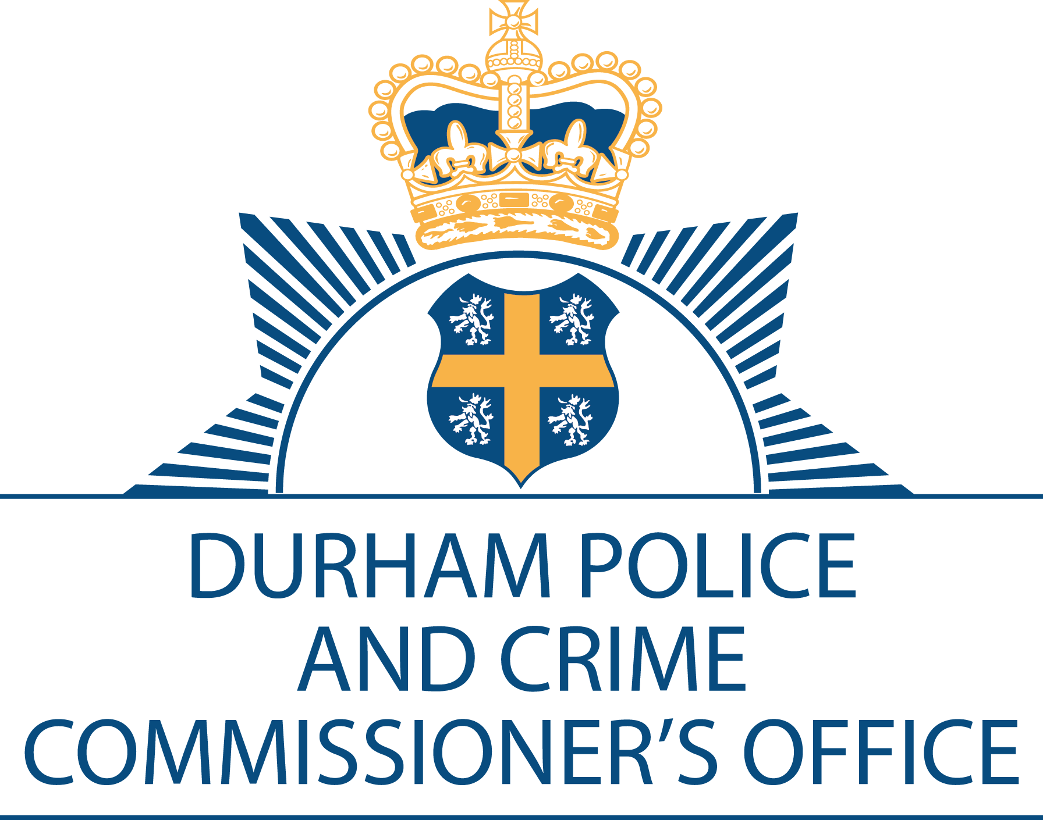

Police and Crime Commissioner for Darlington Durham
Police Headquarters
Aykley Heads
Durham
DH1 5TT
Telephone Number: 0191 3752001
Email: general.enquiries@durham.pcc.pnn.gov.uk
Website: http://www.durham-pcc.gov.uk

Priti Patel MP
Home Secretary
Home Office
2 Marsham Street
London
SW1P 4DF

Police and Crime Commissioner: Joy Allen
Monitoring Officer: Stephen White

20 September 2021

Dear Home Secretary,

A review of Fraud: Time to choose

This letter constitutes the response to the above inspection from myself, Joy Allen, Durham Police and Crime Commissioner, in order to fulfil my responsibilities with regard to Section 55 of the Police Act 1996. The reply to HMICFRS will also be published on my website.

In turn, here are position statements showing what the Constabulary is doing to meet the recommendations and areas for improvement which relates to Chief Constables, of which I am in support:

Recommendation 1- By 30 September 2021, chief constables should make sure that their forces are following the guidance issued by the National Police Chiefs’ Council Coordinator for Economic Crime about fraud-related calls for service.

Recommendation 3- By 31 October 2021, chief constables should adopt the guidance issued in September 2019 by the National Police Chiefs’ Council Coordinator for Economic Crime that was aimed at improving the information given to victims when reporting fraud.

Fraud Recommendations (1 and 3) are already adopted by Durham Constabulary and tracked through an action log. Additionally, having a more cohesive strategy adopted by national agencies will enhance the response the Force are able to produce in relation to fraud.

I am also copying this letter to Sir Thomas Winsor, Her Majesty’s Chief Inspector of Constabulary and Fire and Rescue Services.

Yours sincerely,
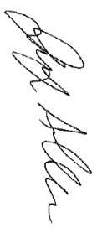
Joy Allen


Police and Crime Commissioner for Darlington and Durham
The Police and Crime Commissioner for Durham is an accredited Living Wage Employer with the Living Wage Foundation

