 | Reference No: 2021-016

DURHAM POLICE & CRIME COMMISSIONER’S OFFICE
DECISION RECORD FORM

REQUEST: For PCC approval

Title: Safer Streets Funding

Executive Summary:
Round 1: In January 2020 the Home Office launched the Safer Streets Fund, which made £25million available to reduce the impact of theft and burglary in some of the country’s most vulnerable communities.

The Durham, Police and Crime Commissioner’s Office submitted bids based on crime prevention criteria to reduce burglaries and improve community safety.

Both bids were successful with £298,918 awarded to Darlington (Northgate and North Road areas), and £485,360 to Horden. These areas were specifically chosen as they both have high rates of acquisitive crime with the aim of reducing burglaries and repeat victimisation and near repeat victimisation.

Round 2: The Durham Police and Crime Commissioner’s Office was awarded £670,864 from the Home Office to tackle neighbourhood crime and make streets safer.
Two bids were submitted to the Home Office’s £18.3 million Safer Streets Fund, which provides money to evidence-based initiatives across the country that aim to reduce burglaries and other acquisitive crimes.
Both bids were successful, with other Police and Crime Commissioners and local authorities having been awarded a share of the fund to make streets safer through projects to crack down on neighbourhood crimes like burglary, vehicle theft and robbery.
The money, from the Government’s Safer Streets Fund, will go towards measures proven to cut crime, including installation of new CCTV and Automatic Number Plate Recognition (ANPR) cameras, securing empty properties and providing window locks, door locks, interior and exterior lighting to occupied properties.
Round 3: Durham Police and Crime Commissioner’s Office has been awarded £453,813 from the Home Office under the Government fund designed to help women and girls feel safe in public places.
A share of the funding will allow Durham Constabulary and Darlington Borough Council to work with the Alice Ruggles Trust to develop and roll out teaching packages on stalking and coercive behaviour for secondary schools and colleges.
E-bikes will also be purchased to assist increased police patrols allowing officers to gather a greater distance during each day, getting to locations that they often are not able to. There will also be improvements to street lighting in key routes home and taxi ranks, bus stops.
In addition, the funding will be used for training and empowerment programmes. The training will assist staff working in the night-time economy with understanding vulnerability, and various empowerment and engagement programmes will run in order to raise awareness of the issues.
A progressive campaign will also be developed with the aim of improving the understanding amongst the public of violence and intimidation against women and girls.
Decision: The PCC office accepted the monies awarded and agreed to work in partnership with Durham Police, Darlington Borough Council and Durham County Council, as part of the delivery of the Safer Streets Projects.
OPCC Lead Officer: Stephanie Kilili-Guttridge
Contractor Details (if applicable): Darlington Borough Council, Durham County Council, Durham Constabulary, Safer Communities
Implications:
Has consideration been taken of the following? | Yes | No
Financial
Legal
Equality & Diversity
Human Rights
Sustainability
Risk
Consultation
(If yes please provide further details below)

Decision Required – Supporting Information

Financial Implications: (Must include comments of the PCC’s CFO where the decision has financial implications)
There is sufficient funding available to cover the commitments made within this decision.

Legal Implications: (Must include comments of the Monitoring Officer where the decision has legal implication)
Having read this form and having considered such information as has been provided at the time of being asked to express this view, the monitoring officer approver is satisfied that this form does not ask the PCC to make a decision which would (or would be likely to) give rise to a contravention of the law.

Equality and Diversity Implications
Funding is to support and protect all members of the community from crime, and all will have equal access to the services that are being funded in the eligible areas as per fund criteria.

Human Rights Implications
No specific human rights implications.

Sustainability Implications
No specific sustainability implications.

Risk Management Implications
No specific risk management implications.

Consultations
No specific consultation undertaken.

OFFICER APPROVAL
Monitoring Officer
I have been consulted about the decision and confirm that financial, legal, and equalities advice has been taken into account. I am satisfied that this is an appropriate request to be submitted to the Police and Crime Commissioner.
Signed: | 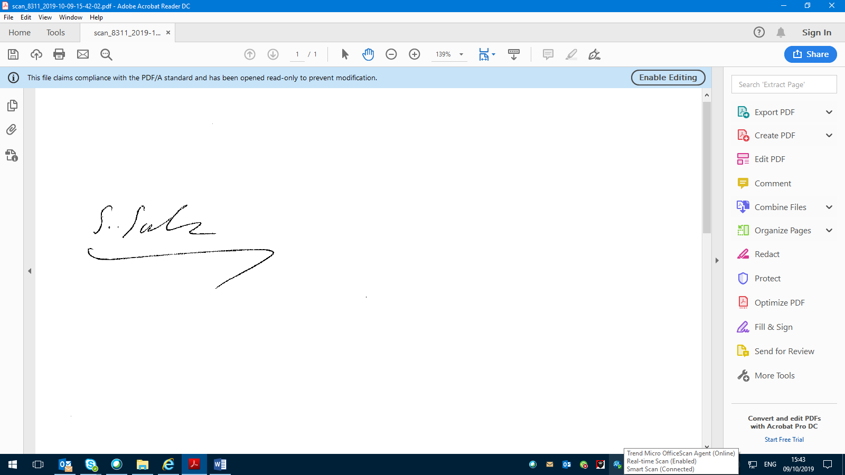 | Date:7/10/21
Monitoring Officer

OFFICER APPROVAL
Assistant Chief Officer/Joint Chief Finance Officer
I have been consulted about the decision and confirm that financial, legal, and equalities advice has been taken into account. I am satisfied that this is an appropriate request to be submitted to the Police and Crime Commissioner.
Signed:  Date: 7th October 2021
…………………………………………………………………………………………….. …………………………………………………….
Assistant Chief Officer/Joint Chief Finance Officer

Police and Crime Commissioner:
The above request has my approval.
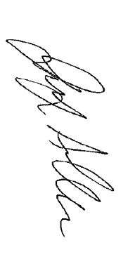
Signed: |  | Date: | 7th October 2021
Police and Crime Commissioner

