OFFICE OF THE DURHAM POLICE CRIME & VICTIMS’ COMMISSIONER
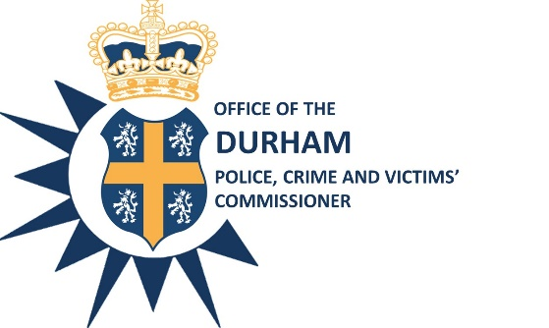

EXTRAORDINARY EXECUTIVE BOARD

Date: 25th February 2021

Time: 08:00am – 09:00am

Venue: Teams Meeting

AGENDA

- Budget Report: Revenue and Capital Budgets 2020/21 2021/22, Medium Term Financial Plan 2021/22 – 2024/25 & Precept Setting - ACO Mr Gary Ridley

- Any other business -

Steve White
Acting Police, Crime and Victims’ Commissioner

To: The Members of the Executive Board:
Mr S White Mrs S Caddell
Mrs J Farrell Mr G Ridley

