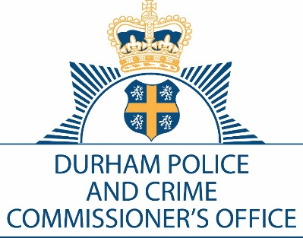

DURHAM POLICE AND CRIME COMMISSIONER’S OFFICE

EXECUTIVE BOARD

Date: 14th October 2021

Time: 10:00 a.m. – 12:00 p.m.

Venue: Police Headquarters, Dixon Room & Microsoft Teams Meeting

AGENDA

Item No. | Item | Paper/ Verbal | Presenter | Time
1. | Introductions and Apologies | Verbal | SS | 10:00am
2. | Minutes of the meeting held 9th September 2021 | Paper | SS | 10:05am
3. | Action Log Update | Paper | SS | 10:10am
4. | Police and Crime Plan Update | Verbal | SS | 10:30am
5. | Thematic: Road Safety | Paper | Supt. Steve Ball | 10:45am
6. | PCC Accountability Report | Paper | Mr James Atkinson | 11:00am
7. | National Violence against Women and Girls (VAWG) | Verbal | Det. Ch/Supt Green | 11:15am
8. | Annual Review of Executive Board Terms of Reference | Paper | Mrs Sweety Sahani/Mr James Atkinson | 11:30am
9. | Any Other Business:  Next Meeting: 24th November 2021 9am  Close | Verbal |  | 11:45am  12:00pm
Joy Allen
Police and Crime and Commissioner
To: The Members of the Executive Board:
Mrs J Allen Mr S White Mrs J Farrell Mr D Orford
Mr J Ward Mr G Ridley Mrs J Trotter Mr C Oakley
Mrs S Sahani Mrs G Routledge T/Detective Chief Superintendent P Gray

