 | Reference No: 2023-003

DURHAM POLICE & CRIME COMMISSIONER’S OFFICE
DECISION RECORD FORM

REQUEST: For PCC approval
Title: Commissioning Board Decisions 27th March 2023
PCC made the below decisions at the Commissioning Board held on 27th March 2023.
- Darlington PSEG: CO to contact Director at Darlington to get further information about the impact of this funding on delivery of the Police & Crime Plan,
- Contribution of £20,000 from the PCC Office to purchase additional CCTV units and ancillary equipment to support the Durham County Council Neighbourhood Warden tackle illegal fly tipping in areas of the county, which are among the left behind areas.
- Contribution of £10,000 to Durham Community Action (DCA) but before releasing the funding, agreement to be reached with the DCA Chief Executive to clarify the specific use of the funding.
- Darlington Young People’s Engagement & Justice Service: Confirmation that the previous year’s contribution of £122,300 will be continued in 2023/24 along with £20,000 of funding towards a 0.5fte Victim Support post. The question of a cost-of-living increase is to be considered as part of a wider OPCC financial exercise.
- Durham County Council Youth Justice Service: Confirmation that the previous year’s contribution of £264,325 will be continued in 2023/24. The question of a cost-of-living increase is to be considered as part of a wider OPCC financial exercise.
- The proposal to extend the local domestic abuse support infrastructure for group work cost £47,500 was agreed.
- The proposal to contribute £30,000 to the Derwent Valley Speeding & Traffic Management Project was agreed.
OPCC Lead Officer: Andrea Petty
Contractor Details (if applicable): Not applicable
Implications:
Has consideration been taken of the following? | Yes | No
Financial
Legal
Equality & Diversity
Human Rights
Sustainability
Risk
Consultation
Victim Impact Assessment
(If yes please provide further details below)

Decision Required – Supporting Information
Financial Implications: (Must include comments of the PCC’s CFO where the decision has financial implications)
This has been considered as part of and is included in the 2022/23 PCC strategic budgets.

Legal Implications: (Must include comments of the Monitoring Officer where the decision has legal implication)
Having read this form and having considered such information as has been provided at the time of being asked to express this view, the Monitoring Officer approver is satisfied that this form does not ask the PCC to make a decision which would (or would be likely to) give rise to a contravention of the law.

Equality and Diversity Implications
Characteristics considered including Age (ie services for young people)

Human Rights Implications
No specific human rights implications.

Sustainability Implications
Successful projects will be monitored and reviewed by the Office of the PCC to inform future commissioning/grant funding opportunities.

Risk Management Implications
Any risk minimised and mitigated by performance framework requirements in grant agreements.

Consultations
No specific consultation undertaken.

Victim Impact Assessment
Considered.

Police and Crime Commissioner:
The above request has my approval.
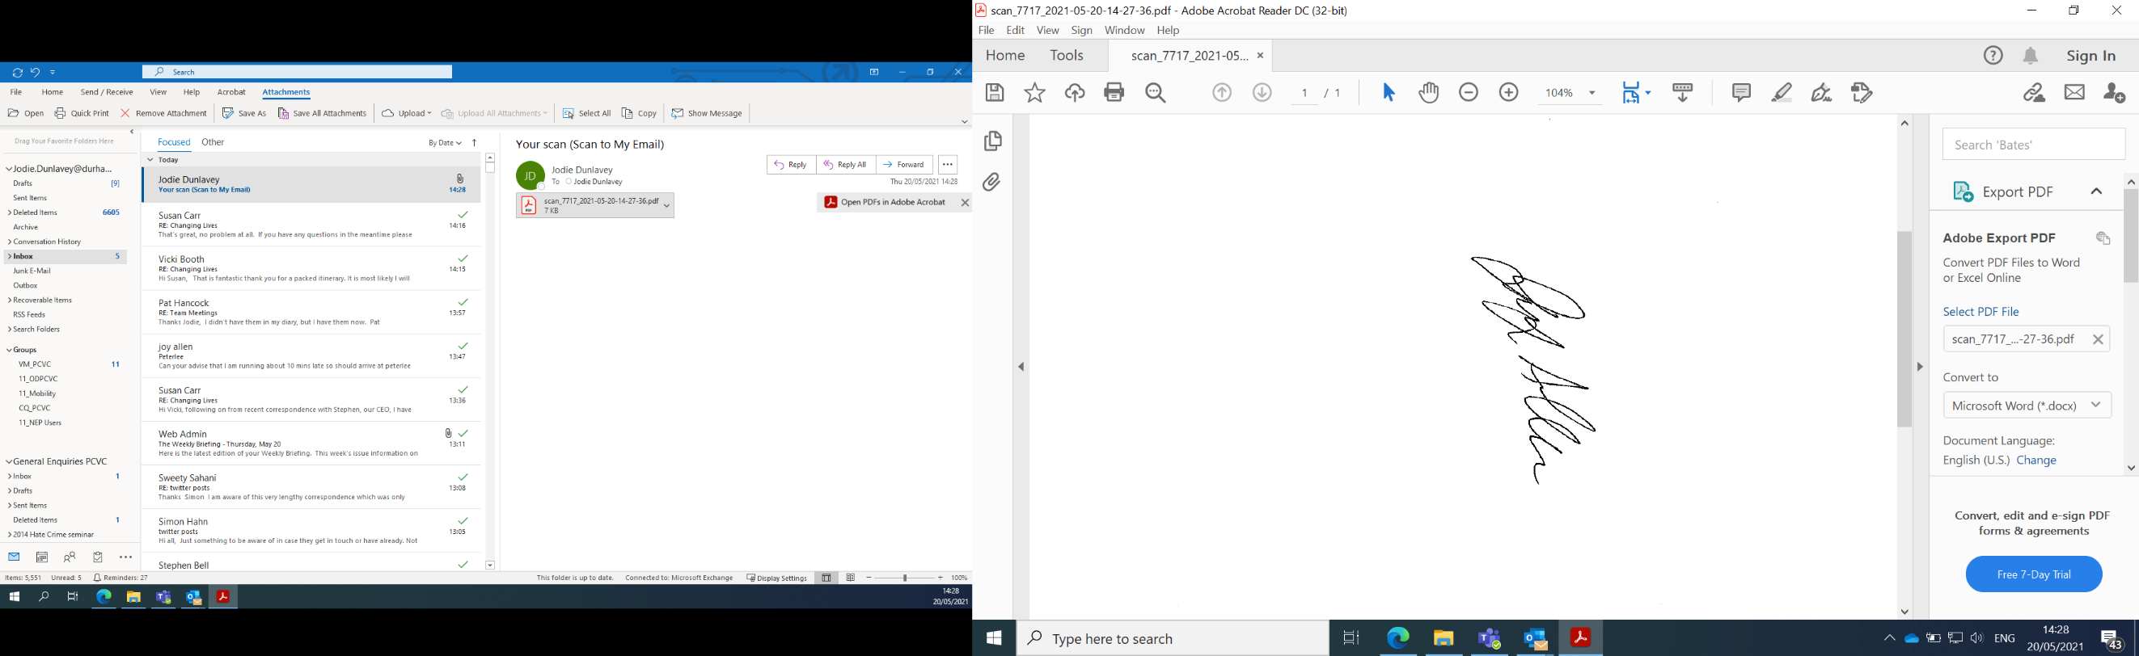
Signed: |  | Date: | 27th March 2023
Police and Crime Commissioner (Durham)

Chief of Staff and Monitoring Officer:
I have been consulted about the decision and confirm that financial, legal, and equalities advice has been considered. I am and satisfied that this is an appropriate request to be submitted to the Police and Crime Commissioner.
Signed: |  | Date: | 27th March 2023
Chief of Staff and Monitoring Officer

OFFICER APPROVAL
Assistant Chief Officer/Joint Chief Finance Officer
I have been consulted about the decision and confirm that financial, legal, and equalities advice has been taken into account. I am satisfied that this is an appropriate request to be submitted to the Police and Crime Commissioner.
Signed:  Date: 27th March 2023
…………………………………………………………………………………………….. …………………………………………………….
Assistant Chief Officer/Joint Chief Finance Officer

