Starting Secondary School
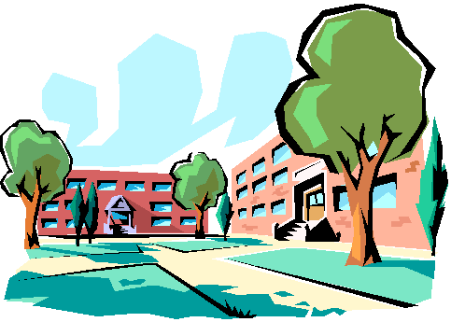
Insert Picture

My name is NAME

I am nearly 11 / 11 years old and in Year 6 at School name.

In September I will be moving to Secondary School.

Moving to Secondary School is something that happens to everyone.

It is a very exciting time.

Going to secondary school is a sign that I am growing up and ready to learn new things.

If I stayed at Junior School I would get bored and very soon I will be so tall I wouldn’t fit on the chairs!!

Choosing a secondary school was tricky.
We looked at lots of different schools and then choose 3 favourites in order. Then a team of people at the council make the decision. Each school has rules for giving places at their school.

The decision made is sometimes based on where you live, religion or if you are good at a particular subject (like music).
Most of the time, it is completely random.

Any school that gets me as a pupil is very lucky as I am kind, hardworking and smart.
The school I am going to is SCHOOL NAME
Insert School Logo

Feeling sad and worried about a new school, and leaving my old school is normal.
There are lots of things I don’t yet know about my new school which is a bit scary.

Everyone going to Secondary School is feeling a similar way. Even adults feel sad and worried when things change.

I have already done lots of preparation for Secondary School by learning how to be independent.

- I walk home from school without Mum. (Example)
- I have a phone and know when to call someone if I am worried.
- I stay home by myself sometimes.
- I shower, get dressed and organise my things for school.

I still need a bit of help sometimes but I am BRILLIANT at being independent ready for Secondary School.
Everyone understands that it is hard moving schools.

The adults at school will help all the year 6 children with getting ready for secondary.

I will have visits to the school and spent time there before September.
I will know which friends are going and might even make new friends.

The things that are important for me to know about my new school are:

- Everyone feels worried, scared and sad about moving to Secondary School
- Mum and Dad(example) are GREAT people to talk to about how I feel.
- There is a lot of help from school and home to learn about Secondary School.
- Practising at being independent will help me at secondary school.

I will be GREAT at my new Secondary School – they are lucky to have me!

