Going to sleep
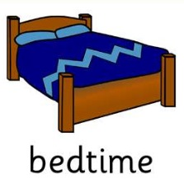

Sleep is really good for me.

It helps me to grow and helps me to learn new things.

It’s good to get as much sleep as possible.

Brains make a sleep hormone, called Melatonin to help us fall sleep.
Sometimes we don’t make enough Melatonin and struggle to fall asleep.

Not having enough sleep makes us feel really tired
Helping my brain to make melatonin is easy – first it needs to know its night time!

So my room needs to be dark and calm, like this:
Insert bedroom pic in dark with night light

Not like my room in the day:
Bedroom in day pic
Bedroom in day pic

Sometimes it’s tricky to know if it is night time, especially in the summer when it is light at bedtime or when you wake up.

The Gro-Clock will help me with this

Stars mean sleep time and the sun appears when it is morning.
Getting ready for bed in the right way helps make melatonin.

Step 1
Downstairs
Screens off and dim lights as my brain cannot make melatonin if it is busy.

Step 2
Downstairs | Pic of child & parent
30 mins relaxing with a calm game, massage or reading. Supper from list on fridge.

Step 3
Bathroom
Bath with lavender for 20mins.
Step 4
Bathroom
Brush teeth calmly.

Step 5
Bathroom
Use toilet

Step 6
Bedroom | 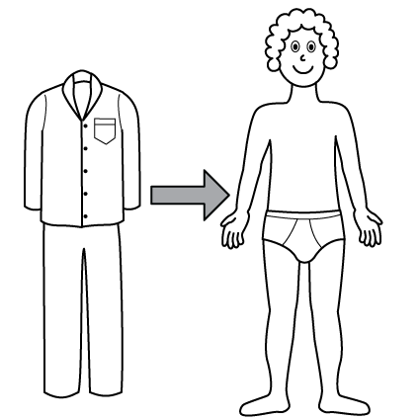
Pyjamas on quietly & calmly.

Step 7
In Bed
Dim lights. Read for 20 mins.

Step 8
In Bed | Pic of child asleep
Give mum book. Start Gro-Clock and lie quietly. Time for sleep.

Top Tips for sleeping:
- No reading at sleep time
- Night light only
- Door ajar, not open.
- Picture of mum by my bed and borrow a top she has worn to keep with me.

Changing things can help them work better than before.

However, it makes everything look different at first and I don’t like this.

It makes me worried and angry.

It’s ok to feel like this.

Top Tips for getting used to my new bedtime:
- Do the new routine every night
- Let mum help me – she is great at massage, cuddles and relaxation.
- Have things around that make my brain feel relaxed:
Pics of comfort items

- Set my bed up in a way that makes me comfortable and has familiar things around:
Pic of bed set up

- Use my weighted blanket:
Pic if relevant

I will be GREAT at making more melatonin and going to sleep!
Pic of child sleeping

And I will be a SUPER-STAR at getting used to things changing!

