Twin Babies
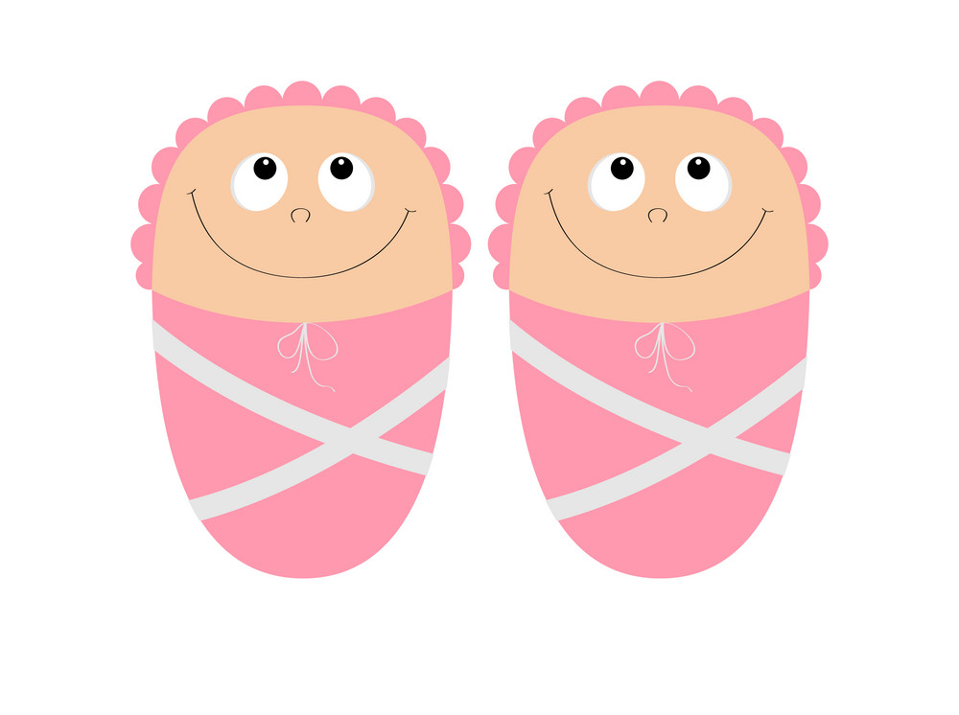

(Picture)

My name is ….. and I am … years old

I live at home with……
(Insert Pictures)

My Mummy is very clever – she is growing TWO babies in her tummy

Having two babies at the same time is called twins
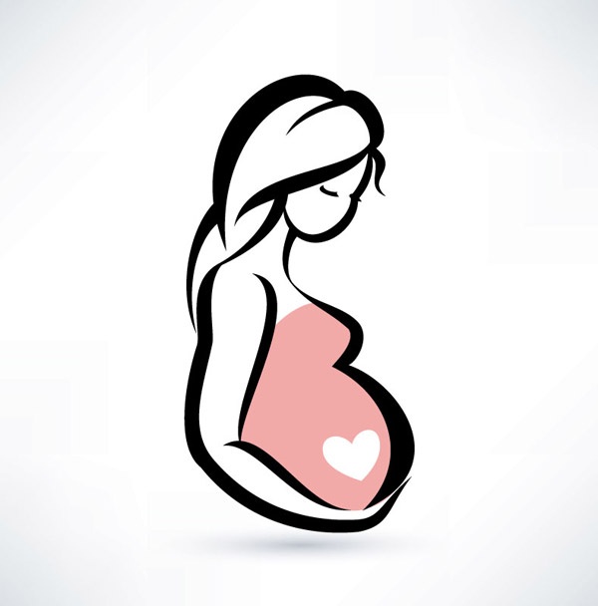
Her tummy has grown very big and sometimes I can see and feel the babies moving!
Growing twins can be very tricky

When ladies have twins they have to go to the hospital to see doctors and midwives.

The doctors and midwives work in a special place called a Maternity Unit - my Mummy stayed there a few weeks ago and I visited!
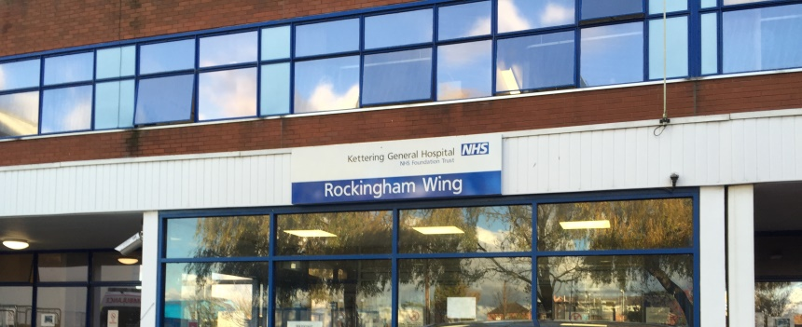

As the babies get bigger in Mummy’s tummy the doctors and midwives will need to see mummy more often.

They will take pictures of the babies and listen to their heart beats
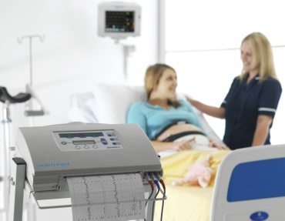
They are just checking that the babies are ok even though the machines make funny noises!
The doctors and midwives might decide to that mummy and the babies need looking after in hospital.

This is ok as …… will look after me and I can visit Mummy.

When I visit I can give mummy lots of hugs and kisses
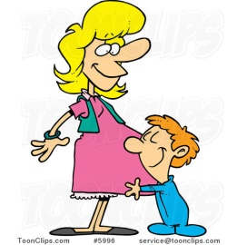
The doctors and midwives might decide that the babies need to be born earlier than planned – this is called being premature.

If this happens Mummy and Daddy will be there whilst the babies are born and I will be with Nanny Pirate and Grandad John.
(Pictures)

If the babies are premature the babies will be very small and will need to be looked after in hospital

They will be in a special place in the Maternity Unit called the Special Care Baby Unit (or SCBU)

Mummy and Daddy will tell me all about it if this happens
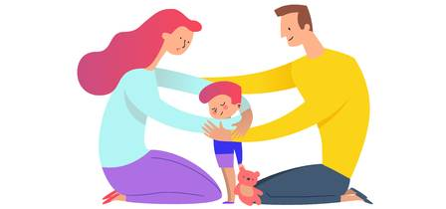
In SCBU the babies are in special beds called incubators
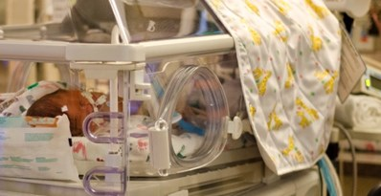
They are very big and scary looking with lots of wires and machines but they are very clever and are helping the babies

When I visit I must wash my hands and I can look but not touch but I can talk to my sisters and sing to them!
The babies will be in SCBU for lots of days and nights before the doctors and nurses let them come home

We won’t know what is happening from day to day

This is ok as Mummy and Daddy will tell me and I know that the doctors and nurses are looking after my sisters
Mummy and Daddy will have to spend a lot of time at the hospital with the babies but will still have time to kiss, hug and tell me stories.

Mummy and Daddy love me very much and that will be the same after the babies are here

