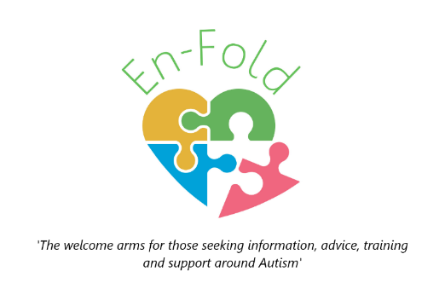
www.enfold.org.uk
diane@enfold.org.uk
07845 905766
Young person’s Autism Advisory Project (YAAP)
YAAP launched in April 2022 and is already making a difference!
It is an exciting opportunity to meet like-minded people, at the same time as have a say on the development of services for young people with Autistic Spectrum Condition.
Some of the projects we get involved with will also offer opportunity to receive gift vouchers as a ‘thank you’ for your input. You will always have a choice over whether to take part, and you can express yourself however you feel comfortable. Some people may be happy to talk to tell us what they think, others may prefer to write or draw for example.

Meet the team:
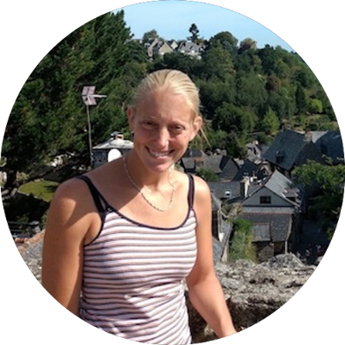 | 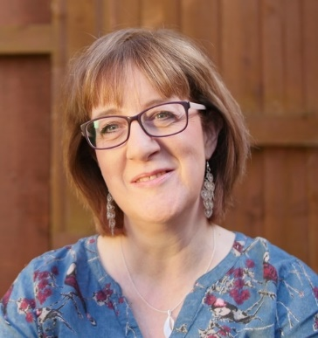
Diane Johnson  (Founder/CEO) | Tracy Vials  (Project worker) | Mike Williams  (Project worker)

As a team we all have Autistic Spectrum Condition and are passionate about ensuring services that are developed involve those with lived experience throughout the development as well as evaluating how good they are. This is sometimes called co-production, participation, or engagement. It basically means that the people who the services are for, are involved in things from the start, as well as saying how good it is.

What are the YAAP meetings like?
The most important thing is that you won’t be forced to do anything you don’t want to do. We listen to what you want and develop the sessions around that. The meetings include time to get to know each other, as well as time to explore an issue facing young people with ASC, or respond to a something we have been asked to give a view on. During the sessions we will have some time split into two age groups: 11 – 17 years olds and then 18 to 25 year olds. We may have some social activities too!
What sort of things might we be able to get involved with?
There will be lots of opportunities to have your voice heard, and the more we get known, the more opportunities will arise. We have already got involved with the Key Worker Project which we will talk about on the first session. Other involvement tasks might include:
- Developing Job descriptions
- Interview panels as part of recruiting staff
- Developing/feeding back on communication materials organisations use
- Reviewing effectiveness of services
- Identifying and feeding back gaps in services
- Research opportunities
Can I bring a carer/support worker?
We recognise that ASC, has a diverse spectrum of needs and we would love to be able to capture the views of all young people wherever they are on the spectrum. We also appreciate how daunting it can be to come to a meeting for the first time on your own. If it would help you to bring a parent/carer/support worker, that is absolutely fine, but the focus will be on your views as young people, not the carer’s views.
How often do we meet?
We meet every two weeks.
We would then sometimes have extra meetings if there was something specific that we had been asked to review. We may also get asked to support with the interviews, for recruiting staff to organisations which would be at different times. You can choose whether to take part or not.
What if I have questions:
Please ask!! We really want everyone to be involved that wants to be… If we need to do something different to make it easier for you, we will, but we need you to let us know.
Diane@enfold.org.uk or 07845 905766

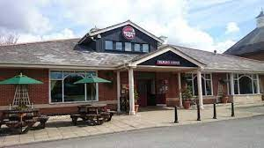
Where we meet…
We are meeting at Telford Lodge, Rothwell Road, Kettering at 5pm – 7pm
We will have a pizza buffet so I need to know if you are able to come and if you have any dietary requirements.
We have a private function room for our group so we won’t be in the noisy area of the restaurant.
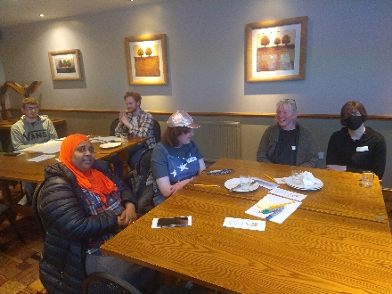
We really look forward to welcoming you.
The sessions will broadly follow the following format:
- Introductions from staff team and overview of the session
- A reminder of the purpose of YAAP
- An introduction-based activity for us to get to know each other
- Update from Diane of progress of projects we are involved with and future opportunities including any visitors.
- FOOD
- Smaller group time to discuss themes and issues and review services. Also, to have a say on the way new services are developed.

