Mindful Connections

Last Minute Rescheduling

- Are you being respectful of colleagues’ time, especially when your actions may affect their personal or rest periods?
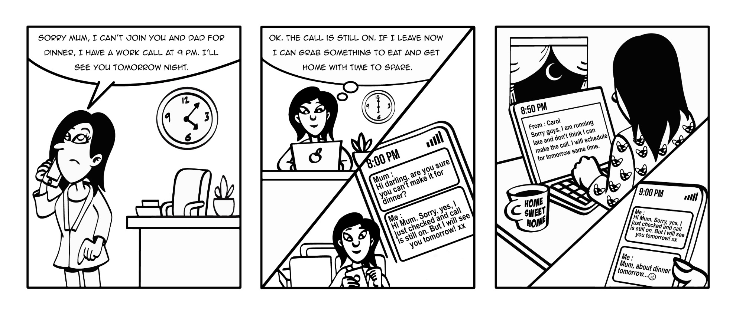
- Cancelling or rescheduling meetings at the last minute is not ideal when it occurs during office hours but can have an exponential affect when it impacts colleagues’ typical rest periods (night or early morning).
- If the cancellation is unavoidable, a short apology with an explanation will help colleagues feel respected.
- Try not to assume that your rescheduled time will work for others, particularly if it is in their rest period. Instead, reach out to them again to reschedule to a time that works for all.

