Mindful Connections

Being Heard

- Are you providing the opportunity for everyone to be heard?

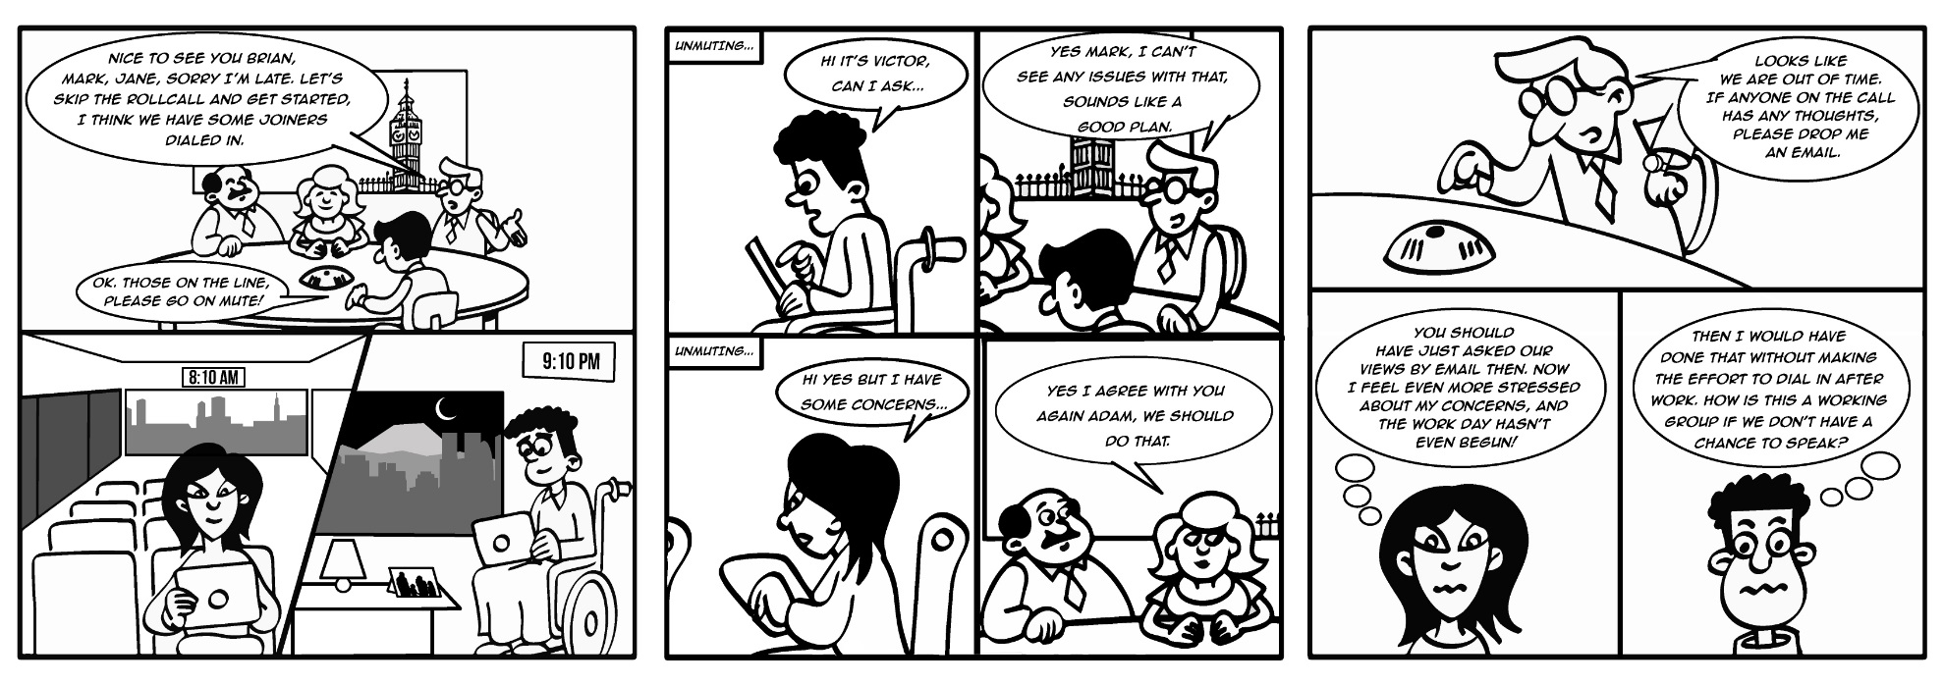
- Consider all participants, particularly if they are not in the room, and give them an opportunity to share their views.

- Take regular pauses for input from all participants.

- Consider whether questions and discussion points can be shared in advance by email.

