This custom-built safari vehicle offers exceptional comfort and visibility paired with the reliability and power of a 4x4. Six of the eight passenger seats have large windows, the roof pops up and we've thrown in air conditioning to sweeten the deal.
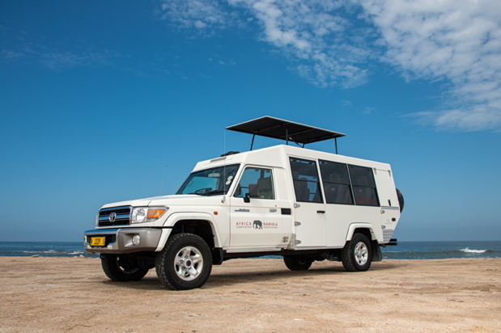 | 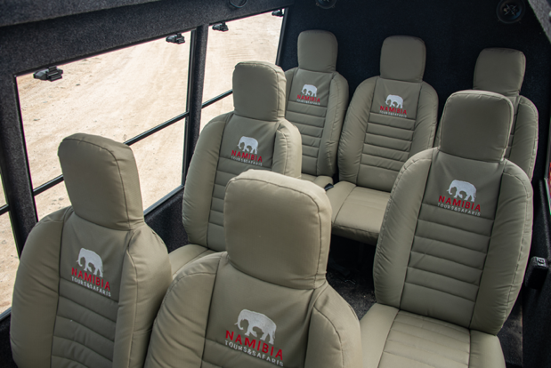

Specifications  - 9 seats (6 window seats)  - Air conditioning  - Pop-up rooftop  - Music player  - ABS brakes  - Extra fuel tank (≈2,000km range)  - 4.5 litre diesel engine  - 4-wheel drive  - Low range  - Diff lock | Included  - Unlimited kilometres  - Cooler box  - GPS vehicle tracker  - Additional driver  - Unlimited km  - 2 spare tyres  - First aid kit  - Breakdown triangles  - Fire extinguisher  - Tyre gauge  - Standard insurance excess  - Collision and Theft Cover  - Tyre and windscreen insurance  - Passenger liability  - Vehicle procedures and information  - Mobile phone  - GPS navigation system  - Day room facilities at our Windhoek depot  - 24/7 Assistance | Extra Options  - Reduced excess  - One-way rental  - Extra spare tyre  - Child and booster seats  - Luggage trailer  - Air compressor  - Jumper cables  - Jerry cans  - Satellite phone  - 12v fridge  - Airport return transfers
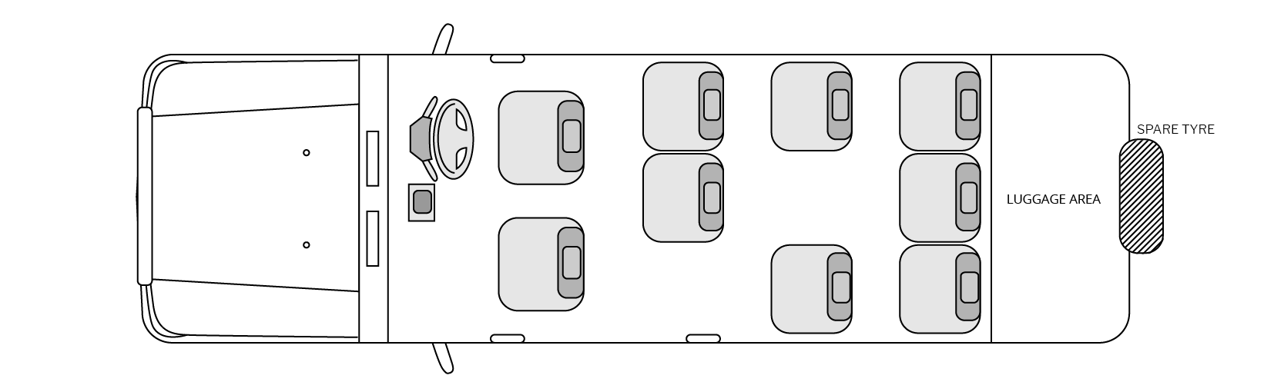
Configuration

Notes
With its extended bulk, this vehicle may only be driven by a qualified driver/guide and is not available for self-drive hire.

