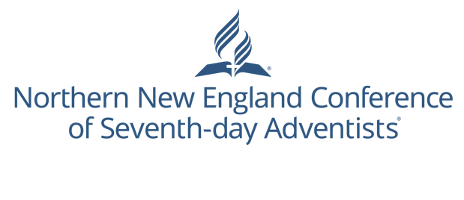

Connect Card

Thanks for visiting with us today!
Please place this card in the offering plate or give it to a greeter.
Name: __________________________________
Address: ________________________________
__________________________________________
City/State/Zip: _________________________
Email: ___________________________________
Phone: (______) ________ - ________________
I’m interested in...
Taking personal Bible studies.
Learning how I can be baptized.
Learning more about what Seventh-day Adventists believe.
Learning more about Adventist Christian Education.
Be contacted on how to grow my church.
Check all that apply...
This is my first time at an Adventist event.
I have a prayer request (use back of card)
Sign me up for NNEC’s informative email called “Church Connect”.

Connect Card

Thanks for visiting with us today!
Please place this card in the offering plate or give it to a greeter.
Name: __________________________________
Address: ________________________________
__________________________________________
City/State/Zip: _________________________
Email: ___________________________________
Phone: (______) ________ - ________________
I’m interested in...
Taking personal Bible studies.
Learning how I can be baptized.
Learning more about what Seventh-day Adventists believe.
Learning more about Adventist Christian Education.
Be contacted on how to grow my church.
Check all that apply...
This is my first time at an Adventist event.
I have a prayer request (use back of card)
Sign me up for NNEC’s informative email called “Church Connect”.

Connect Card

Thanks for visiting with us today!
Please place this card in the offering plate or give it to a greeter.
Name: __________________________________
Address: ________________________________
__________________________________________
City/State/Zip: _________________________
Email: ___________________________________
Phone: (______) ________ - ________________
I’m interested in...
Taking personal Bible studies.
Learning how I can be baptized.
Learning more about what Seventh-day Adventists believe.
Learning more about Adventist Christian Education.
Be contacted on how to grow my church.
Check all that apply...
This is my first time at an Adventist event.
I have a prayer request (use back of card)
Sign me up for NNEC’s informative email called “Church Connect”.
Notes
________________________________________________________________________________________________________________________________________________________________________________________________________________________________________________________________________________________________________________________________________________________________________________________________________________________________________________________________________________________________________________________

Notes
________________________________________________________________________________________________________________________________________________________________________________________________________________________________________________________________________________________________________________________________________________________________________________________________________________________________________________________________________________________________________________________

Notes
________________________________________________________________________________________________________________________________________________________________________________________________________________________________________________________________________________________________________________________________________________________________________________________________________________________________________________________________________________________________________________________

