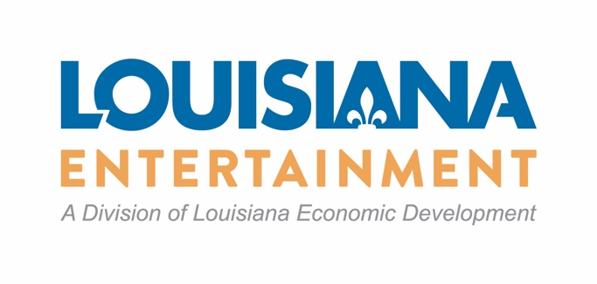
All applicants shall participate in a career based learning and training program approved by the office. To meet this requirement, at the time of application, applicants may choose a method of participation from the list below:
a. provide a minimum of 3 paid internship positions provided to students enrolled in an accredited high school, community college, university or qualified community based program, for a minimum of 75 hours per student and a total of 225 hours; or
b. a minimum of 8 hours of classroom workshop provided to students enrolled in an accredited high school, community college, university or qualified community based program; or
c. a minimum of 8 hours of studio employment and professional skills tour provided to students enrolled in high school, community college, university or qualified community based program; or
d. a minimum of 8 hours of continuing education for educators or faculty to observe the set operations, post production and other specialized departments;
e. financial contribution or donation to a specific local educational agency or higher education institution specializing in arts, media and entertainment career oriented program. Financial contributions calculated at 0.25 percent of the estimated tax credit reservation; or
f. other method of participation approved by the office.

