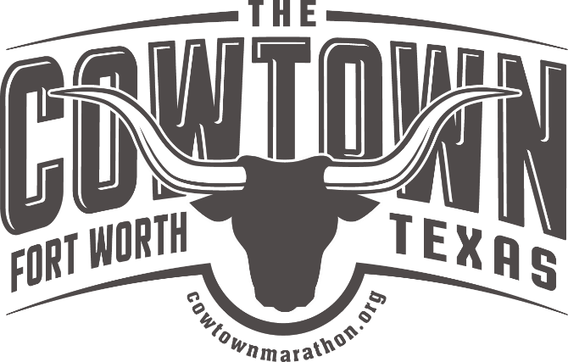
Cowtown Challenge for Commitment Scholarship FAQs

What is the Cowtown Challenge for Commitment?

The Cowtown Challenge for Commitment is a scholarship program for high school students in the Fort Worth Independent School District promoting volunteerism for The Cowtown, as well as participation in The Cowtown races.

What are the requirements?
- Freshman or Sophomore
- Enrolled in a FWISD High School
- Minimum High School GPA of 3.0
- Minimum of 24 volunteer hours per year with Cowtown
- Volunteer on Cowtown Weekend (last weekend in February)
- Participate in and complete one of the following races o Cowtown Kids 5K o Cowtown 10K o
Cowtown Half Marathon o Cowtown CALF 5K in October
- Minimum 3 years of consecutive participation

How do I apply?

To apply for the scholarship, please complete the application available in school counselor offices or at the Cowtown Office.

Please return applications to the Cowtown Office (2617 Whitmore Street, Fort Worth, TX 76107) with the following items
- Completed application with parent signature
- Application Essay
- Letter of reference and contact information from at least one teacher
- Letter of support from a Cowtown Chairman or Cowtown Staff member
- Most recent report card with GPA
- Senior Year Only o Essay o ACT/SAT scores

When are applications due?

For the 2022-2023 school year, applications are due by October 15, 2022.

How do I get volunteer hours?

There are many hours available with Cowtown throughout the year. We are typically open on Saturdays from 9 a.m - 12:00 p.m. in January and February. There are also many hours available the week and weekend of Cowtown. Students can also volunteer at the Cowtown CALF race in October. It is strongly

encouraged that students complete their hours by the end of race weekend. There are fewer volunteer opportunities in the Spring.

If you would like to come in after school, please let a staff member know 48 hours in advance so we can make the necessary arrangements.

When do volunteer hours need to be completed by?

Volunteer hours need to be completed by March 31 of each year. It is strongly encouraged and highly recommended that you try to get hours completed in January and February. We are usually around in the evenings and on weekends during this time. Hours are not guaranteed after Cowtown weekend.

Do I have to participate in a race?

Yes! You must participate in one race every year in-person or virtual.

How much money is available?

Students who enroll as freshmen will be awarded $4,000 with successful completion of all requirements. Students who enroll during the sophomore year will be awarded $3,000 with successful completion of all requirements.

Who do I contact with questions or to get an application?

Please e-mail julie@cowtownmarathon.org for more information, an application, or any questions you may have.

