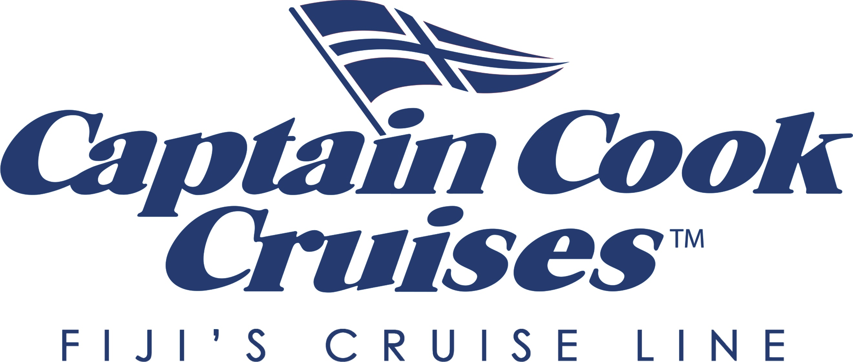
30% off Most Adult Fares* with Captain Cook Cruises Fiji

Captain Cook Cruises Fiji is releasing an incredible deal for expedition small ship cruises exploring the Fiji Islands on four unique itineraries throughout the Mamanucas, Yasawas and Remote North Island groups. The offer is for sale for a limited time only from 1 January 2023 and is a whopping 30% off most adult fares for 3, 4 or 7-night cruises for travel from April 1st 2023. Fares start from A$1162* for a 3-night cruise. Score a free upgrade to Oceanview Staterooms if you travel before the 31st of March 2023*

“Exploring the remote islands of Fiji is a bucket-list experience,” says Allison Haworth, the Company’s CEO, “and we are honored to share its authenticity and beauty with our guests.”

In addition to idyllic adventures that allow guests to absorb the natural beauty of Fiji, Captain Cook Cruises also offers exceptional cultural experiences. Guests are entertained and guided to remote Fijian villages where they will have the opportunity to engage in authentic Fijian culture. This includes visiting remote schools, church visits, watching meke performances, participating in kava ceremonies and enjoying traditional lovo feasts.

Guests are warmly welcomed on board the small expedition cruise ship, MV Reef Endeavour by a friendly Fijian crew. The small expedition ship offers an intimate immersive experience with only 60 rooms, for an attentive and highly personalised experience. Aboard MV Reef Endeavour, guests are able to explore magnificent coral reefs, stunning bays and beaches where larger vessels cannot go. Every morning and afternoon in a new destination there are ample opportunities to snorkel, dive, hike, paddle, learn from the onboard Marine Biologist and even plant coral. Relax with a sunset cocktail on the deck or by the pool is also a highlight along with the delicious cuisine featuring fresh local produce.

Captain Cook Cruises is a leader in sustainable tourism and consistently engages guests in meaningful experiences. As part of their guest lecturer series they have the Chief Scientist from the Australian Museum Prof Kris Helgen joining the 7-night cruise to the Remote Lau Islands. In addition to lectures on the marine ecosystem, Prof Helgen will be in search of one of the planet’s rarest bats which is located in the Lau and has only been sighted once. Dr Penny Berents is joining the 7-night Remote North itinerary on the 22nd of April 2023. Dr Berents is one of Australia's leading Marine Biologists and has spent over 40 years researching all aspects of biodiversity. Guests who join these departures will benefit from a wealth of experience, knowledge and insightful lectures in conjunction with fabulous snorkelling trips and scuba diving expeditions.

Space is limited at this amazing 30% off deal. Book early to secure an experience of a lifetime discovering this fabulous destination.
*Conditions apply

For further information and bookings visit www.captaincookcruisesfiji.com
or Jessica Prasad at jess@captaincookcruisesfiji.com or +61 2 9126 8160

ENDS

Overview of Captain Cook Cruises’ Fiji Itineraries
Captain Cook Cruises Fiji’s 3, 4 and 7-night night itineraries explore the Mamanuca and Yasawa Island groups and departs most Tuesdays and Saturdays. The 7-night Remote North Cruise and the 7 and 11-night Lau & Kadavu Cruise depart on limited and selected dates.

The 3, 4 and 7-night Mamanuca and Yasawa Islands Cruise discovers the beauty of the westerly Fiji Island groups and cruises through some spectacular passages from Malolo lai lai to the Yasawa’s northern reaches. The cruise visits the islands of Waya, Naviti, Sacred Islands, the private island of Tivua, the Sawa-l-Lau limestone caves and lagoon and Monoriki– the island where Tom Hank’s movie Cast Away was filmed.

Captain Cook Cruises' 7-night Remote North Cruise reveals the unique history, art and culture of the Northern Fiji Islands and gives passengers the ultimate experience of ‘standing’ on the 180th Meridian, the natural dateline. The cruise also visits the recent UNESCO, Heritage listed old capital of Levuka, Tavoro Falls and Naselesele Village on Taveuni, Savusavu for a unique hot spring and Pearl farm experience and the historic island of Makogai, a past leper colony and now giant clam farm and turtle sanctuary.

Departure dates for the 7-night Remote North Cruise include 18th February, 22nd April, 26th August, 23rd December 2023 and 17th February 2024.

Explore the idyllic Lau and Kadavu Island groups, an area of Fiji rarely seen by tourists for 7 or 11 nights. Highlights include visiting a freshwater swimming pool on Taveuni, exploring the ruins of an old light house and snorkelling untouched reefs at Wailagilala, a village church service at Oneata and visiting Qilaqila known for its pristine aqua waters, reefs, amazing caves and mushroom-shaped islands. See extinct volcano craters on Fulaga or Totoya Island and experience a traditional Meke, Sevusevu and lovo feast with the people of Naikeleyaga Village.

Departure dates for the 11-night Lau & Kadavu Cruise include 21st March, 24th October 2023 and 19th March 2024. 7-night departure dates include 14th January, 20th May, 9th September, 18th November 2023 and 20th January 2024.

All cruises offer water and beach-based adventures with daily swimming, kayaking, paddle boarding, snorkelling and glass-bottom boat tours over amazing coral reefs. The ship is equipped with a hydraulic platform ensuring boarding and disembarking the glass bottom boat is easy. Our Marine Biologist provides expert knowledge with guided snorkelling, glass bottom boat tours and lectures to help educate passengers on how to best protect and preserve Fijis' natural environment.

Try an extraordinary scuba diving expedition operated by Viti Water Sports, a PADI5 Star Dive Centre Dive with two dives offered daily. Each dive is always at a different location and offers a unique experience with Fiji’s marine life.

In between these thrilling adventures, unwind and be pampered onboard. Guests can enjoy spa treatments, relax on the sun deck by the jacuzzi or freshwater pool and enjoy a bar menu curated with local artisan spirits while watching the breathtaking scenery of the Pacific Ocean pass by. Fuel up with mouthwatering cuisine including buffet breakfasts, alfresco lunches, casual barbecues and a-la-carte dinners.

Minimum age for children is 5 years and complimentary Kids Club is available for children 5 -9 years.

