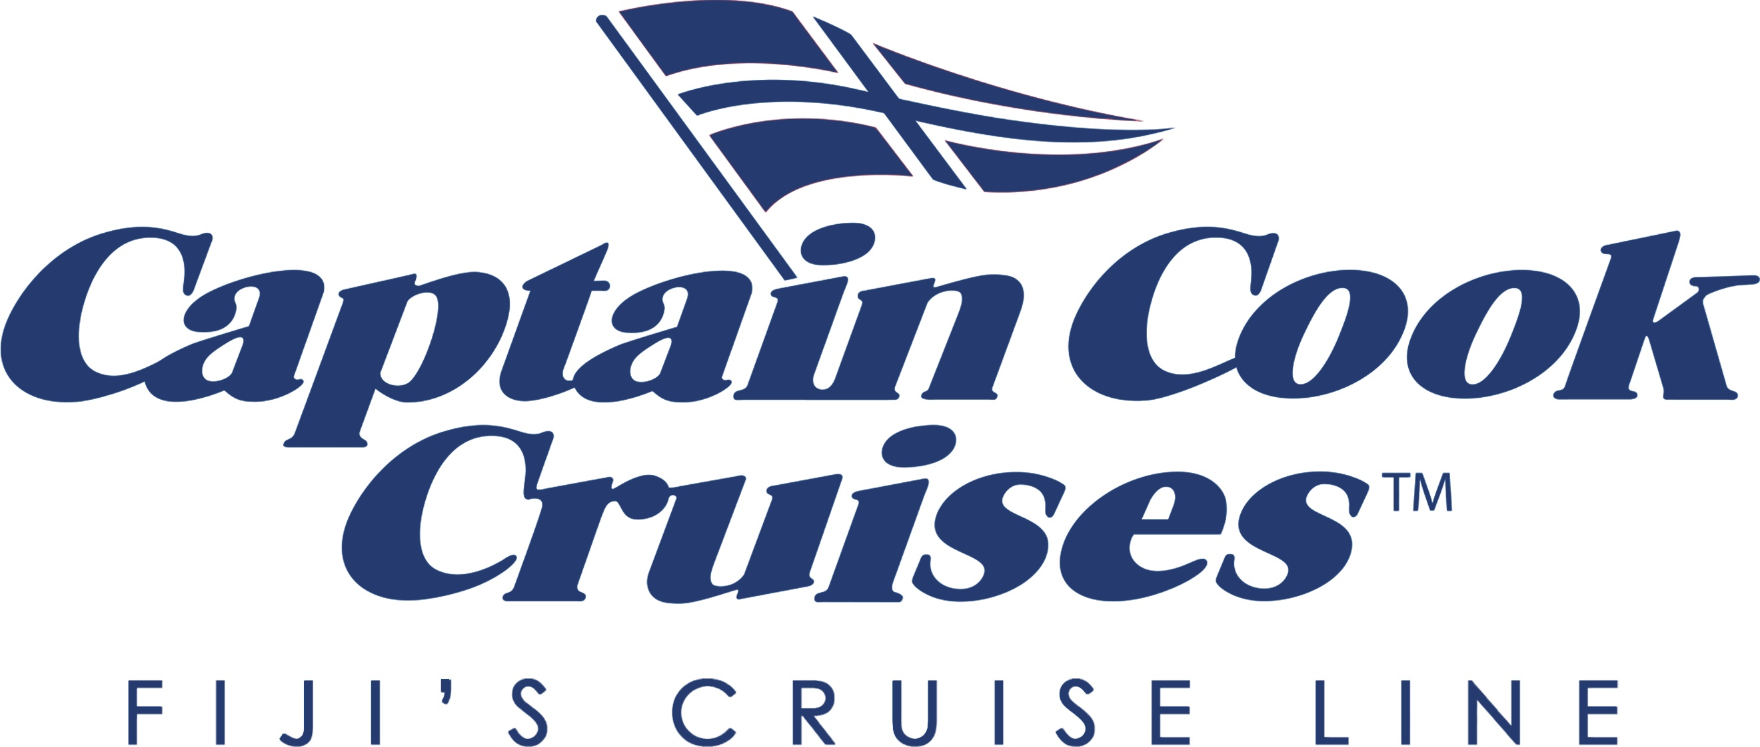

MEDIA RELEASE
July 10, 2023

Captain Cook Cruises Fiji Reveals Private Tivua Island Experience

Captain Cook Cruises Fiji has announced a new half-day exclusive experience, Tivua Private Paradise.

Located in the Mamanuca Group of islands, Tivua Island is a beautiful coral cay fringed by fine white sand and surrounded by turquoise waters and more than 200 hectares of pristine coral reef. Tivua Island is privately owned by Captain Cook Cruises Fiji, guaranteeing exclusive access to its guests.

Captain Cook Cruises’ Tivua Private Paradise Deluxe Half Day package includes 30-minute return transfer to the island from Denarau Marina, Nadi, light brunch and refreshments including a half-bottle of French Champagne. It’s designed as the ultimate deserted island luxury half day experience.

Guests relax in their own private cabana and can join a raft of marine biologist-led activities including a glass bottom boat tour, snorkelling, scuba diving and kayaking to explore the picture-perfect island.

Captain Cook Cruises Fiji Executive Chair Allison Haworth West said the new deluxe island experience set a new standard in premium Fiji excursions.

“We meet our guests with a refreshing cold towel and a glass of bubbles at Port Denarau Marina before they enjoy a 30-minute-high speed transfer out to our gorgeous white sandy island, setting the tone for an unforgettably indulgent morning ahead,” Ms Haworth West said.

The Tivua Private Paradise experience can also be neatly scheduled in on the morning of departure day of Captain Cook Cruises’ multiday small ship cruise itineraries, making a fabulous start to a Fiji marine-based holiday.

Exclusive use island buyouts are also available for a maximum of 30 people, perfect for groups, private events, wedding, special celebration or corporate retreat. Specially tailored sunset experiences on the island are also available on a sole-use basis on request.

Rates on the Tivua Private Paradise package start at AU$299* per person, subject to availability.
For further information and bookings, please contact Captain Cook Cruises Fiji on +61 9126 8160 or from within Australia: 1300 To Fiji (86 3454), email fiji@captaincookcruisesfiji.com or visit www.captaincookcruisesfiji.com

EDITORS NOTES: Since its foundation in 1970, Captain Cook Cruises has been a pioneer in maritime excursions, experiences, dining and small ship cruises. Today, the company’s cruises range from day sails to Tivua Private Island, half-day island experiences, dinner cruises and multi-day small ship expedition cruises. Exploring remote Fiji and visiting more than 90 of Fiji’s 333 islands, all cruises offer marine- and beach-based adventures with swimming, kayaking, paddle boarding, snorkelling, diving and glass bottom boat tours over pristine coral reefs. With a firm commitment to marine science and sustainability, the company’s onboard marine biologists provide expert knowledge through guided activities and lectures to help educate passengers on how to best protect and preserve Fiji’s natural environment. In November 2023 the MV Reef Endeavour will be replaced by MS Caledonian Sky to see the dawn of a new era in luxury small ship expedition cruising in Fiji.
Media Enquiries
Sarah Shields
+61 425 318 966
Click To View High Resolution Images

