Lausanne, XX XX XXXX

SUSTAINABLE PROCUREMENT POLICY

Aware of the environmental impact of its purchases, [the company] has decided to implement a responsible purchasing policy which aims to [to be adapted - e.g. favour local, environmentally friendly and ethical products and services].

WHY A RESPONSIBLE PURCHASING POLICY?

Our responsible purchasing policy aims to:
- Promote the selection of environmentally and ethically responsible suppliers and products,
- Raise awareness of responsible purchasing practices among all [company] employees,
- Align the purchasing practices of the various employees within the [company] team.

OUR COMMITMENTS & GUIDELINES

The guidelines apply, as far as possible, to all purchases made by [company], with a particular focus on purchases of those products most relevant to [company], namely [to be adapted]:
- Digital equipment,
- Office supplies,
- Food supplies,
- Cleaning products,

[The company] uses the guide to responsible business purchasing as a basis for its purchases. https://achats-responsables.ch/. This guide sets out the criteria to be taken into account when assessing the CSR level of a supplier, as well as the criteria to be taken into account when purchasing different products.

Our guidelines are as follows: [to be adapted]
- Favour renewable or recycled materials
- Favour local products
- Favour local suppliers and/or those committed to sustainable development by checking ethical, social and environmental aspects as far as possible
- Favour products and services with sustainability labels to ensure responsible purchasing (non-exhaustive list below)
- Extend the life of our facilities, infrastructure, etc.
- Consume in a way that reduces waste or can be recycled

QUALITY LABELS AND CERTIFICATIONS
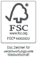
FSC (Forest Stewardship Council) certified wood and paper products are managed and produced according to procedures that ensure sustainable forest management. Look out for FSC certified products.
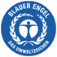
The Blue Angel (Der Blaue Engel) is the world's oldest environmental label for particularly environmentally friendly products and services. This label takes into account the entire life cycle of the appliance - production, use and disposal. In the paper sector, for example, only paper made from 100% waste paper can be awarded this label.

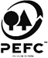
PEFC (Programme for the Endorsement of Forest Certification Schemes): The Programme for the Endorsement of Forest Certification Schemes label guarantees that wood and paper products come from sustainably managed forests.

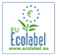
The European Ecolabel is awarded to consumer goods that are distinguished by their high environmental compatibility and low health impact.

The Recycling logo is an international symbol for recyclable goods. The arrows symbolise collection, recycling/processing into a new product and finally purchase by the consumer.
myclimate is a foundation that promotes climate protection through the three principles of Avoid, Reduce and Offset. Companies with the myclimate label adhere to the objective of offering a more environmentally friendly approach.
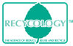

Products with the Recycology label are made from more than 50% recycled material by weight (excluding ink, refill, leads, eraser and tape).

Cradle to Cradle® is a circular economy concept. The production process, use and recycling of products are designed according to the model of maintaining the quality of raw materials over several life cycles. This means that the concept of waste disappears: nothing is lost, everything is transformed.

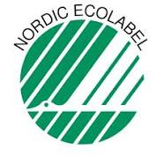
Nordic Ecolabel
These labels take into account the entire life cycle of the appliance - production, use and disposal - including packaging.

TCO certified label
This certification is based on criteria that include responsible production conditions, respect for the health of the user and reduction of environmental impacts related to the production and use of the product. There is also a TCO Certified Edge certification for certain products (TCO Certified Edge Displays, TCO Certified Edge Notebooks, TCO Certified Edge All-in-One PCs and TCO Certified Edge Headsets) which goes further than the normal TCO certification, by requiring the certified product to also meet at least one of the criteria of the excellence list. A new version of the TCO certified labels is due to be released in November 2015.

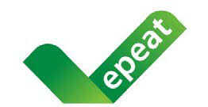
EPEAT declaration
EPEAT declarations are based on different environmental criteria for the whole life cycle of the appliances. They are aligned with Energy Star for power consumption during the use phase. They contain mandatory and optional criteria.

Several levels of certification can be achieved depending on the number of optional criteria met: 0% for bronze level, 50% for silver level and 75% for gold level.
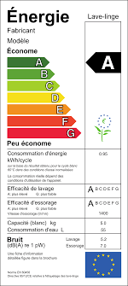

Energy label
This index focuses on energy consumption during the use phase. The threshold values are adjusted annually.

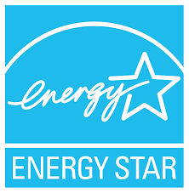
Energy-Star label: this label applies only to energy and its "threshold values" are taken over by other labels such as TCO certified and EPEAT.

European Union (EU) eco-label: This label is not very common on appliances sold in Switzerland.

