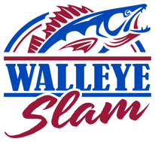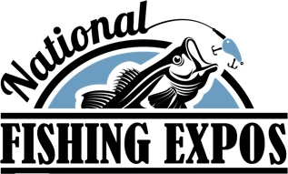
Fall Walleye Slam Begins: Saturday, October 15th, 2022 @ 12:01 a.m.
Fall Walleye Slam Ends: Sunday, November 27^{th,} 2022, at 11:00 AM.
Awards VIP Party: NFE-Columbus, Saturday, Feb. 11th 4-6 PM
REGISTRATION: Please PRINT LEGIBLY
Participant: ___________________________________________________________________
Address: _____________________________________ City: ____________________________
State____________ Zip Code: ______________ Contact number: _______________________
Email address: _________________________________________________________________
By my signature below, I hereby agree to this waiver and release and forever hold harmless all organizers, promoters, sponsors, event directors, agents, agencies and organizations participating in organizing this event. Furthermore, I agree to waive all responsibility for death, injuries, damages, liability, theft, fire, or loss of any kind to entrants. I give permission to use any photo or video I may be included in as needed by the tournament director. Participants are subject to polygraph examination at committee’s discretion. At the Committee’s discretion, participants must successfully take a polygraph examination given by an examiner designated by the committee. I further agree to be bound by the results of any such polygraph examination, including tournament disqualification in the event of polygraph examiners detection of any deception. All participants under the age of 18 (minor) will require a legal guardian's signature. Guardian will assume all liability of the waiver for the minor.

Adult or Legal Gardian________________________________________Date______________
Minor Signature _________________________________________Date______________
RETURN FORM TO ERIE OUTFITTERS WITH CHECK NO LATER THAN Wednesday, October 12th, 2022. Mail in entries must be postmarked by Wednesday, October 12th, 2022. Online Entries open until 11:59 PM, Friday Oct 14th
Mail to: Erie Outfitters, 5404 East Lake Rd. Sheffield Lake, OH 44054
Make checks payable to: WALLEYE SLAM LLP
Online entry deadline is Wednesday, October 12th @11:59pm
Entry Fee: $35.00

