Document Title: SciAps TranslationTable_X-5 Specifications for Precious Metals
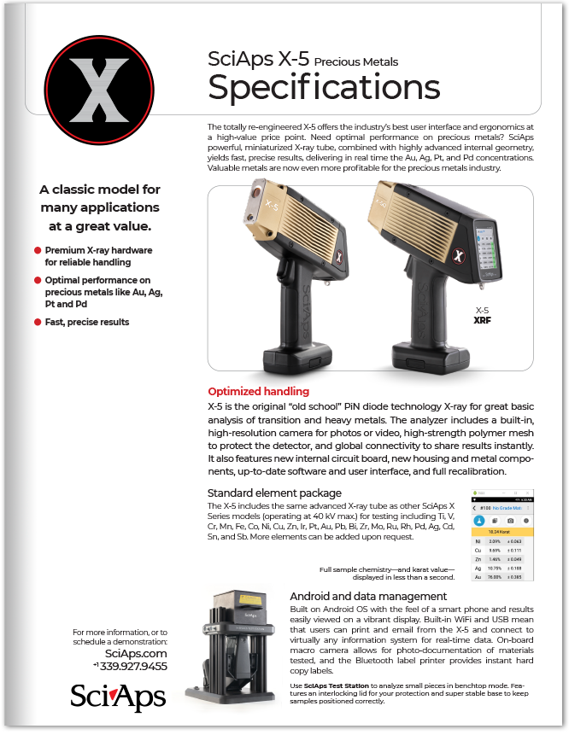
Rev Date: OCT22

Layout Preview | English Text | Translated Text
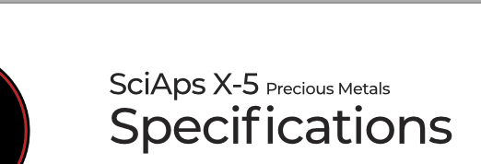 | SciAps X-5
 | Precious Metals
 | Specifications
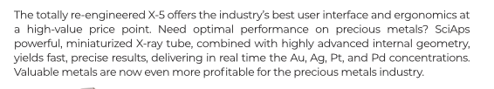 | The totally re-engineered X-5 offers the industry’s best user interface and ergonomics at a high-value price point. Need optimal performance on precious metals? SciAps powerful, miniaturized X-ray tube, combined with highly advanced internal geometry, yields fast, precise results, delivering in real time the Au, Ag, Pt, and Pd concentrations. Valuable metals are now even more profitable for the precious metals industry.
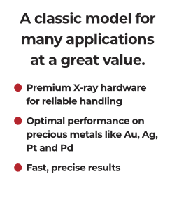 | A classic model for many applications at a great value.
 | Premium X-ray hardware for reliable handling
 | Optimal performance on precious metals like Au, Ag, Pt and Pd
 | Fast, precise results
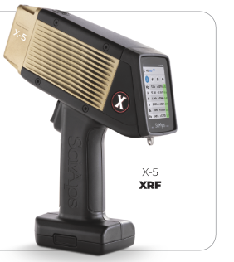 | X-5
 | XRF
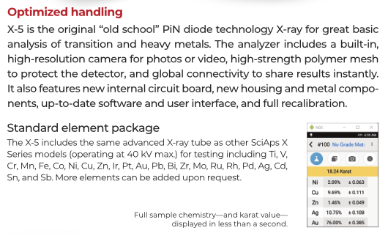 | Optimized handling
 | X-5 is the original “old school” PiN diode technology X-ray for great basic analysis of transition and heavy metals. The analyzer includes a built-in, high-resolution camera for photos or video, high-strength polymer mesh to protect the detector, and global connectivity to share results instantly. It also features new internal circuit board, new housing and metal components, up-to-date software and user interface, and full recalibration.
 | Standard element package
 | The X-5 includes the same advanced X-ray tube as other SciAps X Series models (operating at 40 kV max.) for testing including Ti, V, Cr, Mn, Fe, Co, Ni, Cu, Zn, Ir, Pt, Au, Pb, Bi, Zr, Mo, Ru, Rh, Pd, Ag, Cd, Sn, and Sb. More elements can be added upon request.
Full sample chemistry—and karat value—
displayed in less than a second.
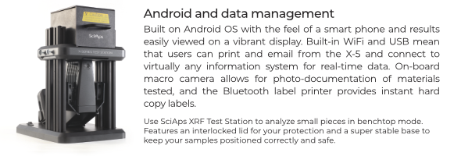 | Android and data management
 | Built on Android OS with the feel of a smart phone and results easily viewed on a vibrant display. Built-in WiFi and USB mean that users can print and email from the X-5 and connect to virtually any information system for real-time data. On-board macro camera allows for photo-documentation of materials tested, and the Bluetooth label printer provides instant hard copy labels.
 | Use
 | SciAps XRF Test Station
 | to analyze small pieces in benchtop mode. Features an interlocking lid for your protection and super stable base to keep samples positioned correctly.
 | For more information, or to schedule a demonstration:
If applicable, please add:
LOCAL COMPANY NAME
LOCAL WEBSITE
LOCAL PHONE

(BACK)
 | SciAps X-5
 | Precious Metals
 | Specifications
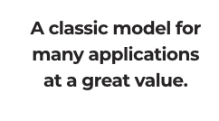 | A classic model for many applications at a great value.
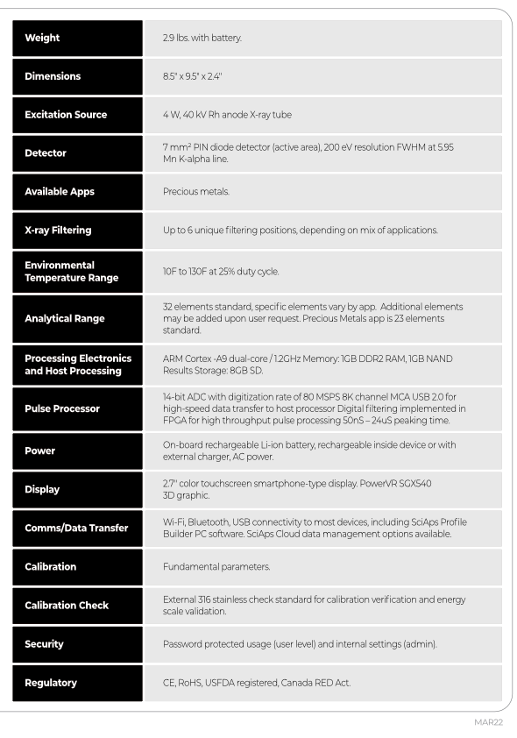 | Weight
 | 2.9 lbs. with battery.
 | Dimensions
 | 8.5" x 9.5" x 2.4"
 | Excitation Source
 | 4 W, 40 kV Rh anode X-ray tube
 | Detector
 | 7 mm2 PIN diode detector (active area), 200 eV resolution FWHM at 5.95 Mn K-alpha line.
 | Available Apps
 | Precious Metals.
 | X-ray Filtering
 | Up to 6 unique filtering positions, depending on mix of applications.
Environmental
Temperature Range
 | 10F to 130F at 25% duty cycle.
 | Analytical Range
 | 32 elements standard, specific elements vary by app. Additional elements may be added upon user request. Precious Metals app is 23 elements standard.
Processing Electronics
and Host Processing
 | ARM Cortex -A9 dual-core / 1.2GHz Memory: 1GB DDR2 RAM, 1GB NAND Results Storage: 8GB SD.
 | Pulse Processor
 | 14-bit ADC with digitization rate of 80 MSPS 8K channel MCA USB 2.0 for high-speed data transfer to host processor Digital filtering implemented in FPGA for high throughput pulse processing 50nS – 24uS peaking time.
 | Power
 | On-board rechargeable Li-ion battery, rechargeable inside device or with external charger, AC power.
 | Display
 | 2.7″ color touchscreen smartphone-type display. PowerVR SGX540 3D graphic.
 | Comms/Data Transfer
 | Wi-Fi, Bluetooth, USB connectivity to most devices, including SciAps Profile Builder PC software. SciAps Cloud data management options available.
 | Calibration
 | Fundamental parameters.
 | Calibration Check
 | External 316 stainless check standard for calibration verification and energy scale validation.
 | Security
 | Password protected usage (user level) and internal settings (admin).
 | Regulatory
 | CE, RoHS, USFDA registered, Canada RED Act.
 | OCT22
 | YouTube.com/SciAps
If applicable, please add:
LOCAL COMPANY NAME
LOCAL WEBSITE
LOCAL PHONE

