Document Title: SciAps TranslationTable_X-5 Specifications Alloy
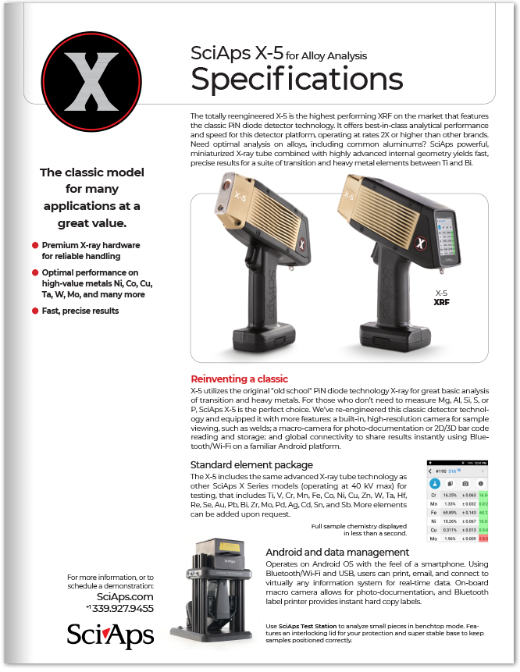
Rev Date:1022

Layout Preview | English Text | Translated Text
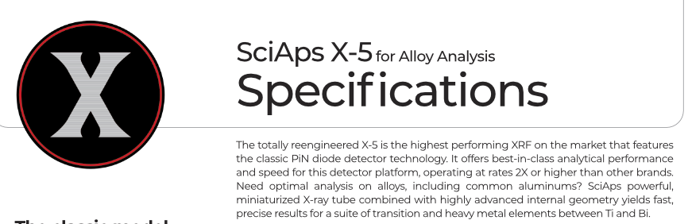 | SciAps X-5
 | for Alloy Analysis
 | Specifications
 | The totally reengineered X-5 is the highest performing XRF on the market that features the classic PiN diode detector technology. It offers best-in-class analytical performance and speed for this detector platform, operating at rates 2X or higher than other brands. Need optimal analysis on alloys, including common aluminums? SciAps powerful, miniaturized X-ray tube combined with highly advanced internal geometry yields fast, precise results for a suite of transition and heavy metal elements between Ti and Bi.
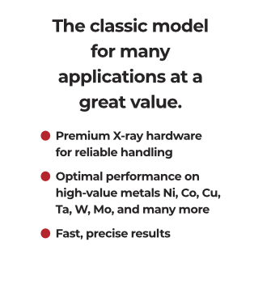 | The classic model for many applications at a great value.
- Premium X-ray hardware
for reliable handling
- Optimal performance on high-value metals Ni, Co, Cu, Ta, W, Mo, and many more
- Fast, precise results
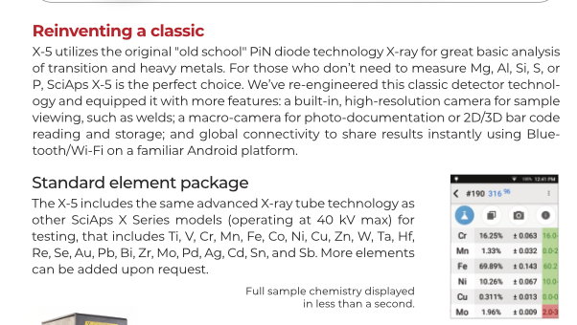 | Reinventing a classic
 | X-5 utilizes the original "old school" PiN diode technology X-ray for great basic analysis of transition and heavy metals. For those who don’t need to measure Mg, Al, Si, S, or P, SciAps X-5 is the perfect choice. We’ve re-engineered this classic detector technology and equipped it with more features: a built-in, high-resolution camera for sample viewing, such as welds; a macro-camera for photo-documentation or 2D/3D bar code reading and storage; and global connectivity to share results instantly using Bluetooth/Wi-Fi on a familiar Android platform.
 | Standard element package
 | The X-5 includes the same advanced X-ray tube technology as other SciAps X Series models (operating at 40 kV max) for testing, that includes Ti, V, Cr, Mn, Fe, Co, Ni, Cu, Zn, W, Ta, Hf, Re, Se, Au, Pb, Bi, Zr, Mo, Pd, Ag, Cd, Sn, and Sb. More elements can be added upon request.
 | Full sample chemistry displayed in less than a second.
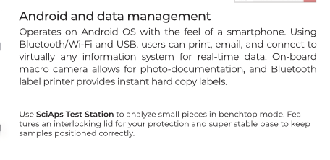 | Android and data management
 | Operates on Android OS with the feel of a smartphone. Using Bluetooth/Wi-Fi and USB, users can print, email, and connect to virtually any information system for real-time data. On-board macro camera allows for photo-documentation, and Bluetooth label printer provides instant hard copy labels.
 | Use
 | SciAps Test Station
 | to analyze small pieces in benchtop mode. Features an interlocking lid for your protection and super stable base to keep samples positioned correctly.
 | For more information, or to schedule a demonstration:
If applicable, please add:
LOCAL COMPANY NAME
LOCAL WEBSITE
LOCAL PHONE
(Page 2)
 | SciAps X-5
 | for Alloy Analysis
 | Specifications
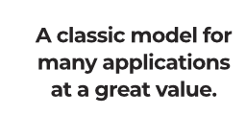 | A classic model for many applications at a great value.
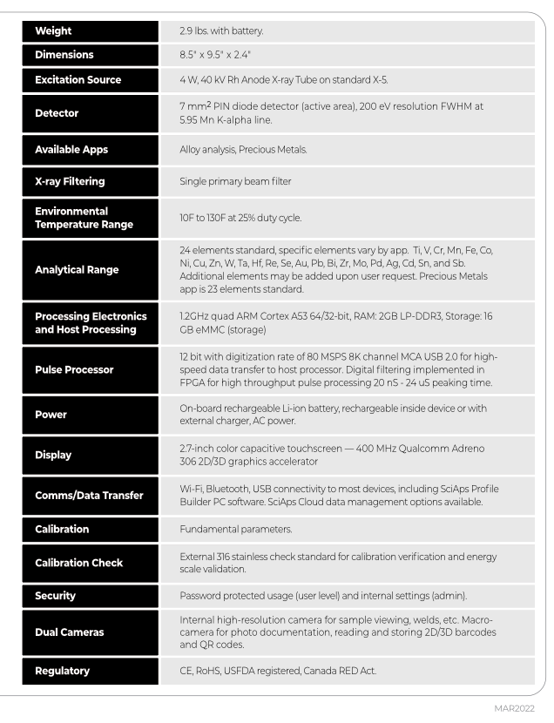 | Weight
 | 2.9 lbs. with battery.
 | Dimensions
 | 8.5" x 9.5" x 2.4"
 | Excitation Source
 | 4 W, 40 kV Rh Anode X-ray Tube on standard X-5.
 | Detector
 | 7 mm2 PIN diode detector (active area), 200 eV resolution FWHM at 5.95 Mn K-alpha line.
 | Available Apps
 | Alloy analysis, Precious Metals.
 | X-ray Filtering
 | Single primary beam filter
Environmental
Temperature Range
 | 10F to 130F at 25% duty cycle.
 | Analytical Range
 | 24 elements standard, specific elements vary by app. Ti, V, Cr, Mn, Fe, Co, Ni, Cu, Zn, W, Ta, Hf, Re, Se, Au, Pb, Bi, Zr, Mo, Pd, Ag, Cd, Sn, and Sb. Additional elements may be added upon user request. Precious Metals app is 23 elements standard.
Processing Electronics
and Host Processing
 | 1.2GHz quad ARM Cortex A53 64/32-bit, RAM: 2GB LP-DDR3, Storage: 16 GB eMMC (storage)
 | Pulse Processor
 | 12 bit with digitization rate of 80 MSPS 8K channel MCA USB 2.0 for high-speed data transfer to host processor. Digital filtering implemented in FPGA for high throughput pulse processing 20 nS - 24 uS peaking time.
 | Power
 | On-board rechargeable Li-ion battery, rechargeable inside device or with external charger, AC power.
 | Display
 | 2.7-inch color capacitive touchscreen — 400 MHz Qualcomm Adreno 306 2D/3D graphics accelerator
 | Comms/Data Transfer
 | Wi-Fi, Bluetooth, USB connectivity to most devices, including SciAps Profile Builder PC software. SciAps Cloud data management options available.
 | Calibration
 | Fundamental parameters.
 | Calibration Check
 | External 316 stainless check standard for calibration verification and energy scale validation.
 | Security
 | Password protected usage (user level) and internal settings (admin).
 | Dual Cameras
 | Internal high-resolution camera for sample viewing, welds, etc. Macro-camera for photo documentation, reading and storing 2D/3D barcodes and QR codes.
 | Regulatory
 | CE, RoHS, USFDA registered, Canada RED Act.
 | OCT2022
 | YouTube.com/SciAps
If applicable, please add:
LOCAL COMPANY NAME
LOCAL WEBSITE
LOCAL PHONE

