Document Title: SciAps TranslationTable_Z-903 Specifications
Rev Date: 1121
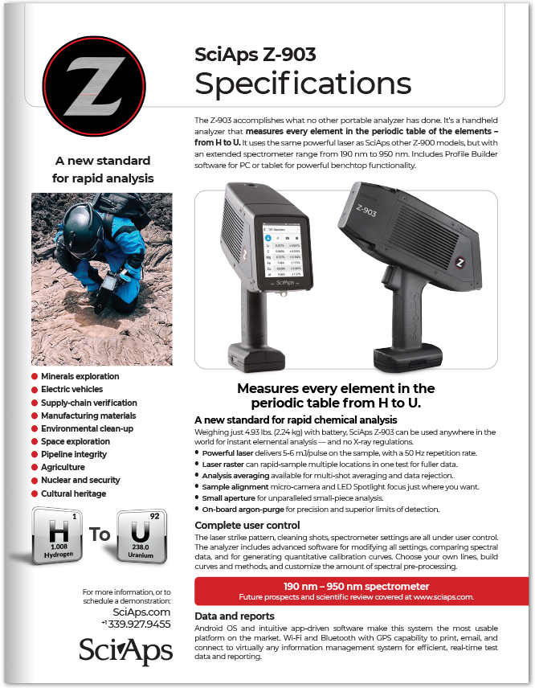
Layout Preview | English Text | Translated Text
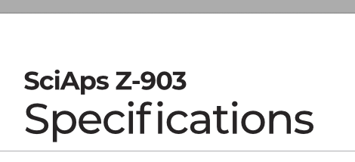 | SciAps Z-903
 | Specifications
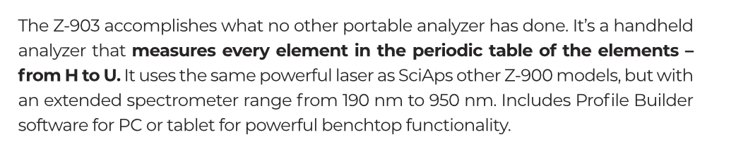 | The Z-903 accomplishes what no other portable analyzer has done. It’s a handheld analyzer that
 | measures every element in the periodic table of the elements – from H to U.
 | It uses the same powerful laser as SciAps other Z-900 models, but with an extended spectrometer range from 190 nm to 950 nm. Includes Profile Builder software for PC or tablet for powerful benchtop functionality.
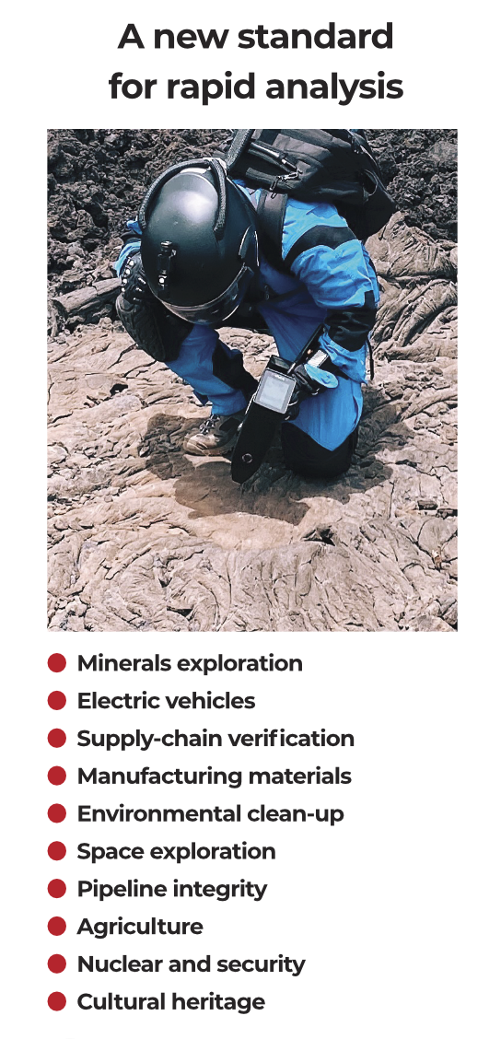 | A new standard for rapid analysis
•Mineral exploration
• Electric vehicles
• Supply-chain verification
• Manufacturing materials
• Environmental clean-up
• Space exploration
• Pipeline integrity
• Agriculture
• Nuclear and security
• Cultural heritage
 | Measures every element in the periodic table from H to U.
 | A new standard for rapid chemical analysis
 | Weighing just 4.93 lbs. (2.24 kg) with battery, SciAps Z-903 can be used anywhere in the world for instant elemental analysis — and no X-ray regulations.
 | • Powerful laser
 | delivers 5-6 mJ/pulse on the sample, with a 50 Hz repetition rate.
 | •Laser raster
 | can rapid-sample multiple locations in one test for fuller data.
 | •Analysis averaging
 | available for multi-shot averaging and data rejection.
 | •Sample alignment
 | micro-camera and LED Spotlight focus just where you want.
 | •Small aperture
 | for unparalleled small-piece analysis.
 | •On-board argon-purge
 | for precision and superior limits of detection.
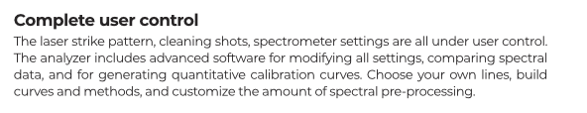 | Complete user control
 | The laser strike pattern, cleaning shots, spectrometer settings are all under user control. The analyzer includes advanced software for modifying all settings, comparing spectral data, and for generating quantitative calibration curves. Choose your own lines, build curves and methods, and customize the amount of spectral pre-processing.
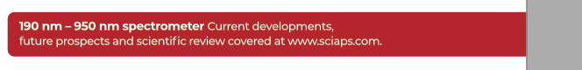 | 190 nm – 950 nm spectrometer
 | Future prospects and scientific review covered at www.sciaps.com.
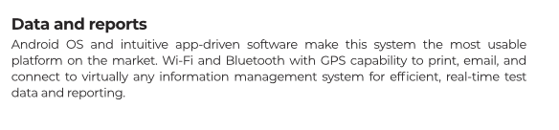 | Data and reports
 | Android OS and intuitive app-driven software make this system the most usable platform on the market. Wi-Fi and Bluetooth with GPS capability to print, email, and connect to virtually any information management system for efficient, real-time test data and reporting.
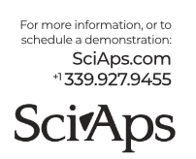 | For more information, or to schedule a demonstration:
SciAps.com
+1 339.927.9455
(Back)
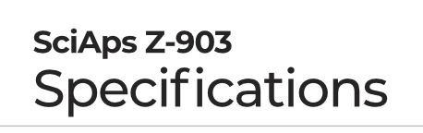 | SciAps Z-903
 | Specifications
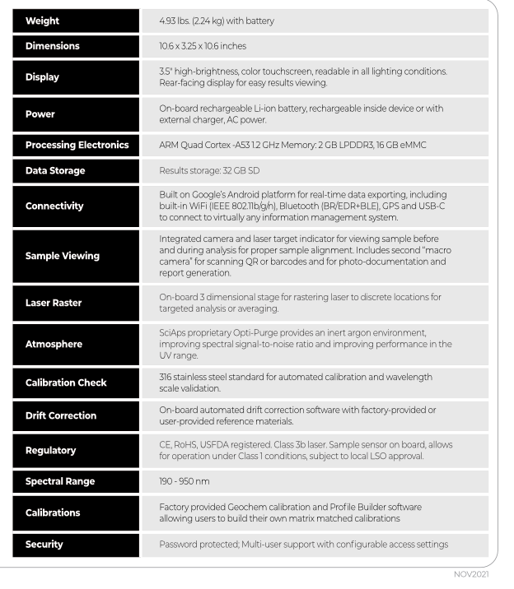 | Weight
 | 4.93 lbs. (2.24 kg) with battery
 | Dimensions
 | 10.6 x 3.25 x 10.6 inches
 | Display
 | 3.5″ high-brightness, color touchscreen, readable in all lighting conditions. Rear-facing display for easy results viewing.
 | Power
 | On-board rechargeable Li-ion battery, rechargeable inside device or with external charger, AC power.
 | Processing Electronics
 | ARM Quad Cortex -A53 1.2 GHz Memory: 2 GB LPDDR3, 16 GB eMMC
 | Data Storage
 | Results storage: 32 GB SD
 | Connectivity
 | Built on Google’s Android platform for real-time data exporting, including built-in WiFi (IEEE 802.11b/g/n), Bluetooth (BR/EDR+BLE), GPS and USB-C to connect to virtually any information management system.
 | Sample Viewing
 | Integrated camera and laser target indicator for viewing sample before and during analysis for proper sample alignment. Includes second “macro camera” for scanning QR or barcodes and for photo-documentation and report generation.
 | Laser Raster
 | On-board 3 dimensional stage for rastering laser to discrete locations for targeted analysis or averaging.
 | Atmosphere
 | SciAps proprietary Opti-Purge provides an inert argon environment, improving spectral signal-to-noise ratio and improving performance in the UV range.
 | Calibration Check
 | 316 stainless steel standard for automated calibration and wavelength scale validation.
 | Drift Correction
 | On-board automated drift correction software with factory-provided or user-provided reference materials.
 | Regulatory
 | CE, RoHS, USFDA registered. Class 3b laser. Sample sensor on board, allows for operation under Class 1 conditions, subject to local LSO approval.
 | Spectral Range
 | 190 - 950 nm
 | Calibrations
 | Factory provided Geochem calibration and Profile Builder software allow users to build their own matrix matched calibrations.
 | Security
 | Password protected; multi-user support with configurable access settings.
 | NOV2021
 | YouTube.com/SciAps
If applicable, please add:
LOCAL COMPANY NAME
LOCAL WEBSITE
LOCAL PHONE

