Document Title: Z-50 SpecSheet_NoTSIComparison
Rev Date: February 2020
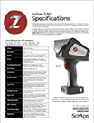
Layout Preview | English Text | Translated Text
(Page 1)
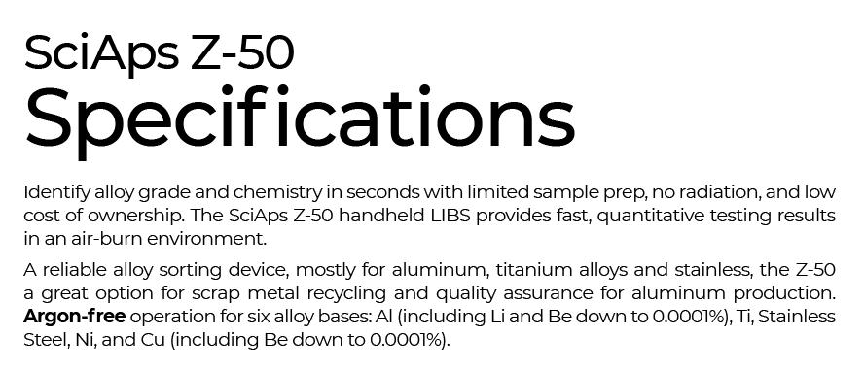 | SciAps Z-50
 | Specifications
Identify alloy grade and chemistry in seconds with limited sample prep, no radiation, and low cost of ownership. The SciAps Z-50 handheld LIBS provides fast, quantitative testing results in an air-burn environment.
A reliable alloy sorting device, mostly for aluminum, titanium alloys and stainless, the Z-50 is a great option for scrap metal recycling and quality assurance for aluminum production.
 | Argon-free
 | operation for six alloy bases: Al (including Li and Be down to 0.0001%), Ti, Stainless Steel, Ni, and Cu (including Be down to 0.0001%).
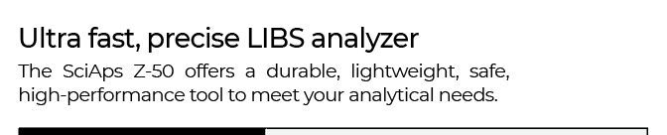 | Ultra fast, precise LIBS analyzer
 | The SciAps Z-50 offers a durable, lightweight, safe, high-performance tool to meet your analytical needs.
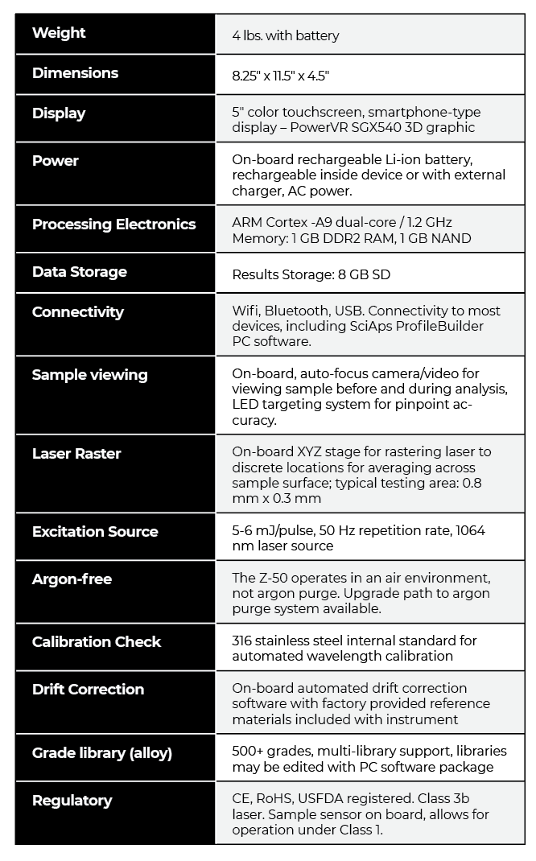 | Weight
 | 4 lbs. with battery
 | Dimensions
 | 8.25″ x 11.5″ x 4.5″
 | Power
 | On-board rechargeable Li-ion battery, rechargeable inside device or with external charger, AC power.
 | Processing Electronics
ARM Cortex -A9 dual-core / 1.2 GHz
Memory: 1 GB DDR2 RAM, 1 GB NAND
 | Data Storage
 | Results Storage: 8 GB SD
 | Connectivity
Wifi, Bluetooth, USB. Connectivity to most devices, including SciAps ProfileBuilder
PC software.
 | Sample viewing
 | On-board, auto-focus camera/video for viewing sample before and during analysis, LED targeting system for pinpoint accuracy.
 | Laser Raster
 | On-board XYZ stage for rastering laser to discrete locations for averaging across sample surface; typical testing area: 0.8 mm x 0.3 mm
 | Excitation Source
 | 5-6 mJ/pulse, 50 Hz repetition rate, 1064 nm laser source
 | Argon-free
The Z-50 operates in an air environment,
not argon purge. Upgrade path to argon purge system available.
 | Calibration Check
316 stainless steel internal standard for
automated wavelength calibration
 | Drift Correction
On-board automated drift correction
software with factory provided reference materials included with instrument
 | Grade library (alloy)
 | 500+ grades, multi-library support, libraries may be edited with PC software package
 | Regulatory
CE, RoHS, USFDA registered. Class 3b
laser. Sample sensor on board, allows for operation under Class 1.
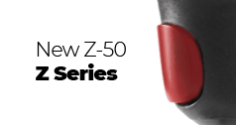 | New Z-50
 | Z Series
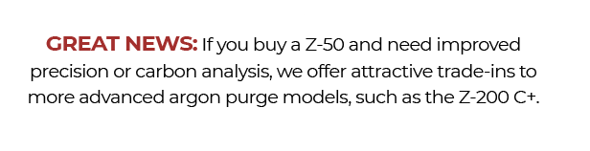 | Great News:
 | If you buy a Z-50 and need improved precision or carbon analysis, we offer attractive trade-ins to more advanced argon purge models, such as the Z-200 C+.
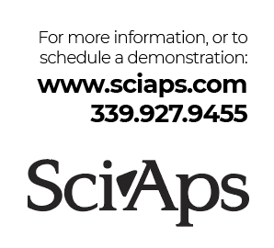 | For more information, or to  schedule a demonstration:
www.sciaps.com
339.927.9455
 | SciAps

